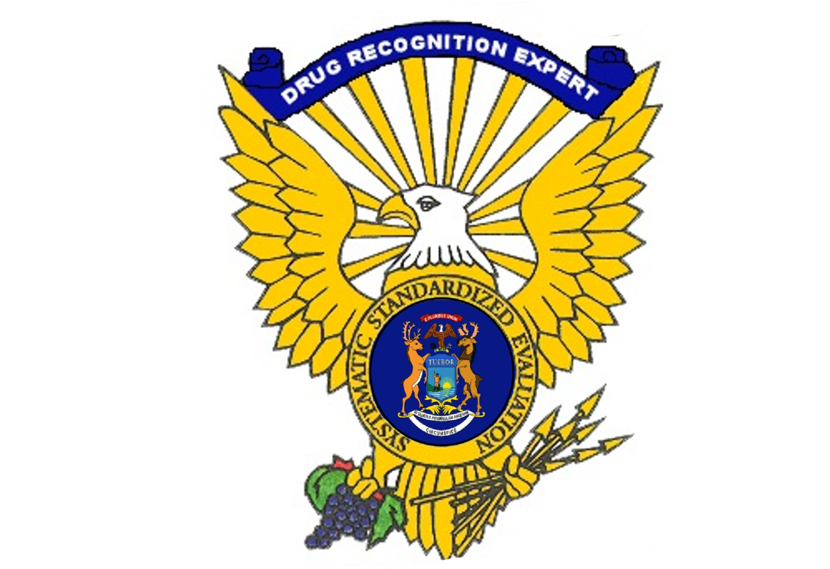

2025-1 Michigan Drug Evaluation and Classification
Drug Recognition Expert Program Training Application
Phase I & II December 2-13, 2024
Phase III January 27-Febuary 2, 2025

The Drug Evaluation and Classification Program (DECP) is a transportation safety initiative focusing on the detection and apprehension of drug-impaired drivers. The program is managed and coordinated by the International Association of Chiefs of Police (IACP) with support from the National Highway Traffic Safety Administration (NHTSA) of the U.S. Department of Transportation.

The DECP has received international acclaim for its success in helping officers identify the drug impaired driver. Drug Recognition Experts (DRE’s) are frequently called upon to differentiate between drug influence and medical and/or mental disorders. The certified DRE is an extremely valuable tool for combating the adverse impact of drug and alcohol impaired driving.

DRE training is demanding. Students must successfully complete three separate phases of training with a minimum score of 80 percent on all final exams before proceeding to the next phase. The following summarizes each phase:
Phase I (Preliminary Training): Consists of 16 hours of basic knowledge the prospective candidate will need to successfully complete the next phase. Training consists of skills learned in taking accurate vital signs, pulse, blood pressure, and body temperature. Students are also given hands-on practice in pupillary estimation, pupillary response, examination of muscle tone, and an overview of the seven major drug categories used in the DECP.

Phase II (DRE School): Typically conducted directly after the preliminary training. This is a seven-day (56-hour) course dealing with physiology, toxicology, overall drug evaluation, and familiarization with the signs and symptoms of the seven drug categories. This portion includes three written examinations; five quizzes; and a demonstration of proficiency in SFST and the entire drug evaluation process. Students must successfully complete all portions to proceed to Phase III.
Phase III (Field Certification): The responsibility of successfully completing the field certification phase lies with the student. Certification events will be scheduled to assist all prospective DREs in completing this phase within six months following the academic portions of the training. The requirements of this phase include evaluating at least 12 drug impaired individuals under supervision of a DRE instructor, identifying individuals under the influence of at least three of the seven drug categories, and attaining a 75 percent toxicological corroboration rate.
In addition to the hands-on evaluations, a DRE candidate must maintain a progress log of individuals they have evaluated, up to date rolling log, and submit an approved curriculum vitae. A final examination is given once a student has met all the requirements set forth by the IACP. After successful completion of the final examination, the DRE candidate must obtain endorsement and recommendation by two DRE Instructors.
The DRE certification is valid for a period of two years from the date of endorsement. In order to maintain certification as a DRE, the officer must complete at least four drug evaluations, one evaluation under the direct supervision of a DRE instructor, submit an up to date rolling log, be current in the National Data Tracking System, and receive at least eight hours of approved drug or alcohol-related training within the two-year period.
For more information about the DECP visit www.DECP.org, or visit OHSP Drug Recognition Expert Program
ALL APPLICANTS MUST BE AVAILABLE TO ATTEND ALL THREE PHASES OF TRAINING TO BE CONSIDERED
** Application deadline is September 30, 2024.
(Applications received after, will not be reviewed)
Michigan Drug Recognition Expert Training
Application

To be considered for DRE training, the applicant must meet all requirements listed below:

- Full-time certified law enforcement officer or qualified motor carrier officer
- Off probation with your present agency
- Have successfully completed NHTSA/IACP approved SFST/Practitioner training
- Demonstrate proficiency in the administration of the SFSTs
- Experience arresting impaired drivers
- Be willing to appear before an online or in person interview if requested
- Provide up to date resume of law enforcement experience
- Provide at least two OWI reports indicating use of SFSTs within the past year for review
- Only attach copies of report narrative including administration of the SFSTs and Lab Reports
- Provide a written recommendation from your chief, sheriff, or post commander approving your application and support as a DRE
- Officers must attend and successfully complete all three phases of DRE School

DRE certification is valid for two years. Requirements for re-certification are listed below:

- Complete four approved enforcement evaluations and one evaluation under the direct supervision of a certified DRE instructor
- Complete eight hours of approved drug/alcohol related training
- Maintain up to date resume, rolling log, and DataTracking entry

Cost covered for training:

- Cost of the training are covered by federal grants. Those cost include:
  - Instructors and materials
  - Equipment
  - Lodging at double occupancy
  - Travel expenses to and from training, including airfare, parking, and luggage
  - Meals

- Cost not Covered:
  - Wages or other benefits

APPLICANT INFORMATION

Name: |  |  |  |  |  |  |  |  |  |  |  |  |  |  |  |  |  | Rank:
(Last, first, middle initial)

Date of Birth: |  |  |  |  |  |  |  | Agency Hire Date: |  |  |  |  |  |  |  | MCOLES Number:
Work Phone: |  |  |  |  |  |  |  |  |  |  |  | Cell Phone:
Agency Name:
Agency
Address:
(Street address, city, state, zip code)

Agency  Email: |  |  |  |  |  |  |  |  |  |  |  | Personal  Email:
 |  |  | (required) |  |  |  |  |  |  |  |  |  |  | (optional)
To assist in the selection process, please provide the following information:
IACP/NHTSA approved  SFST training date: |  |  |  |  |  |  |  |  |  |  |  |  | OWI arrests in the last  two years:
SFST Instructor: |  |  |  |  |  |  | Yes |  |  | No |  |  | ARIDE training completed: |  |  |  |  |  |  | Yes |  |  | No
DMT Certified: |  |  |  |  |  |  | Yes |  |  | No

Michigan Drug Recognition Expert Training
Application
DREs often handle suspects who are drug addicts or have other ailments. It is often necessary to come into close contact with these subjects, including collecting biological samples. Are you willing to accept this responsibility?
 | Yes |  | No
Summarize any prior assignments that may be related to the DECP:
Summarize any formal education, work or practical experience, and training that may be related to the DECP. (EMT training, college, corrections, etc.).
How do you expect DRE training to benefit you, your department, and your community?
Is there anything else the selection committee should know about you or your interest in the DECP?

I understand and accept the requirements of the Drug Recognition Expert training program and attest to the information listed above as accurate and true.

Applicant’s signature: _________________________________________ Date: _________________

Email Application and Supporting Documents to:
Sgt. Jim Janes, DECP Coordinator
Enforcement Career Development Section
Organizational Development Division
Michigan State Police
269-921-5666
JanesJ@michigan.gov

