Executive Summary

ES-05 Executive Summary - 91.300(c), 91.320(b)
1. Introduction
The State of Michigan's Housing and Community Development Consolidated Plan is submitted pursuant to a U.S. Department of Housing and Urban Development (HUD) rule (24 CFR Part 91, 1/5/95) as a single submission covering the planning and application aspects of HUD's Community Development Block Grant (CDBG), Emergency Solutions Grant (ESG), HOME Investment Partnership (HOME) and Housing Opportunities for Persons with AIDS (HOPWA), Housing Trust Fund (HTF) and Recovery Housing Program (RHP) formula programs.
The purpose of the 2020-2024 Consolidated Plan is to describe programs and activities that will be undertaken in conjunction with HUD programs by the state of Michigan within the next 5 years. Funding from these programs is awarded to the State by HUD and administered by the Michigan State Housing Development Authority, the Michigan Strategic Fund, and the Michigan Department of Health and Human Services. Each of the programs and activities that are proposed are described in detail within the following documents.
The programs and activities to be provided in year one of the five year plan (July 1, 20205 - June 30, 2016) address the housing and community development needs and goals identified within the State of Michigan's Consolidated Plan. The 2015 Consolidated Plan references strategies developed to address the following goals of the programs that it covers during the five-year period July 1, 2015 through June 30, 2020. These goals are to:
- Expand the availability and supply of safe, decent, affordable, and accessible rental housing for low and extremely low-income individuals and families;
- Improve and preserve the existing affordable housing stock and neighborhoods;
- Increase sustainable homeownership opportunities for individuals and families by reducing the costs of homeownership;
- Make homeless assistance more effective and responsive to local need through local autonomy and movement toward a continuum of care;
- Develop linkages between the housing and service sectors to provide greater housing opportunities for households with special needs;
- Establish a suitable living environment and expand economic opportunities for low and moderate-income people through economic and community infrastructure development;
- Reduce incidences of spot and/or area blight to improve safety and revitalize downtown districts;
- Respond to community's urgent needs or unique opportunities to support economic and community development; and
- Support communities and businesses in job creation and business assistance.
This consolidated submission specifies the State of Michigan's plan to use federal funds to implement housing and community development activities under four HUD-funded formula programs.
2. Summary of the objectives and outcomes identified in the Plan Needs Assessment Overview
Housing programs authorized by the National Affordable Housing Act (NAHA) represent a significant source of funding through which states, like Michigan, may address their need for affordable housing.
These programs include the: Community Development Block Grant (CDBG) program; HOME investment partnership program; Housing Trust Fund (HTF); HOPE program; Shelter Plus Care program; Supportive Housing for the Elderly (Section 211); Emergency Solution Grants (ESG) program; Supportive Housing program; Moderate Rehabilitation Single Room Occupancy program; Housing Opportunities for Persons With AIDS (HOPWA) program; Technical Assistance; Rural Homelessness Grant program; Revitalization of Severely Distressed Public Housing program; and the Low-Income Housing Preservation program and the Recovery Housing Program (RHP).
The state has identified job creation, job training, blight elimination, infrastructure assistance and responding to unique community development needs and opportunities as the desired outcomes in the next five years.
MSHDA endorses the objectives of the Housing and Economic Recovery Act of 2008 which established the Housing Trust Fund to increase and preserve the supply of rental housing for extremely low income families and thereby amends this plan to account for these priorities.
This plan will utilize the same objectives and outcomes as the previously approved plan for FY20. It is anticipated that a substantial amendment will be needed post-covid to address State resident needs for FY21-FY24 In addition, all of the data sets will need to updated to account for economic/non-residential and residential changes that occur which throughout the State as a result of the pandemic.
3. Evaluation of past performance
The State believes the activities and strategies funded through the Consolidated Plan are making an impact on identified needs. The demand for the programs funded under CDBG, HOME, ESG and HOPWA remain greater than the funding available. Commitment and disbursement of funds are proceeding on a timely basis. Federal funding is being used to accomplish the major goals cited in the State of Michigan Consolidated Plan. The overall goals of providing affordable housing and a suitable living environment are being accomplished with our homeowner, homebuyer, and rental housing development programs. The overall goal of expanding economic opportunities for low and moderate-income persons is being met with the CDBG economic development program. The State does not believe an adjustment to its strategies is needed at this time.
The 2020 Program Year anticipated achievements are identified within this document and the accomplishment data will be provided in the CAPER. It should also be noted that the HOPWA achievement data will be fully reported within the CAPER.
4. Summary of citizen participation process and consultation process
The Michigan State Housing Development Authority (MSHDA), which is the lead agency responsible for preparing the Michigan Consolidated Plan solicited written and/or verbal comments from the public regarding the planned use of the funding. The formal public comment period was held between August 31, 2019 through September 29, 2020 and covered the proposed use of FY2020 funding. Formal in person public hearings were not held and the Notice for the plan was not published in newspapers due to the pandemic. Notice was given via formal website posting and all interested parties were encouraged to attend a virtual Teams meeting on September 22, 2020 instead of an in-person public hearing.
5. Summary of public comments
In total, we received no formal comment and/or written responses an no one attended the Teams meeting.
6. Summary of comments or views not accepted and the reasons for not accepting them
Not applicable.
7. Summary
Overall, for all program funding the Consolidated Plan is to continue to utilize funding in the same manner as previously authorized for FY20 and then to solicit additional comments as part of the amendment process for future years.

The Process

PR-05 Lead & Responsible Agencies 24 CFR 91.300(b)
1. Describe agency/entity responsible for preparing the Consolidated Plan and those responsible for administration of each grant program and funding source
The following are the agencies/entities responsible for preparing the Consolidated Plan and those responsible for administration of each grant program and funding source.
Agency Role | Name | Department/Agency

CDBG Administrator | MICHIGAN | MSF
HOPWA Administrator | MICHIGAN | MDHHS
HOME Administrator | MICHIGAN | MSHDA
ESG Administrator | MICHIGAN | MSHDA
 | MICHIGAN | MSHDA
Table 1 – Responsible Agencies

Narrative
MSHDA is responsible for the submission of the Consolidated Plan on behalf of the State of Michigan. The Michigan State Housing Development Authority encourages participation in the development of the plan, any substantial amendments to the plan, and the performance report. Participation of low and moderate-income persons is encouraged, particularly those living in slum and blighted areas and in areas where CDBG funds are proposed to be used, and by residents of predominantly low and moderate-income neighborhoods.
All meeting announcements and comment periods specifically reference the fact that comments are requested on both the consolidated plan and the annual action plan. These plans will be made available in a format accessible to persons with disabilities upon request, translated upon request, and copies will be made available for free to any Michigan resident upon request.
Consolidated Plan Public Contact Information
Written comments are being accepted by mail to the attention of Tonya Young, Consolidated Plan Coordinator, MSHDA, 735 East Michigan Avenue, P.O. Box 30044, Lansing, Michigan 48909 or electronically via the Housing Initiatives mailbox e-mail address: hidmailbox@michigan.gov.

PR-10 Consultation – 91.100, 91.110, 91.200(b), 91.300(b), 91.200(I) and 91.315(l)
1. Introduction
The State supports the continuum concept by providing technical assistance for the development of local continua of care and the Balance of State (BOS) continuum. Additionally, applicants for the State’s Emergency Solutions Grant Program must be part of a local continuum of care to be funded.
It should be noted that the State submits a competitive application each year through the Balance of State Continuum of Care for competitive Homeless Assistance Grant (HAG) funds. These funds support the creation of new permanent supportive housing projects, as well as the ongoing operation of over 31 existing projects.
Provide a concise summary of the state’s activities to enhance coordination between public and assisted housing providers and private and governmental health, mental health and service agencies (91.215(l))
Ending homelessness in Michigan is an achievable goal through well-planned, sustained (long-term) effort, with all partners working toward this common goal. To that end, the State of Michigan created a state Interagency Council on Homelessness (ICH) in January 2015. The Michigan ICH consists of directors from the Michigan departments of Military Affairs, Health and Human Services, Education, Natural Resources, MSHDA, Corrections, Management and Budget, Courts and five members representing the general public.
In addition, Michigan has a state level plan to end homelessness. The state’s plan is aligned with “Opening Doors”, the federal strategic plan to prevent and end homelessness adopted by the United States interagency council on homelessness.
Describe coordination with the Continuum of Care and efforts to address the needs of homeless persons (particularly chronically homeless individuals and families, families with children, veterans, and unaccompanied youth) and persons at risk of homelessness
The Michigan State Housing Development Authority (MSHDA) and the Michigan Homeless Assistance Advisory Board (MHAAB) representatives work diligently to foster collaborative relationships with private and public sector stakeholder groups and to recruit key personnel from those entities to serve on the Balance of State Continuum of Care planning body. The CoC Planning Body is known as the Michigan Homeless Assistance Advisory Board (MHAAB). There are twenty regular members representing both private and public stakeholders. State officials from the Michigan Department of
Education, Veteran’s Affairs, and the Michigan Department of Health and Human Services participate in MHAAB and the Michigan ICH and work to meet the needs of chronically homeless, families with children, veterans, youth and survivors of domestic violence.
In addition, the Michigan ICH has a working committee consisting with staff members from the state departments listed above along with staff from the Michigan Coalition Against Homeless, the Coalition Against Homelessness, the Michigan Municipal League, Veteran’s Affairs, the United Way, and the Michigan Community Action Agency.
Michigan has held many Project Homeless Connect events across the state. These events were sponsored in part by MSHDA.
Describe consultation with the Continuum(s) of Care that serves the state in determining how to allocate ESG funds, develop performance standards and evaluate outcomes, and develop funding, policies and procedures for the administration of HMIS
The Balance of State Continuum sponsors the applications for funding by stakeholders in geographic locations of the State that do not apply directly to HUD for HAG funding. The MHAAB provides the leadership and decision-making body for the Balance of State Continuum of Care. It develops annual action plans, establishes funding priorities, engages local continua representatives in planning dialogue, and promotes inter-agency collaboration.
2. Describe Agencies, groups, organizations and others who participated in the process and describe the jurisdictions consultations with housing, social service agencies and other entities

Table 2 – Agencies, groups, organizations who participated
1 | Agency/Group/Organization | Michigan Homeless Assistance Advisory Board (MHAAB)
 | Agency/Group/Organization Type | Housing  PHA  Services - Housing  Services-homeless  Services-Health  Health Agency  Child Welfare Agency  Other government - Federal  Other government - State  Other government - County  Other government - Local
 | What section of the Plan was addressed by Consultation? | Homelessness Strategy  Homeless Needs - Chronically homeless  Homeless Needs - Families with children  Homelessness Needs - Veterans
 | How was the Agency/Group/Organization consulted and what are the anticipated outcomes of the consultation or areas for improved coordination? | On behalf of the BOS, the MHAAB is responsible for applying for CoC Program funds annually during the HUD CoC Program Competition. In addition, the MHAAB oversees the HUD ESG Program funds awarded to BOS geographic areas. The Michigan State Housing Development Authority (MSHDA) and the Michigan Homeless Assistance Advisory Board (MHAAB) representatives work diligently to foster collaborative relationships with private and public sector stakeholder groups and to recruit key personnel from those entities to serve on the Balance of State Continuum of Care planning body. The CoC Planning Body is known as the Michigan Homeless Assistance Advisory Board (MHAAB). There are twenty regular members representing both private and public stakeholders. State officials from the Michigan Department of Education, Veteran Affairs, and the Michigan Department of Health and Human Services participate in MHAAB and the Michigan ICH and work to meet the needs of chronically homeless, families with children, veterans, youth and survivors of domestic violence. In addition, the Michigan ICH has a working committee consisting with staff members from the state departments listed above along with staff from the Michigan Coalition Against Homeless, the Coalition Against Homelessness, the Michigan Municipal League, Veteran Affairs, the United Way, and the Michigan Community Action Agency. Michigan has held many Project Homeless Connect events across the state. These events were sponsored in part by MSHDA.

Identify any Agency Types not consulted and provide rationale for not consulting

Other local/regional/state/federal planning efforts considered when preparing the Plan
Name of Plan | Lead Organization | How do the goals of your Strategic Plan overlap with the goals of each plan?
Continuum of Care | MSHDA | The goal of making homeless assistance more effective and responsive to local need through local autonomy and movement toward continuum of care is being achieved through the process outlined in the plan.
Michigan Hazard Mitigation Plan | Michigan State Police | Two goals of the Michigan Hazard Mitigation Plan "Reduce Property Damage" and "Build Alliances" align with the goals of the CDBG Program through creating more resilient communities and supporting partnerships with other state agencies.
Table 3 – Other local / regional / federal planning efforts
Describe cooperation and coordination among the State and any units of general local government, in the implementation of the Consolidated Plan (91.315(l))
MSHDA coordinates with all Continuums of Care throughout the state when allocating ESG funds. HMIS data is used to develop an allocation plan to distribute ESG to all 83 counties in Michigan. Performance measures and outcomes are measured through our statewide HMIS to determine which CoCs are being most successful and which need additional assistance. MSHDA works with Independent Jurisdictions that receive ESG directly from HUD to ensure both state allocated and direct HUD ESG are used in a coordinated fashion. Our statewide HMIS coordinator, Michigan Coalition Against Homelessness, provides HMIS policy guidance and support to all CoCs across the state.
Narrative (optional):

PR-15 Citizen Participation – 91.105, 91.115, 91.200(c) and 91.300(c)
1. Summary of citizen participation process/Efforts made to broaden citizen participation
Summarize citizen participation process and how it impacted goal-setting

The citizen participation comment process has been changed for this fiscal year to a fully remote process without holding in-person public hearings. Specific goal-setting for FY20 has been difficult to identify due to the pandemic. However, continued receipt of funding has been and continues to be a high priority for all of the programs based on limited resources and high demand and need for the products.
As part of the citizen participation process, a written public comment period between August 31, 2020 and September 29, 2020 was held.
There were no comments submitted that were related to the programs during the initial public comment period. To encourage public comment the written public comment period has been extended to September 29, 2020 and a Teams public meeting has been scheduled for Tuesday, September 22nd.

Citizen Participation Outreach
Sort Order | Mode of Outreach | Target of Outreach | Summary of  response/attendance | Summary of  comments received | Summary of comments not accepted and reasons | URL (If applicable)
1 | Internet Outreach | All Michigan Residents | Draft Plan was posted on our website requesting written comments. | No written comments received. | Not applicable. | https://www.michigan.gov/documents/mshda/Plan_-__2020_-_Publication_700938_7.pdf
2 | Public Meeting | All Michigan Residents | On September 22nd a Teams Meeting was held for public comment. No one attended. | No comments were provided. | Not applicable.
4 | Internet Outreach | Non-Entitlement Communities | Community Voice of the Customer - yearly outreach by MEDC of Non-Entitlement | Stakeholders list access to broadband as one of the primary barriers to economic development in their rural community.Stakeholders list a housing shortage as one of the primary issues in their region. Lack of housing makes it even more difficult to attract and retain talent. Stakeholders discuss out-of-date infrastructure as one of the primary problems facing their regions. When discussing the primary challenges associated with conducting economic development in a rural area, many stakeholders discuss a lack of access to transportation. | Not applicable.
Table 4 – Citizen Participation Outreach

Needs Assessment

NA-05 Overview
Needs Assessment Overview
The State believes the activities and strategies funded through the Consolidated Plan are making an impact on identified needs. The demand for the programs funded under CDBG, HOME, ESG and HOPWA remain greater than the funding available.
Despite the progress made in recent months and years, Michigan still has a higher unemployment rate than the national average and therefore support for job creation is an ongoing need in the state. In addition to unemployment, Michigan is experiencing a skills gap, where qualified trained personnel are not always available in certain sectors like skilled trades and information technology requiring job training of existing workforce.
In addition to workforce challenges, the state also faces community development challenges. Throughout the state of Michigan, there are vacant and blighted structures in areas with insufficient local funds available to deal with these issues. Due to aging infrastructure and limited community level assets in low to moderate-income areas, there is a need for financial assistance with infrastructure improvements.
The State of Michigan has completed a needs assessment which can be located at: https://www.michigan.gov/documents/mshda/MSHDA-Statewide-Housing-Needs-web_653602_7.pdf

NA-10 Housing Needs Assessment - 24 CFR 91.305 (a,b,c)
Summary of Housing Needs
Michigan's statewide data is essential for statewide planning and sub-state comparisons and planning, even though the state is highly diverse, and unique local/county characteristics become muted in the big picture. Michigan's diversity in demographics, and social and economic characteristics cover a very wide spectrum, which is why the housing needs vary somewhat by region.

Demographics | Base Year: 2009 | Most Recent Year: 2015 | % Change
Population | 9,883,640 | 9,900,571 | 0%
Households | 3,860,160 | 3,841,148 | -0%
Median Income | $48,700.00 | $49,576.00 | 2%
Table 5 - Housing Needs Assessment Demographics

Data Source: | 2005-2009 ACS (Base Year), 2011-2015 ACS (Most Recent Year)

Number of Households Table
 | 0-30% HAMFI | >30-50% HAMFI | >50-80% HAMFI | >80-100% HAMFI | >100% HAMFI
Total Households | 518,560 | 458,265 | 663,340 | 397,875 | 1,803,110
Small Family Households | 165,435 | 139,450 | 220,485 | 150,865 | 943,070
Large Family Households | 36,155 | 33,885 | 48,930 | 32,075 | 149,835
Household contains at least one person 62-74 years of age | 81,485 | 91,590 | 153,365 | 100,300 | 396,305
Household contains at least one person age 75 or older | 56,735 | 98,260 | 120,720 | 52,380 | 130,035
Households with one or more children 6 years old or younger | 94,625 | 69,220 | 93,410 | 54,415 | 157,635

Table 6 - Total Households Table
Data Source: | 2011-2015 CHAS

Housing Needs Summary Tables
1. Housing Problems (Households with one of the listed needs)
 | Renter |  |  |  |  | Owner
 | 0-30% AMI | >30-50% AMI | >50-80% AMI | >80-100% AMI | Total | 0-30% AMI | >30-50% AMI | >50-80% AMI | >80-100% AMI | Total
NUMBER OF HOUSEHOLDS
Substandard Housing - Lacking complete plumbing or kitchen facilities | 6,650 | 3,990 | 4,785 | 1,685 | 17,110 | 3,345 | 2,045 | 2,455 | 1,390 | 9,235
Severely Overcrowded - With >1.51 people per room (and complete kitchen and plumbing) | 2,930 | 2,255 | 1,685 | 590 | 7,460 | 560 | 765 | 1,050 | 625 | 3,000
Overcrowded - With 1.01-1.5 people per room (and none of the above problems) | 8,130 | 5,535 | 4,260 | 1,545 | 19,470 | 3,250 | 4,335 | 6,080 | 2,935 | 16,600
Housing cost burden greater than 50% of income (and none of the above problems) | 197,840 | 58,490 | 10,925 | 1,305 | 268,560 | 118,235 | 66,350 | 41,680 | 9,180 | 235,445
Housing cost burden greater than 30% of income (and none of the above problems) | 33,095 | 95,990 | 75,835 | 10,695 | 215,615 | 32,145 | 75,655 | 113,670 | 54,325 | 275,795
Zero/negative Income (and none of the above problems) | 31,480 | 0 | 0 | 0 | 31,480 | 21,320 | 0 | 0 | 0 | 21,320
Table 7 – Housing Problems Table
Data Source: | 2011-2015 CHAS

2. Housing Problems 2 (Households with one or more Severe Housing Problems: Lacks kitchen or complete plumbing, severe overcrowding, severe cost burden)
 | Renter |  |  |  |  | Owner
 | 0-30% AMI | >30-50% AMI | >50-80% AMI | >80-100% AMI | Total | 0-30% AMI | >30-50% AMI | >50-80% AMI | >80-100% AMI | Total
NUMBER OF HOUSEHOLDS
Having 1 or more of four housing problems | 215,550 | 70,265 | 21,655 | 5,125 | 312,595 | 125,390 | 73,495 | 51,265 | 14,130 | 264,280
Having none of four housing problems | 75,195 | 141,405 | 202,930 | 98,450 | 517,980 | 49,625 | 173,100 | 387,490 | 280,165 | 890,380
Household has negative income, but none of the other housing problems | 31,480 | 0 | 0 | 0 | 31,480 | 21,320 | 0 | 0 | 0 | 21,320
Table 8 – Housing Problems 2
Data Source: | 2011-2015 CHAS

3. Cost Burden > 30%
 | Renter |  |  |  | Owner
 | 0-30% AMI | >30-50% AMI | >50-80% AMI | Total | 0-30% AMI | >30-50% AMI | >50-80% AMI | Total
NUMBER OF HOUSEHOLDS
Small Related | 89,855 | 59,985 | 31,035 | 180,875 | 45,805 | 42,925 | 58,880 | 147,610
Large Related | 19,230 | 11,580 | 4,675 | 35,485 | 11,565 | 11,870 | 12,665 | 36,100
Elderly | 38,820 | 34,445 | 21,855 | 95,120 | 58,025 | 64,745 | 55,915 | 178,685
Other | 96,970 | 56,280 | 32,955 | 186,205 | 40,210 | 25,915 | 30,130 | 96,255
Total need by income | 244,875 | 162,290 | 90,520 | 497,685 | 155,605 | 145,455 | 157,590 | 458,650
Table 9 – Cost Burden > 30%
Data Source: | 2011-2015 CHAS

4. Cost Burden > 50%
 | Renter |  |  |  | Owner
 | 0-30% AMI | >30-50% AMI | >50-80% AMI | Total | 0-30% AMI | >30-50% AMI | >50-80% AMI | Total
NUMBER OF HOUSEHOLDS
Small Related | 79,225 | 22,355 | 2,360 | 103,940 | 37,790 | 21,645 | 14,610 | 74,045
Large Related | 16,780 | 3,395 | 195 | 20,370 | 8,820 | 5,210 | 2,555 | 16,585
Elderly | 28,290 | 14,655 | 5,525 | 48,470 | 42,155 | 26,960 | 16,600 | 85,715
Other | 85,050 | 20,825 | 4,230 | 110,105 | 33,325 | 13,720 | 8,230 | 55,275
Total need by income | 209,345 | 61,230 | 12,310 | 282,885 | 122,090 | 67,535 | 41,995 | 231,620
Table 10 – Cost Burden > 50%
Data Source: | 2011-2015 CHAS

5. Crowding (More than one person per room)
 | Renter |  |  |  |  | Owner
 | 0-30% AMI | >30-50% AMI | >50-80% AMI | >80-100% AMI | Total | 0-30% AMI | >30-50% AMI | >50-80% AMI | >80-100% AMI | Total
NUMBER OF HOUSEHOLDS
Single family households | 9,340 | 6,110 | 4,540 | 1,525 | 21,515 | 3,385 | 4,240 | 5,270 | 2,585 | 15,480
Multiple, unrelated family households | 1,330 | 1,245 | 1,000 | 415 | 3,990 | 695 | 1,120 | 1,900 | 970 | 4,685
Other, non-family households | 540 | 525 | 500 | 265 | 1,830 | 30 | 24 | 70 | 30 | 154
Total need by income | 11,210 | 7,880 | 6,040 | 2,205 | 27,335 | 4,110 | 5,384 | 7,240 | 3,585 | 20,319
Table 11 – Crowding Information – 1/2
Data Source: | 2011-2015 CHAS

 | Renter |  |  |  | Owner
 | 0-30% AMI | >30-50% AMI | >50-80% AMI | Total | 0-30% AMI | >30-50% AMI | >50-80% AMI | Total
Households with Children Present | 0 | 0 | 0 | 0 | 0 | 0 | 0 | 0
Table 12 – Crowding Information – 2/2

Data Source Comments:

Describe the number and type of single person households in need of housing assistance.
Based on the data, small related households and the elderly under 50% AMI with a cost burden are the most in need of rental and owner-occupied housing assistance.
Estimate the number and type of families in need of housing assistance who are disabled or victims of domestic violence, dating violence, sexual assault and stalking.
Michigan serves women, men & children each fiscal year. Of the total number of women/men served, the date also presumes that is the number of families served annually. This is a non-duplicated number, i.e., if a family came back to the shelter during the fiscal year, they would not be counted again. In addition to that number, we track denials because shelters were at capacity. Note that this number is duplicated as there the callers were not clients, so it is not possible to track by a client number.
What are the most common housing problems?
In Michigan, by far the most common housing problem is high housing cost burden. Predictably, the proportion of households experiencing this problem increases as household income levels decrease: about 70% of all renter households reporting severe cost burdens earn less than 30% of AMI. The situation is similar among owner households in this income group; there, 40% of severely overburdened households earn less than 30% of AMI. Statewide, about 542,000 households—14% of the total--pay up to half of their incomes on housing
Compared to housing overburden, physical deficiencies in housing units (overcrowded units, or those that lack plumbing or kitchen facilities) are a much smaller problem. Overall, about 24,000 (of about 3.8 million households total) live in units that lack plumbing or kitchen facilities and about 44,000 live in overcrowded conditions—35,000 of them in severely overcrowded units.
Are any populations/household types more affected than others by these problems?
According to the data from the CHAS, among renters, four groups seem to have elevated levels of overburden: small related households earning less than 30% AMI, small related households earning between 30% to 50% AMI, other households earning below 30% AMI, and other households earning between 30% and 50% AMI. These four groups account for about 60% of all overburdened low and moderate income households in the state.
Owner households also have four groups that have elevated concentrations of overburden. These are small related households earning between 50% and 80% of AMI, and elderly households earning below 30% AMI, between 30% and 50% of AMI, and between 50% and 80% of AMI. Together, these groups equal 51% of low or middle income overburdened households.
The crowding situation is similar, in that at least among renters the incidence of overcrowding tends to increase at lower income levels. This is especially true among single family households. Among owners, the relationship between income and crowding is not as clear. Single family households earning between 50% and 80% of AMI is the largest group among owners experiencing overcrowding.
Describe the characteristics and needs of Low-income individuals and families with children (especially extremely low-income) who are currently housed but are at imminent risk of either residing in shelters or becoming unsheltered 91.205(c)/91.305(c)). Also discuss the needs of formerly homeless families and individuals who are receiving rapid re-housing assistance and are nearing the termination of that assistance
Michigan’s Homeless Management Information System (HMIS) identified 40,251 people at significant risk of becoming homeless in 2014. People at imminent of homelessness lack employment or entitlement benefits and face a wide array of other problems, e.g. lack of health care, domestic violence, substance abuse, etc. In some areas of Michigan more affordable housing is needed.
Through the Campaign to End Homelessness in Michigan numerous programs have been put in place to prevent homelessness or to assist re-housed people in retaining housing. For example, Michigan has a statewide SOAR Program, each CoC Body in Michigan has their own communitywide plan to end homelessness, each CoC has MSHDA staff assigned to them to provide technical assistance, the Michigan Coalition Against Homelessness (MCAH) has a Campaign to End Homelessness AmeriCorps Program which provides members to work at local service agencies to assist with homelessness. These are only a few of the programs and initiatives embraced by MSHDA and its’ team, the MI ICH, in working to end homelessness.
If a jurisdiction provides estimates of the at-risk population(s), it should also include a description of the operational definition of the at-risk group and the methodology used to generate the estimates:
One methodology used to define at-risk groups would be the HOPWA Housing Stability Codes below:
Stable Permanent Housing/Ongoing Participation
3 = Private Housing in the private rental or home ownership market (without known subsidy, including permanent placement with families or other self-sufficient arrangements) with reasonable expectation that additional support is not needed.
4 = Other HOPWA-funded housing subsidy assistance (not STRMU), e.g. TBRA or Facility-Based Assistance.
5 = Other subsidized house or apartment (non-HOPWA sources, e.g., Section 8, HOME, public housing).
6 = Institutional setting with greater support and continued residence expected (e.g., residential or long-term care facility).
Temporary Housing
2 = Temporary housing - moved in with family/friends or other short-term arrangement, such as Ryan White subsidy, transitional housing for homeless, or temporary placement in institution (e.g., hospital, psychiatric hospital or other psychiatric facility, or substance abuse treatment facility or detox center).
Unstable Arrangements
1 = Emergency shelter or no housing destination, such as places not meant for habitation (e.g., a vehicle, an abandoned building, bus/train/subway station, or anywhere outside).
7 = Jail/prison.
8 = Disconnected or disappeared from project support, unknown destination, or no assessment of housing needs were undertaken.
Life Event
9 = Death, (i.e., remained in housing until death). This characteristic is not factored into the housing stability equation.
More details regarding this process is provided in the CAPER submission.
Specify particular housing characteristics that have been linked with instability and an increased risk of homelessness
See stability codes above.
Discussion

NA-15 Disproportionately Greater Need: Housing Problems - 91.305 (b)(2)
Assess the need of any racial or ethnic group that has disproportionately greater need in comparison to the needs of that category of need as a whole.
Introduction
The State of Michigan has completed a needs assessment which can be located at: https://www.michigan.gov/documents/mshda/MSHDA-Statewide-Housing-Needs-web_653602_7.pdf
0%-30% of Area Median Income
Housing Problems | Has one or more of four housing problems | Has none of the four housing problems | Household has no/negative income, but none of the other housing problems
Jurisdiction as a whole | 406,350 | 60,104 | 53,172
White | 249,078 | 38,068 | 30,884
Black / African American | 118,228 | 16,514 | 17,021
Asian | 7,551 | 915 | 2,089
American Indian, Alaska Native | 2,613 | 451 | 308
Pacific Islander | 38 | 14 | 0
Hispanic | 18,855 | 2,693 | 1,936
Table 13 - Disproportionally Greater Need 0 - 30% AMI
Data Source: | 2011-2015 CHAS

*The four housing problems are:
1. Lacks complete kitchen facilities, 2. Lacks complete plumbing facilities, 3. More than one person per room, 4.Cost Burden greater than 30%

30%-50% of Area Median Income
Housing Problems | Has one or more of four housing problems | Has none of the four housing problems | Household has no/negative income, but none of the other housing problems
Jurisdiction as a whole | 315,472 | 143,104 | 0
White | 224,244 | 110,087 | 0
Black / African American | 63,363 | 21,882 | 0
Asian | 5,326 | 1,659 | 0
American Indian, Alaska Native | 1,788 | 1,094 | 0
Pacific Islander | 44 | 0 | 0
Hispanic | 14,689 | 6,109 | 0
Table 14 - Disproportionally Greater Need 30 - 50% AMI
Data Source: | 2011-2015 CHAS

*The four housing problems are:
1. Lacks complete kitchen facilities, 2. Lacks complete plumbing facilities, 3. More than one person per room, 4.Cost Burden greater than 30%

50%-80% of Area Median Income
Housing Problems | Has one or more of four housing problems | Has none of the four housing problems | Household has no/negative income, but none of the other housing problems
Jurisdiction as a whole | 262,461 | 400,829 | 0
White | 201,479 | 319,731 | 0
Black / African American | 41,468 | 52,302 | 0
Asian | 4,649 | 5,031 | 0
American Indian, Alaska Native | 1,029 | 2,175 | 0
Pacific Islander | 58 | 48 | 0
Hispanic | 9,579 | 16,274 | 0
Table 15 - Disproportionally Greater Need 50 - 80% AMI
Data Source: | 2011-2015 CHAS

*The four housing problems are:
1. Lacks complete kitchen facilities, 2. Lacks complete plumbing facilities, 3. More than one person per room, 4.Cost Burden greater than 30%
80%-100% of Area Median Income
Housing Problems | Has one or more of four housing problems | Has none of the four housing problems | Household has no/negative income, but none of the other housing problems
Jurisdiction as a whole | 84,416 | 313,903 | 0
White | 68,405 | 257,947 | 0
Black / African American | 9,623 | 35,928 | 0
Asian | 1,846 | 4,551 | 0
American Indian, Alaska Native | 354 | 1,424 | 0
Pacific Islander | 8 | 117 | 0
Hispanic | 3,008 | 10,422 | 0
Table 16 - Disproportionally Greater Need 80 - 100% AMI
Data Source: | 2011-2015 CHAS

*The four housing problems are:
1. Lacks complete kitchen facilities, 2. Lacks complete plumbing facilities, 3. More than one person per room, 4.Cost Burden greater than 30%
Discussion
While it is true that the prevalence of housing problems is highly related to income, some population groups still show a higher degree of need for safe and affordable housing across most income categories. The table provided above is a recalculation of the information presented on the previous pages, so that the percentage of each ethnic or racial group with housing problems is displayed.
Disproportionately greater need seems to exist among many Black/African American, Asian and Hispanic households. All three types of households display higher proportions of housing problems than does the State as a whole. It is difficult to ascertain the situation among Pacific Islanders, as their numbers are small in Michigan, and any trend may be due to data issues rather than real trends.

NA-20 Disproportionately Greater Need: Severe Housing Problems – 91.305(b)(2)
Assess the need of any racial or ethnic group that has disproportionately greater need in comparison to the needs of that category of need as a whole.
Introduction
The State of Michigan has completed a needs assessment which can be located at: https://www.michigan.gov/documents/mshda/MSHDA-Statewide-Housing-Needs-web_653602_7.pdf
0%-30% of Area Median Income
Severe Housing Problems* | Has one or more of four housing problems | Has none of the four housing problems | Household has no/negative income, but none of the other housing problems
Jurisdiction as a whole | 341,062 | 125,066 | 53,172
White | 207,427 | 79,535 | 30,884
Black / African American | 101,221 | 33,537 | 17,021
Asian | 6,692 | 1,764 | 2,089
American Indian, Alaska Native | 2,069 | 1,024 | 308
Pacific Islander | 38 | 14 | 0
Hispanic | 15,409 | 6,107 | 1,936
Table 17 – Severe Housing Problems 0 - 30% AMI
Data Source: | 2011-2015 CHAS

*The four severe housing problems are:
1. Lacks complete kitchen facilities, 2. Lacks complete plumbing facilities, 3. More than 1.5 persons per room, 4.Cost Burden over 50%

30%-50% of Area Median Income
Severe Housing Problems* | Has one or more of four housing problems | Has none of the four housing problems | Household has no/negative income, but none of the other housing problems
Jurisdiction as a whole | 143,930 | 314,548 | 0
White | 101,397 | 232,885 | 0
Black / African American | 29,043 | 56,240 | 0
Asian | 3,050 | 3,945 | 0
American Indian, Alaska Native | 743 | 2,132 | 0
Pacific Islander | 40 | 4 | 0
Hispanic | 6,886 | 13,883 | 0
Table 18 – Severe Housing Problems 30 - 50% AMI
Data Source: | 2011-2015 CHAS

*The four severe housing problems are:
1. Lacks complete kitchen facilities, 2. Lacks complete plumbing facilities, 3. More than 1.5 persons per room, 4.Cost Burden over 50%

50%-80% of Area Median Income
Severe Housing Problems* | Has one or more of four housing problems | Has none of the four housing problems | Household has no/negative income, but none of the other housing problems
Jurisdiction as a whole | 73,222 | 590,381 | 0
White | 57,363 | 464,066 | 0
Black / African American | 9,440 | 84,326 | 0
Asian | 1,626 | 8,046 | 0
American Indian, Alaska Native | 342 | 2,862 | 0
Pacific Islander | 29 | 77 | 0
Hispanic | 3,197 | 22,650 | 0
Table 19 – Severe Housing Problems 50 - 80% AMI
Data Source: | 2011-2015 CHAS

*The four severe housing problems are:
1. Lacks complete kitchen facilities, 2. Lacks complete plumbing facilities, 3. More than 1.5 persons per room, 4.Cost Burden over 50%

80%-100% of Area Median Income
Severe Housing Problems* | Has one or more of four housing problems | Has none of the four housing problems | Household has no/negative income, but none of the other housing problems
Jurisdiction as a whole | 19,385 | 378,943 | 0
White | 15,088 | 311,283 | 0
Black / African American | 2,118 | 43,458 | 0
Asian | 661 | 5,737 | 0
American Indian, Alaska Native | 62 | 1,707 | 0
Pacific Islander | 0 | 125 | 0
Hispanic | 1,134 | 12,294 | 0
Table 20 – Severe Housing Problems 80 - 100% AMI
Data Source: | 2011-2015 CHAS

*The four severe housing problems are:
1. Lacks complete kitchen facilities, 2. Lacks complete plumbing facilities, 3. More than 1.5 persons per room, 4.Cost Burden over 50%

Discussion
The table displays the percentage of a racial or ethnic group that is beset with at least one severe housing issue by income group. The data suggests that, as in the case for less-severe housing problems, Asian, Hispanic, and Black/African American households tend to have disproportionate rates when compared to the statewide figure. Asian and Hispanic households outpace the general population in terms of severe housing issues regardless of income. Black/African American households have a greater rate in three of the four income categories used. The table shows the percentage distribution between groups.

NA-25 Disproportionately Greater Need: Housing Cost Burdens – 91.305 (b)(2)
Assess the need of any racial or ethnic group that has disproportionately greater need in comparison to the needs of that category of need as a whole.
Introduction
The State of Michigan has completed a needs assessment which can be located at: https://www.michigan.gov/documents/mshda/MSHDA-Statewide-Housing-Needs-web_653602_7.pdf
Housing Cost Burden
Housing Cost Burden | <=30% | 30-50% | >50% | No / negative income (not computed)
Jurisdiction as a whole | 2,653,089 | 597,351 | 536,423 | 55,627
White | 2,214,768 | 448,469 | 358,337 | 32,050
Black / African American | 258,492 | 101,472 | 132,282 | 18,106
Asian | 59,670 | 10,969 | 10,362 | 2,248
American Indian, Alaska Native | 11,430 | 3,052 | 2,932 | 347
Pacific Islander | 429 | 120 | 99 | 0
Hispanic | 77,639 | 22,762 | 20,533 | 2,096
Table 21 – Greater Need: Housing Cost Burdens AMI
Data Source: | 2011-2015 CHAS

Discussion
Two groups among the state's households tend to experience overburden at a higher rate than the general population: African Americans and Hispanics. The picture worsens when households paying more than 50% of their income on shelter are considered. In this case, only White and Asian households have rates at or below the state figure. African American households, on the other hand, experience nearly twice the rate of severe overburden than the state as a whole. The table shows the percentage distribution.

NA-30 Disproportionately Greater Need: Discussion – 91.305 (b)(2)
Are there any Income categories in which a racial or ethnic group has disproportionately greater need than the needs of that income category as a whole?
Among households that earn less than 30% of AMI, Black/African American and Hispanic households are disproportionately affected by housing problems. This situation holds true for households in those two groups in the 30% to 50% AMI and 50% to 80% AMI income categories as well. Asian households are disproportionately affected in all but the 0% to 30% AMI income group. A similar pattern holds in the information regarding severe housing problems.
If they have needs not identified above, what are those needs?
N/A
Are any of those racial or ethnic groups located in specific areas or neighborhoods in your community?
More than 40% of Michigan's population lives in its six urban Entitlement Counties plus the 17 additional Entitlement Cities in other counties. The non-entitlement parts of the state are comprised of the less-densely populated areas, as well as those with less-diverse economies. Therefore, from a state perspective, the question is more of how to target the funds in a strategic manner to eligible applicants within an area/region.

NA-35 Public Housing – (Optional)
Introduction

Totals in Use
Program Type
 | Certificate | Mod-Rehab | Public Housing | Vouchers
 |  |  |  | Total | Project -based | Tenant -based | Special Purpose Voucher
 |  |  |  |  |  |  | Veterans Affairs Supportive Housing | Family Unification Program | Disabled  *
# of units vouchers in use | 0 | 344 | 0 | 23,858 | 898 | 22,453 | 318 | 0 | 113

Table 22 - Public Housing by Program Type
*includes Non-Elderly Disabled, Mainstream One-Year, Mainstream Five-year, and Nursing Home Transition

Data Source: | PIC (PIH Information Center)

Characteristics of Residents
Program Type
 | Certificate | Mod-Rehab | Public Housing | Vouchers
 |  |  |  | Total | Project -based | Tenant -based | Special Purpose Voucher
 |  |  |  |  |  |  | Veterans Affairs Supportive Housing | Family Unification Program
# Homeless at admission | 0 | 0 | 0 | 104 | 30 | 21 | 53 | 0
# of Elderly Program Participants (>62) | 0 | 52 | 0 | 3,469 | 168 | 3,229 | 29 | 0
# of Disabled Families | 0 | 209 | 0 | 8,327 | 317 | 7,816 | 85 | 0
# of Families requesting accessibility features | 0 | 344 | 0 | 23,858 | 898 | 22,453 | 318 | 0
# of HIV/AIDS program participants | 0 | 0 | 0 | 0 | 0 | 0 | 0 | 0
# of DV victims | 0 | 0 | 0 | 0 | 0 | 0 | 0 | 0

Table 23 – Characteristics of Public Housing Residents by Program Type

Data Source: | PIC (PIH Information Center)

Race of Residents
Program Type
Race | Certificate | Mod-Rehab | Public Housing | Vouchers
 |  |  |  | Total | Project -based | Tenant -based | Special Purpose Voucher
 |  |  |  |  |  |  | Veterans Affairs Supportive Housing | Family Unification Program | Disabled  *
White | 0 | 182 | 0 | 11,658 | 444 | 10,987 | 91 | 0 | 85
Black/African American | 0 | 159 | 0 | 11,802 | 420 | 11,105 | 226 | 0 | 28
Asian | 0 | 0 | 0 | 101 | 4 | 97 | 0 | 0 | 0
American Indian/Alaska Native | 0 | 3 | 0 | 262 | 25 | 234 | 1 | 0 | 0
Pacific Islander | 0 | 0 | 0 | 35 | 5 | 30 | 0 | 0 | 0
Other | 0 | 0 | 0 | 0 | 0 | 0 | 0 | 0 | 0

*includes Non-Elderly Disabled, Mainstream One-Year, Mainstream Five-year, and Nursing Home Transition
Table 24 – Race of Public Housing Residents by Program Type
Data Source: | PIC (PIH Information Center)

Ethnicity of Residents
Program Type
Ethnicity | Certificate | Mod-Rehab | Public Housing | Vouchers
 |  |  |  | Total | Project -based | Tenant -based | Special Purpose Voucher
 |  |  |  |  |  |  | Veterans Affairs Supportive Housing | Family Unification Program | Disabled  *
Hispanic | 0 | 18 | 0 | 692 | 37 | 643 | 6 | 0 | 0
Not Hispanic | 0 | 326 | 0 | 23,166 | 861 | 21,810 | 312 | 0 | 113

*includes Non-Elderly Disabled, Mainstream One-Year, Mainstream Five-year, and Nursing Home Transition
Table 25 – Ethnicity of Public Housing Residents by Program Type
Data Source: | PIC (PIH Information Center)

Section 504 Needs Assessment: Describe the needs of public housing tenants and applicants on the waiting list for accessible units:
The State does not own or operate public housing in Michigan.
What are the number and type of families on the waiting lists for public housing and section 8 tenant-based rental assistance? Based on the information above, and any other information available to the jurisdiction, what are the most immediate needs of residents of public housing and Housing Choice voucher holders?
MSHDA has approximately 36,000 households on our Housing Choice Voucher waiting lists. We currently have funding to assist approximately 27,000 families annually. MSHDA has a statewide Homeless Preference in our HCV program, so we are using the HCV program to combat homelessness and serve those that are the most in need of rental assistance. MSHDA also Project Bases our HCV to provide Permanent Supportive Housing in partnership with local service providers.
How do these needs compare to the housing needs of the population at large
Giving preference for housing choice vouchers to the homeless and rapid re-housing activities are actions taken to address immediate needs in a short-term manner, while addressing the housing needs of the population at large is more of a long-term housing stock issue.
Discussion:

NA-40 Homeless Needs Assessment – 91.305(c)
Introduction:
Agencies who participated in writing Michigan's 10 Year Plan to End Homelessness consist of the Michigan Department of Health and Human Services, MSHDA, Education, Corrections, Veterans Affairs, the Corporation for Supportive Housing, the Michigan Coalition Against Homelessness and others. The Plan was updated as aligns with the federal "Opening Doors" plan.

If data is not available for the categories "number of persons becoming and exiting homelessness each year," and "number of days that persons experience homelessness," describe these categories for each homeless population type (including chronically homeless individuals and families, families with children, veterans and their families, and unaccompanied youth):
Through the Emergency Solutions Grant Program (ESG) and the PATH Program CoC’s provide outreach to people living on the streets and in shelters. MSHDA provides media/awareness and training on conducting a Point in Time account.
MSHDA’s ESG follow the HUD HEARTH regulations in making maximum amounts of ESG available to CoC Bodies to provide to shelters. MSHDA provides a Domestic Violence (DV) grant to the Michigan Department of Health and Human Services (MDHHS). These funds are awarded to DV shelters statewide. MSHDA works closely with the MDHHS who has contracts with the Salvation Army to provide hotel/motel rooms when shelters are full. CoCs use a state-wide common assessment and prioritization tool to ensure resources are used efficiently and households are provided the most appropriate housing intervention.

Nature and Extent of Homelessness: (Optional)
Race: | Sheltered: | Unsheltered (optional)
White | 0 | 0
Black or African American | 0 | 0
Asian | 0 | 0
American Indian or Alaska Native | 0 | 0
Pacific Islander | 0 | 0
Ethnicity: | Sheltered: | Unsheltered (optional)
Hispanic | 0 | 0
Not Hispanic | 0 | 0

Data Source Comments:

Estimate the number and type of families in need of housing assistance for families with children and the families of veterans.
Despite the success of serving thousands of families last fiscal year, Michigan has an ongoing ratio of over 2:1 denials because shelters were at capacity. Note that this number is duplicated as the count includes callers which were not clients and therefore impossible to track completely by client number.
Describe the Nature and Extent of Homelessness by Racial and Ethnic Group.
Homelessness can impact any racial and/or ethnic individual or household experiencing a wide array of factors in and/or beyond their control. State government has broken the state into Ten Regions to facilitate congruent messaging and training from state government staff. The Homeless Solutions staff consists of a manager and four staff that oversee the Regions, working with Regional elected representatives and CoC chairpersons providing training and technical assistance. Representatives from Michigan's Department of Health and Human Services, Education, Veterans Affairs, and Corrections work with MSHDA staff, traveling to regions to provide technical assistance and holding webinars and group trainings. In addition, Michigan has a website: www.thecampaigntoendhomelessness.org which highlights the work completed and provides a medium for people living in homelessness to seek assistance.
Describe the Nature and Extent of Unsheltered and Sheltered Homelessness.
Ending homelessness in Michigan is an achievable goal. The state's plan is aligned with "Opening Doors", the federal strategic plan to prevent and end homelessness adopted by the United States Interagency Council on Homelessness.
Discussion:

NA-45 Non-Homeless Special Needs Assessment – 91.305 (b,d)
Introduction
Supportive housing is targeted to those individuals and families, who are at or below 30% of AMI, are homeless, and/or have a special need condition. Specific subpopulations targeted include: homeless youth, homeless families with children, survivors of domestic violence, individuals who are considered to be chronically homeless, homeless veterans, and those with special needs.
Eligible HOME projects include:
1. Supportive housing developments of 12-100+ units, where all units in the development are targeted to individuals and families who are homeless or have a special need. In these developments, all tenants have access to a moderately intensive array of supportive services.
2. Small-scale supportive housing developments of 1-11 units, which typically are targeted 100% to individuals and families with special needs. Tenants should be assured access to available supportive services with assistance provided in their residence as desired.
3. Supportive housing integrated into multi-family projects with typically no more than 10% of the development’s total units committed to people who are homeless and/or have special needs. In this model, HOME funds are generally used to assure that the supportive housing units are targeted to those whose income is at or below 30% AMI. The partnership between the developer, service agency, and property manager is documented through a Memorandum of Understanding, outlining the roles and responsibilities of all parties.
All services are voluntary and at no time can acceptance of services be made a requirement of tenancy.
HOPWA
Current HOPWA formula use:
Cumulative cases of AIDS reported | 0
Area incidence of AIDS | 0
Rate per population | 0
Number of new cases prior year (3 years of data) | 0
Rate per population (3 years of data) | 0

Current HIV surveillance data:
Number of Persons living with HIV (PLWH) | 0
Area Prevalence (PLWH per population) | 0
Number of new HIV cases reported last year | 0
Table 28 – HOPWA Data

Data Source Comments:

HIV Housing Need (HOPWA Grantees Only)
Type of HOPWA Assistance | Estimates of Unmet Need
Tenant based rental assistance | 0
Short-term Rent, Mortgage, and Utility | 0
Facility Based Housing (Permanent, short-term or transitional) | 0
Table 29 – HIV Housing Need
Data Source: | HOPWA CAPER and HOPWA Beneficiary Verification Worksheet

Describe the characteristics of special needs populations in your community:
Each project sponsor submits a plan of service annually outlining the characteristics and needs of the persons they estimate will provide assistance to, how they coordinate with other housing health care and community services, and how they plan to spend their allocation. Documentation of additional need by a Sponsor can also be considered.
What are the housing and supportive service needs of these populations and how are these needs determined?
The Michigan Department of Health and Human Services (MDHHS) has the belief that HOPWA services need to be integrated with the provision of CARE Act-funded services. Other important considerations were the closeness to major population centers, being near hospitals or health care centers providing needed services, availability of transportation services, etc.
Discuss the size and characteristics of the population with HIV/AIDS and their families within the Eligible Metropolitan Statistical Area:
HOPWA sponsors are encouraged to utilize housing funded by other sources such as Shelter Plus Care, Supportive Housing Programs, and the various Voucher programs. However, continued HOPWA assistance (case management) usually ends as these services are provided by the other programs/agencies. In general, HOPWA sponsors do not provide other housing services or programs.
MDHHS contracts with seven Project Sponsors from the seven state regions that serve all areas of the state, except the Detroit EMSA (Wayne County) and the Warren EMSA (Lapeer, Livingston, Macomb, Monroe, Oakland, and St. Clair counties). The Project Sponsors include 1 Health Department, 1 Hospital and 5 nonprofit agencies. All Sponsors provide tenant-based rental assistance (TBRA), short-term rent, mortgage and utility assistance (STRMU), housing information services, resource identification, permanent housing placement and supportive services (mainly housing case management).
The MDHHS Division of Community Living, strives to assure that comprehensive housing and supportive services are available to meet the needs of people and families living with HIV and AIDS. Project Sponsors assure that all persons living with HIV/AIDS (PLWH/A) have access to:
Direct Housing Assistance
Includes rent, mortgage payments, and utility assistance in rental arrangements or mortgage assistance in a home that the person owns. New construction, renovation of existing facilities and facility-based programs are not part of the MDHHS program at this time.
Case management focused on housing
• Helping a person find and obtain housing, developing a housing plan to maintain housing stability, avoid homelessness, and increase access to care services
• Help to access other benefits, such as health care and other supportive services
• Connecting persons with HIV/AIDS to generic sources of housing (such as Vouchers – Section 8), financial support (such as SSI) and service dollars (such as Medicaid, Care Act assistance)
Permanent Housing Placement Services
• Security Deposit & first month’s rent
• Fees for credit checks
• One time utility hookup and processing costs
• Life skills and housing counseling for household budgeting, cleaning, and maintenance
• Support with completing applications and eligibility screenings for tenancy or utilities
Housing Information services
Provide information and develop materials or other supports used to locate and apply for housing assistance, find affordable housing, etc.
Resource Identification
This is not a direct client service, but staff activities include developing housing assistance resources, such as brochures and web resources, building relationships with landlords, identifying affordable housing and vacancies, and attending community housing related meetings, which should benefit clients with better housing.
Discussion:

NA-50 Non-Housing Community Development Needs - 91.315 (f)
Describe the jurisdiction’s need for Public Facilities:
A significant portion of Michigan's communities have ownership of blighted buildings as a result of tax foreclosures or other means of acquisition. Communities need assistance with reducing this type of spot blight. There is also a limited need for public facilities like restrooms in parks, farmers markets, or other public facilities. There are multiple funding sources available to address these needs.
How were these needs determined?
The MSF has a community assistance team in the field who works with communities to help address and identify needs. Survey data was collected by the Michigan Economic Development Corporation of Michigan communities, businesses and workforce audiences asking which types of community amenities were most important to them and their top responses included some public facility needs like green/public spaces and trails for recreation.

Describe the jurisdiction’s need for Public Improvements:
A significant portion of Michigan's communities have aging infrastructure in service. CDBG grants are provided to upgrade existing public infrastructure systems either by replacing deteriorating, obsolete systems or by adding capacity to existing services. There is also a need in Michigan communities for infrastructure upgrades that support a sense of place, which in turn supports businesses, jobs, and a sense of community. The state also has a need for blight elimination. A major goal of the state's support of public improvements is to provide assistance in these areas where job creation and private investment is also a goal.
How were these needs determined?
An annual survey is conducted by the Michigan Economic Development Corporation of Michigan communities, businesses, and workforce audiences also indicated a need for Public Improvements. The top response from every group was a need for local unique business options. This response was even more prevalent in CDBG eligible communities. These local businesses often need public improvements in order to support their development and/or growth. An infographic communicating the top results of this survey by customer type is below.
In addition to the data collected through the MEDC survey, the state of Michigan received a "D" on the 2009 American Society of Civil Engineers America's Infrastructure Report Card, clearly indicating a need for infrastructure assistance. The report can be found at www.infrastructurereportcard.org.

Describe the jurisdiction’s need for Public Services:
We do not provide assistance for public services.
How were these needs determined?
Not applicable.

Housing Market Analysis

MA-05 Overview
Housing Market Analysis Overview:
The State of Michigan has completed a needs assessment which can be located at: https://www.michigan.gov/documents/mshda/MSHDA-Statewide-Housing-Needs-web_653602_7.pdf
Housing Market Analysis Overview:
The data indicates that the majority of property (72%) in Michigan is 1-unit detached structures with the second highest category (8%) being large multi-unit structures of 5 - 19 units. The majority of homeowner units (79%) is 3 or more bedrooms and the rental units are pretty varied with 41% with 2 bedrooms, 30% 3+ bedrooms and 27% 1 bedroom units.
The housing cost data does not reflect the significant market issues that were experienced between 2000 and 2011, but it does reflect, in absolute terms, that the median home value and contract rent amounts have continued to increase by 24 percent and 30 percent respectively. However, when one takes into account the effects of inflation, housing prices have actually fallen by about five percent, while rents have stayed basically stable. This change in inflation-adjusted pricing has not affected the affordability of the stock for a variety of reasons, including employment challenges, changes in single-family mortgage underwriting standards, and others.
The data clearly shows a lack of affordable units at less than 80% HAMFI. As the market continues to rebound, the number of available affordable units continues to go down.

MA-10 Number of Housing Units – 91.310(a)
Introduction
The data indicates that the majority of property (72%) in Michigan is 1-unit detached structures with the second highest category (8%) being large multi-unit structures of 5 - 19 units. The majority of homeowner units (79%) is 3 or more bedrooms and the rental units are pretty varied with 41% with 2 bedrooms, 30% 3+ bedrooms and 27% 1 bedroom units.
The housing cost data does not reflect the significant market issues that were experienced between 2000 and 2011, but it does reflect, in absolute terms, that the median home value and contract rent amounts have continued to increase by 24 percent and 30 percent respectively. However, when one takes into account the effects of inflation, housing prices have actually fallen by about five percent, while rents have stayed basically stable. This change in inflation-adjusted pricing has not affected the affordability of the stock for a variety of reasons, including employment challenges, changes in single-family mortgage underwriting standards, and others.
The data clearly shows a lack of affordable units at less than 80% HAMFI. As the market continues to rebound, the number of available affordable units continues to go down.
All residential properties by number of units
Property Type | Number | %
1-unit detached structure | 3,272,125 | 72%
1-unit, attached structure | 211,330 | 5%
2-4 units | 230,109 | 5%
5-19 units | 355,280 | 8%
20 or more units | 226,576 | 5%
Mobile Home, boat, RV, van, etc | 244,418 | 5%
Total | 4,539,838 | 100%
Table 30 – Residential Properties by Unit Number
Data Source: | 2011-2015 ACS

Unit Size by Tenure
 | Owners |  | Renters
 | Number | % | Number | %
No bedroom | 4,495 | 0% | 33,951 | 3%
1 bedroom | 45,872 | 2% | 279,927 | 25%
2 bedrooms | 504,751 | 19% | 435,497 | 39%
3 or more bedrooms | 2,173,697 | 80% | 362,958 | 33%
Total | 2,728,815 | 101% | 1,112,333 | 100%
Table 31 – Unit Size by Tenure
Data Source: | 2011-2015 ACS

Describe the number and targeting (income level/type of family served) of units assisted with federal, state, and local programs.
The HOME funds are targeted at households at 60% AMI for rental assistance and owner-occupied rehabilitation.
Provide an assessment of units expected to be lost from the affordable housing inventory for any reason, such as expiration of Section 8 contracts.
Typically, there are not units expected to be lost from the affordable housing inventory within Michigan. As Section 8 contracts expire, they tend to be renewed in most areas of the state. However, in some markets recently (downtown Detroit, for example), two projects have just moved out of the Section 8 program and have become market-rate properties. As some markets see more of a gap develop between top-end LIHTC or Section 8 rents and market rents, pressure to take formerly affordable units market-rate will increase.
Does the availability of housing units meet the needs of the population?
No, there is a shortage of safe, decent, affordable, and accessible housing in Michigan.
Describe the need for specific types of housing:
A significant portion of Michigan's population is aging and therefore, additional rental unit choices and accessible units will be needed. Single family safe, decent, and affordable housing units both owner-occupied and rental are also needed.
Discussion

MA-15 Cost of Housing – 91.310(a)
Introduction

Cost of Housing
 | Base Year: 2009 | Most Recent Year: 2015 | % Change
Median Home Value | 147,500 | 122,400 | (17%)
Median Contract Rent | 582 | 637 | 9%
Table 32 – Cost of Housing

Data Source: | 2005-2009 ACS (Base Year), 2011-2015 ACS (Most Recent Year)

Rent Paid | Number | %
Less than $500 | 335,503 | 30.2%
$500-999 | 644,994 | 58.0%
$1,000-1,499 | 93,981 | 8.5%
$1,500-1,999 | 21,994 | 2.0%
$2,000 or more | 15,861 | 1.4%
Total | 1,112,333 | 100.0%
Table 33 - Rent Paid
Data Source: | 2011-2015 ACS

Housing Affordability
% Units affordable to Households earning | Renter | Owner
30% HAMFI | 89,230 | No Data
50% HAMFI | 327,230 | 324,320
80% HAMFI | 753,440 | 784,345
100% HAMFI | No Data | 1,100,705
Total | 1,169,900 | 2,209,370
Table 34 – Housing Affordability
Data Source: | 2011-2015 CHAS

Monthly Rent
Monthly Rent ($) | Efficiency (no bedroom) | 1 Bedroom | 2 Bedroom | 3 Bedroom | 4 Bedroom
Fair Market Rent | 0 | 0 | 0 | 0 | 0
High HOME Rent | 0 | 0 | 0 | 0 | 0
Low HOME Rent | 0 | 0 | 0 | 0 | 0
Table 35 – Monthly Rent

Data Source Comments:

Is there sufficient housing for households at all income levels?
There is a lack of affordable housing units within Michigan.
How is affordability of housing likely to change considering changes to home values and/or rents?
As home values and rents increase, the availability of affordable housing incrementally decreases.
How do HOME rents / Fair Market Rent compare to Area Median Rent? How might this impact your strategy to produce or preserve affordable housing?
In most areas around the state, fair market rents compare to approximately the 50% AMI rents in most cases. They are always lower than the 60% AMI rents, usually by between $50 and $100.
Discussion

MA-20 Condition of Housing – 91.310(a)
Introduction:

Definitions
Substandard housing Housing that has more than one person per room, lacks complete plumbing, does not have a private kitchen, has inadequate heating, or is physically deteriorated. The definition of "substandard condition but suitable for rehabilitation" varies by agency and program parameters.
Condition of Units
Condition of Units | Owner-Occupied |  | Renter-Occupied
 | Number | % | Number | %
With one selected Condition | 628,938 | 23% | 514,453 | 46%
With two selected Conditions | 13,800 | 1% | 27,628 | 2%
With three selected Conditions | 1,616 | 0% | 1,711 | 0%
With four selected Conditions | 224 | 0% | 51 | 0%
No selected Conditions | 2,084,237 | 76% | 568,490 | 51%
Total | 2,728,815 | 100% | 1,112,333 | 99%
Table 36 - Condition of Units
Data Source: | 2011-2015 ACS

Year Unit Built
Year Unit Built | Owner-Occupied |  | Renter-Occupied
 | Number | % | Number | %
2000 or later | 337,474 | 12% | 103,558 | 9%
1980-1999 | 639,719 | 23% | 260,021 | 23%
1950-1979 | 1,165,164 | 43% | 495,609 | 45%
Before 1950 | 586,458 | 21% | 253,145 | 23%
Total | 2,728,815 | 99% | 1,112,333 | 100%
Table 37 – Year Unit Built
Data Source: | 2011-2015 CHAS

Risk of Lead-Based Paint Hazard
Risk of Lead-Based Paint Hazard | Owner-Occupied |  | Renter-Occupied
 | Number | % | Number | %
Total Number of Units Built Before 1980 | 1,751,622 | 64% | 748,754 | 67%

Housing Units build before 1980 with children present | 204,290 | 7% | 143,275 | 13%
Table 38 – Risk of Lead-Based Paint
Data Source: | 2011-2015 ACS (Total Units) 2011-2015 CHAS (Units with Children present)

Vacant Units
 | Suitable for Rehabilitation | Not Suitable for Rehabilitation | Total
Vacant Units | 0 | 0 | 0
Abandoned Vacant Units | 0 | 0 | 0
REO Properties | 0 | 0 | 0
Abandoned REO Properties | 0 | 0 | 0
Table 39 - Vacant Units
Data Source: | 2005-2009 CHAS

Need for Owner and Rental Rehabilitation
Over a quarter of the owner-occupied units have current conditions. In addition, over half of the renter-occupied units have conditions. Based on the fact that over 65% of the housing/rental stock within Michigan was built pre-1980, the need for owner and rental rehabilitation will continue to increase as the housing stock continues to age.
Estimated Number of Housing Units Occupied by Low or Moderate Income Families with LBP Hazards
Potential lead-based paint hazard issues continue to be a significant factor in Michigan's housing stock. Over 200 units currently are occupied by households with children that are at risk of exposure to potential lead-based paint hazards.
Discussion:
Michigan is currently facing a contractor and lead-based paint abatement contractor shortage. Michigan is implementing training opportunities and partnerships to try to increase the number of contractors available to address this issue.

MA-25 Public and Assisted Housing – (Optional)
Introduction:
Not Applicable.
Totals Number of Units
Program Type
 | Certificate | Mod-Rehab | Public Housing | Vouchers
 |  |  |  | Total | Project -based | Tenant -based | Special Purpose Voucher
 |  |  |  |  |  |  | Veterans Affairs Supportive Housing | Family Unification Program | Disabled  *
# of units vouchers available | 0 | 333 |  | 24,609 | 843 | 23,766 | 2,313 | 0 | 1,064
# of accessible units

*includes Non-Elderly Disabled, Mainstream One-Year, Mainstream Five-year, and Nursing Home Transition
Table 40 – Total Number of Units by Program Type
Data Source: | PIC (PIH Information Center)

Describe the supply of public housing developments:
Describe the number and physical condition of public housing units in the jurisdiction, including those that are participating in an approved Public Housing Agency Plan:
Not Applicable.
Describe the Restoration and Revitalization Needs of public housing units in the jurisdiction:
Not Applicable.
Describe the public housing agency's strategy for improving the living environment of low- and moderate-income families residing in public housing:
Not Applicable.
Discussion:
Not Applicable.

MA-30 Homeless Facilities – 91.310(b)
Introduction

Facilities Targeted to Homeless Persons
 | Emergency Shelter Beds |  | Transitional Housing Beds | Permanent Supportive Housing Beds
 | Year Round Beds (Current & New) | Voucher / Seasonal / Overflow Beds | Current & New | Current & New | Under Development
Households with Adult(s) and Child(ren) | 0 | 0 | 0 | 0 | 0
Households with Only Adults | 0 | 0 | 0 | 0 | 0
Chronically Homeless Households | 0 | 0 | 0 | 0 | 0
Veterans | 0 | 0 | 0 | 0 | 0
Unaccompanied Youth | 0 | 0 | 0 | 0 | 0
Table 41 - Facilities Targeted to Homeless Persons

Data Source Comments:

Describe mainstream services, such as health, mental health, and employment services to the extent those services are use to complement services targeted to homeless persons
Planning for homeless activities, including allocation of ESG funds, is grounded in the Continuum of Care structure. Membership of the State level planning groups includes representatives from MSHDA, the Michigan Department of Health and Human Services (MDHHS), Community Health (Health, Mental Health and Substance Abuse), Veterans, Education, and Corrections; the Domestic Violence Board, Disability Rights, Youth and Family Services, Head Start, United Way, Advocacy Organizations (Corporation of Supportive Housing and the Michigan Coalition Against Homelessness), and the Statewide HMIS Director.
List and describe services and facilities that meet the needs of homeless persons, particularly chronically homeless individuals and families, families with children, veterans and their families, and unaccompanied youth. If the services and facilities are listed on screen SP-40 Institutional Delivery Structure or screen MA-35 Special Needs Facilities and Services, describe how these facilities and services specifically address the needs of these populations.
Several work groups, as part of the campaign to end homelessness, meet monthly to address specialized issues including housing, employment/income, training, communication/advocacy, and planning/evaluating/technology. The workgroup members are state department and advocacy group representatives, leadership from provider agencies, specialized consultants such as public relations staff, and HMIS system administrators from multiple CoCs. The workgroups are facilitated professionally, operated according to the action plan, and are responsible for generating specific products related to Michigan's Campaign to End Homelessness.

MA-35 Special Needs Facilities and Services – 91.310(c)
Introduction

HOPWA Assistance Baseline Table
Type of HOWA Assistance | Number of Units Designated or Available for People with HIV/AIDS and their families
TBRA | 0
PH in facilities | 0
STRMU | 0
ST or TH facilities | 0
PH placement | 0
Table 42 – HOPWA Assistance Baseline
Data Source: | HOPWA CAPER and HOPWA Beneficiary Verification Worksheet

To the extent information is available, describe the facilities and services that assist persons who are not homeless but who require supportive housing, and programs for ensuring that persons returning from mental and physical health institutions receive appropriate supportive housing
ESG funding is utilized to assist persons that are in need of non-homeless supportive housing services.
Describe programs for ensuring that persons returning from mental and physical health institutions receive appropriate supportive housing
HOPWA sponsors are encouraged to utilize housing funded by other sources such as Shelter Plus Care, Supportive Housing Programs, and the various voucher programs. However, continued HOPWA assistance (case management) usually ends as these services are provided by the other programs/agencies. In general, HOPWA sponsors do not provide other housing services or programs.
Specify the activities that the jurisdiction plans to undertake during the next year to address the housing and supportive services needs identified in accordance with 91.215(e) with respect to persons who are not homeless but have other special needs. Link to one-year goals. 91.315(e)
The Michigan Department of Health and Human Services (MDHHS), Division of Community Living, strives to assure that comprehensive housing and supportive services are available to meet the needs of people and families living with HIV and AIDS. Project Sponsors assure that all persons living with HIV/Aids have access to: direct housing assistance, case management focused on housing, permanent housing placement services, housing information services, and resource identification.
For entitlement/consortia grantees: Specify the activities that the jurisdiction plans to undertake during the next year to address the housing and supportive services needs identified in accordance with 91.215(e) with respect to persons who are not homeless but have other special needs. Link to one-year goals. (91.220(2))

MA-40 Barriers to Affordable Housing – 91.310(d)
Negative Effects of Public Policies on Affordable Housing and Residential Investment
Due to the housing crisis that Michigan is slowly rebounding from, one of the main barriers to affordable housing is the increased demand for affordable rental housing by previous single-family homeowners. Michigan has a shortage of affordable quality rental units. In many areas across Michigan, the increased demand for rental units means some previously affordable units have been converted to higher rents. In addition, most new developments are tied to high-end properties based on having to find independent investors. This is primarily because lenders have tightened up their lending parameters making it harder to obtain direct financing. The size and scale of projects are determined by the structuring of the deal and most mixed-use housing projects have multiple financial sources that make them very difficult and time-consuming from a financial perspective. In addition, the millennial generation is going to impact the housing market and their needs and preferences need to be taken into account when looking at the type and location of new affordable housing over the next ten years.
Some other barriers to affordable housing are local zoning and permitting processes which may result in increased costs and/or project delays. Another barrier to affordable housing is the aging of Michigan's housing stock and/or the lack of code enforcement actions which have led to many properties being in poor quality and needing extensive repairs to meet code. Substandard housing conditions as seen in the data within this consolidated plan are a major issue that Michigan is currently facing.
A lack of access to mortgage credit by both individual buyers and developers is currently a huge affordable housing barrier being faced by Michigan. The emphasis on credit history and the larger down payment requirements continue to be a deterrent to potential buyers. Other factors such as employment and transportation can also be barriers to individuals when it comes to housing. Another barrier that has come up at our advisory council and regional meetings is the issue of tax delinquencies and/or insurance companies cancelling home insurance policies which makes the applicant ineligible for our programs. As Michigan recovers from the market decline, we hope that the housing market will stabilize and lenders will be active participants, insurance companies will be more accommodating to reinstatements, and tax delinquencies will decline.
In conclusion, being able to meet Michigan's housing demand will require MSHDA to continue to educate communities and lenders on the importance of affordable housing, while still placing an emphasis on determining the market needs of each area, both of which are key components to ensuring that affordable housing is available and barriers are overcome to the greatest extent possible.

MA-45 Non-Housing Community Development Assets -91.315(f)
Introduction
The economic outlook in Michigan has changed substantially over the last 5 years and is anticipated to be impacted by the pandemic and change substantially more in the next 5 years. This section contains statistical information for business activity pre-Covid. It is anticipated that this section will need to be modified and a substantial amendment completed to accurately reflect the State of Michigan's economic development market post-Covid.

Economic Development Market Analysis
Business Activity
Business by Sector | Number of Workers | Number of Jobs | Share of Workers  % | Share of Jobs  % | Jobs less workers  %
Agriculture, Mining, Oil & Gas Extraction | 25,585 | 27,599 | 2 | 3 | 1
Arts, Entertainment, Accommodations | 152,727 | 129,954 | 12 | 13 | 1
Construction | 70,694 | 55,822 | 5 | 6 | 1
Education and Health Care Services | 235,591 | 152,562 | 18 | 16 | -2
Finance, Insurance, and Real Estate | 68,391 | 49,147 | 5 | 5 | 0
Information | 18,406 | 11,396 | 1 | 1 | 0
Manufacturing | 286,932 | 225,182 | 22 | 23 | 1
Other Services | 54,435 | 41,431 | 4 | 4 | 0
Professional, Scientific, Management Services | 87,139 | 47,989 | 7 | 5 | -2
Public Administration | 0 | 0 | 0 | 0 | 0
Retail Trade | 188,157 | 155,444 | 15 | 16 | 1
Transportation and Warehousing | 42,970 | 31,902 | 3 | 3 | 0
Wholesale Trade | 64,420 | 38,466 | 5 | 4 | -1
Total | 1,295,447 | 966,894 | -- | -- | --
Table 43- Business Activity
Data Source: | 2011-2015 ACS (Workers), 2015 Longitudinal Employer-Household Dynamics (Jobs)

Labor Force
Total Population in the Civilian Labor Force | 0
Civilian Employed Population 16 years and over | 0
Unemployment Rate | 0.00
Unemployment Rate for Ages 16-24 | 0.00
Unemployment Rate for Ages 25-65 | 0.00
Table 44 - Labor Force

Data Source Comments:

Occupations by Sector | Number of People
Management, business and financial | 0
Farming, fisheries and forestry occupations | 0
Service | 0
Sales and office | 0
Construction, extraction, maintenance and repair | 0
Production, transportation and material moving | 0
Table 45 – Occupations by Sector

Data Source Comments:

Travel Time
Travel Time | Number | Percentage
< 30 Minutes | 0 | 0%
30-59 Minutes | 0 | 0%
60 or More Minutes | 0 | 0%
Total | 0 | 0%
Table 46 - Travel Time

Data Source Comments:

Education:
Educational Attainment by Employment Status (Population 16 and Older)
Educational Attainment | In Labor Force
 | Civilian Employed | Unemployed | Not in Labor Force
Less than high school graduate | 0 | 0 | 0
High school graduate (includes equivalency) | 0 | 0 | 0
Some college or Associate's degree | 0 | 0 | 0
Bachelor's degree or higher | 0 | 0 | 0
Table 47 - Educational Attainment by Employment Status

Data Source Comments:

Educational Attainment by Age
 | Age
 | 18–24 yrs | 25–34 yrs | 35–44 yrs | 45–65 yrs | 65+ yrs
Less than 9th grade | 0 | 0 | 0 | 0 | 0
9th to 12th grade, no diploma | 0 | 0 | 0 | 0 | 0
High school graduate, GED, or alternative | 0 | 0 | 0 | 0 | 0
Some college, no degree | 0 | 0 | 0 | 0 | 0
Associate's degree | 0 | 0 | 0 | 0 | 0
Bachelor's degree | 0 | 0 | 0 | 0 | 0
Graduate or professional degree | 0 | 0 | 0 | 0 | 0
Table 48 - Educational Attainment by Age

Data Source Comments:

Educational Attainment – Median Earnings in the Past 12 Months
Educational Attainment | Median Earnings in the Past 12 Months
Less than high school graduate | 0
High school graduate (includes equivalency) | 0
Some college or Associate's degree | 0
Bachelor's degree | 0
Graduate or professional degree | 0
Table 49 – Median Earnings in the Past 12 Months

Data Source Comments:

Based on the Business Activity table above, what are the major employment sectors within the state?
The major employment sectors within the State of Michigan currently are: Manufacturing, Education and Health Care Services, Retail Trade and Arts, Entertainment, and Accommodations.
Describe the workforce and infrastructure needs of business in the state.
There is a need for employee training of available talent in the State of Michigan, particularly in technical trades like welding, machining, and truck driving. The percentage of Michigan residents receiving a Bachelor's degree or higher education is slightly lower than national averages. That fact combined with the important role the manufacturing sector has played in the state, make job training very important. Further supporting the importance of job training is the statistic that 33% of all Michigan's jobs are classified as middle skill jobs, which require a high school education and at least one month of on the job training, but not a bachelor's degree.
There is also a need for new infrastructure capacity for new or expanding larger businesses.
Describe any major changes that may have an economic impact, such as planned public or private sector investments or initiatives that have affected or may affect job and business growth opportunities during the planning period. Describe any needs for workforce development, business support or infrastructure these changes may create.

How do the skills and education of the current workforce correspond to employment opportunities in the state?
For the MSF, major changes that may have an economic impact include additional budget constraints on the state and local level, making HUD funds even more important in meeting the community development and economic development needs of non-entitlement areas of the state. There has also been a substantial increase in unemployment and private sector jobs in recent months due to the pandemic.
Describe current workforce training initiatives supported by the state. Describe how these efforts will support the state's Consolidated Plan.
There is a gap between the need for skilled trades and middle skill workers and the availability of those workers in the state. In addition to the need employers have for skilled employees, middle skill jobs tend to pay higher wages than low skill jobs.
Describe any other state efforts to support economic growth.
The State of Michigan has several workforce training initiatives in place that support the efforts of the Consolidated Plan. The Michigan Advanced Technician Program, the Skilled Trades Training Fund, and Career Jumpstart programs together totaled an investment of more than $72 million over the past few years. Michigan also established the Community College Skilled Trades Equipment Program in 2015 as a commitment to build capacity to expand skilled trade instruction delivered through the community college system by awarding $50 million in grants to purchase and install equipment required for educational programs in high-wage, high-skill, and high-demand occupations. Local communities have matched that commitment with an additional $21.5 million in leverage, resulting in upgrades valued at more than $70 million dollars for Michigan in the areas of Advanced Manufacturing, Information Technology, Healthcare and other fields related to H1B occupations. All of the college partners of the Apprenticeship Success Network Project (Montcalm Community College, West Shore Community College, Delta College and Northwestern Michigan College) have been awarded funds through this program totaling more than $5.35 million.
The Michigan Advanced Training (MAT2) Program is a partnership between the State of Michigan, industry, and academic providers to address the skills gap and an aging workforce in skilled trades occupations. MAT2 was inspired by Germany's dual-education system combining classroom and workplace experience. MAT2 students are hired by participating companies at the onset of the program. The employer pays for the student's tuition, provides a weekly stipend during the school period, and a salary during the work period. After graduation, students are committed to work for their employer full time for two years.
All MAT2 occupational programs are aligned to USDOL Registered Apprenticeship Standards.
Four occupation programs have been developed as part of the MAT2 model: Mechatronics, Information Technology, Technical Product Design, and Computer Numerical Control (CNC). Where there is alignment, employers participating in this program will be encouraged to establish apprenticeships through existing apprenticeship programs like MAT2.
In addition, their are covid related educational opportunities that are being made available at this time.

Discussion
The Michigan Strategic Fund has many programs with the goal of supporting economic development. These programs generally focus on community vitality, talent enhancement and/or business investment. Some examples of these programs include Brownfield tax credits, substantial dedication of funds to Economic Gardening activities, loan and capital access programs, and much more. In addition to the activities of the MSF, the State of Michigan has reduced business taxes and burdensome regulation, which has led to an environment of increased economic investment and job creation.

MA-50 Needs and Market Analysis Discussion
Are there areas where households with multiple housing problems are concentrated? (include a definition of "concentration")
In this analysis, concentration is defined as counties that exhibit higher-than-average values for housing problem indicators. Using this metric, households with multiple housing problems are concentrated in two types of areas. The first are the core counties of many of the state’s metropolitan areas. The second are scattered rural counties in the north and north central part of the state.
Are there any areas in the jurisdiction where racial or ethnic minorities or low-income families are concentrated? (include a definition of "concentration")
In this analysis, “concentration” indicates areas with an above-statewide-average proportion of the group in question.
In general, concentration of racial/ethnic populations tend to be located in the state’s larger cities and metropolitan areas. This is especially true of Detroit, the state’s largest metropolitan center, as well as Saginaw. However, there are rural places around the state with higher-than-average minority populations. The Native American population in certain counties in the Upper Peninsula is one example of this development, as well as the Hispanic population in the southwestern portion of the state.
The geographic pattern of low-income families is different. Higher incidences of low-income occur in certain urbanized areas around the state, including Wayne County (which includes Detroit), Ingham County (Lansing), Washtenaw County (Ann Arbor and Ypsilanti), Muskegon County and Berrien County (Benton Harbor). In addition, many of the rural counties in the northern portion of the state (including most of the counties in the Upper Peninsula) have a higher concentration of low-income households than the state average. Areas with lower proportions of low incomes include the suburban rings around major urban centers, as well as many smaller urban centers and a region of the northwestern Lower Peninsula centered on Grand Traverse County.
What are the characteristics of the market in these areas/neighborhoods?
Since the areas of racial, ethnic, and income concentrations mentioned above span the whole state, it is hard to generalize conditions within them. However, some typical urban housing market conditions would include lower prices, older stock and problems with housing quality in many neighborhoods, along with an increase in pricing nearer to downtown, walkable districts. Typical rural housing market conditions can include a lack of housing type diversity, lower prices in non-resort or non-vacation home submarkets, and issues with housing quality in more outlying areas.
Are there any community assets in these areas/neighborhoods?
Our programs are distributed statewide.
Are there other strategic opportunities in any of these areas?
Our programs are distributed statewide.

MA-60 Broadband Needs of Housing occupied by Low- and Moderate-Income Households - 91.210(a)(4), 91.310(a)(2)
Describe the need for broadband wiring and connections for households, including low- and moderate-income households and neighborhoods.
Stakeholders list access to broadband as one of the primary barriers to economic development in their rural community. Stakeholders list a housing shortage as one of the primary issues in their region. Lack of housing makes it even more difficult to attract and retain talent. Stakeholders discuss out-of-date infrastructure as one of the primary problems facing their regions.

Describe the need for increased competition by having more than one broadband Internet service provider serve the jurisdiction.
Our programs provide services statewide and therefore the need for increased competition varies.

MA-65 Hazard Mitigation - 91.210(a)(5), 91.310(a)(3)
Describe the jurisdiction’s increased natural hazard risks associated with climate change.
The State programs provide services statewide and therefore individual jurisdiction natural hazard risks vary.
Two goals of the Michigan Hazard Mitigation Plan "Reduce Property Damage" and "Build Alliances" align with the goals of the CDBG Program through creating more resilient communities and supporting partnerships with other state agencies.
Describe the vulnerability to these risks of housing occupied by low- and moderate-income households based on an analysis of data, findings, and methods.
The State programs provide services statewide and therefore vulnerability varies.

Strategic Plan

SP-05 Overview
Strategic Plan Overview
The overall goals of providing affordable housing and a suitable living environment are being accomplished with our homeowner, homebuyer, and rental housing development programs.
The desired outcomes of Community and Economic Development grants and/or loans are to:
- Establish a suitable living environment and expand economic opportunities for low and moderate-income people through economic and community infrastructure development.
- Reduce incidences of spot and/or area blight to improve safety and revitalize downtown districts.
- Respond to communities' unique opportunities to support economic and community development.
- Support communities and businesses in job creation and business assistance.
The State does not believe an adjustment to its strategies is needed at this time for FY20 funding but this will be reexamined for future funding years.

SP-10 Geographic Priorities – 91.315(a)(1)
Geographic Area
Table 50 - Geographic Priority Areas
1 | Area Name: | Statewide
 | Area Type: | Statewide
 | Other Target Area Description: | Statewide
 | HUD Approval Date:
 | % of Low/ Mod:
 | Revital Type:
 | Other Revital Description:
 | Identify the neighborhood boundaries for this target area.
 | Include specific housing and commercial characteristics of this target area.
 | How did your consultation and citizen participation process help you to identify this neighborhood as a target area?
 | Identify the needs in this target area.
 | What are the opportunities for improvement in this target area?
 | Are there barriers to improvement in this target area?

General Allocation Priorities
Describe the basis for allocating investments geographically within the jurisdiction (or within the EMSA for HOPWA)
The method of distribution for the Emergency Solutions Grant Program is based on allocation to geographic area(s). The rationale for the priorities of this allocation are more fully described in each allocation's specific action plans.
The MHAAB covers BOS communities within those geographic areas of the state that do not directly apply for HUD’s Homeless Assistance Program funding. Homeless Assistance Program funding includes the Continuum of Care (CoC) Program and the Emergency Solutions Grant (ESG) Program.
CDBG grant and loan funds are distributed on an on-going basis based on board approved priorities. Priorities include impact of location, private investment, jobs and local support.
MSHDA, as sub-recipient, receives their CDBG allocation from the MSF and sets priorities for their housing programs, which include rental rehabilitation, homeowner rehabilitation, homebuyer assistance, emergency repair, blight elimination, and their program income funding priorities. CDBG housing funds may be awarded only to non-entitled UGLGs, including counties and municipalities. UGLGs may enter into sub-recipient agreements or contracts with other entities with prior approval from MSHDA.
The EMSA HOPWA program makes TBRA and STRMU available through 7 providers. This provides access to the resources throughout the entire EMSA. Resources are distributed according to HIV/AIDs prevalence data and are provided on a first come, first serve basis up to approved budget amounts and based on regulatory restrictions.
The HOME and HTF programs make funding available through statewide distribution via a competitive process or on a continuous basis per program parameters.

SP-25 Priority Needs – 91.315(a)(2)
Priority Needs
Table 51 – Priority Needs Summary
1 | Priority Need Name | Residential and Non-Residential Assistance
 | Priority Level | High
 | Population | Extremely Low  Low  Moderate  Middle  Large Families  Families with Children  Elderly  Public Housing Residents  Rural  Chronic Homelessness  Individuals  Families with Children  Chronic Substance Abuse  veterans  Persons with HIV/AIDS  Elderly  Frail Elderly  Persons with Alcohol or Other Addictions  Persons with HIV/AIDS and their Families  Non-housing Community Development
 | Geographic Areas Affected | Statewide
 | Associated Goals | MSHDA HOME Rental  ESG  HOPWA  CDBG - Blight Elimination  CDBG - Community Development  CDBG - Economic Development  CDBG - Housing Rehabilitation  CDBG - Urgent Need  CDBG - Planning, Technical Assistance, & Admin.  Recovery Housing Program
 | Description | The needs outlined within the Consolidated Plan indicated that households below 80% AMI are in need of affordable rental units. This distribution formula will address their need by providing additional affordable rental units.  The distribution of CDBG funds reflects the need for job creation, infrastructure improvements and blight elimination. CDBG urgent need projects are not assigned funding in this action plan, as there is no way to foresee the use of urgent need funds, but these funds may be used if a need arises.
 | Basis for Relative Priority | The programs are directly tied to assisting residents statewide.

Narrative (Optional)
Each program addresses statewide priority needs.

SP-30 Influence of Market Conditions – 91.315(b)
Influence of Market Conditions
Affordable Housing Type | Market Characteristics that will influence  the use of funds available for housing type
Tenant Based Rental Assistance (TBRA) | N/A
TBRA for Non-Homeless Special Needs | N/A
New Unit Production | HOME, HTF and CDBG housing funds in Michigan are used for projects to expand the supply and availability of safe, decent, accessible, and affordable housing for moderate, low and extremely low-income households through a statewide network of public/private partnerships in areas where the market conditions identify a need.
Rehabilitation | HOME, HTF and CDBG housing funds in Michigan are used for projects to expand the supply and availability of safe, decent, accessible, and affordable housing for moderate, low and extremely low-income households through a statewide network of public/private partnerships where the market conditions identify a need.
Acquisition, including preservation | HOME and CDBG housing funds in Michigan are used for projects to expand the supply and availability of safe, decent, accessible, and affordable housing for moderate, low and extremely low-income households through a statewide network of public/private partnerships where the market conditions identify a need.
Table 52 – Influence of Market Conditions

SP-35 Anticipated Resources - 91.315(a)(4), 91.320(c)(1,2)
Introduction

Anticipated Resources
Program | Source of Funds | Uses of Funds | Expected Amount Available Year 1 |  |  |  | Expected Amount Available Remainder of ConPlan  $ | Narrative Description
 |  |  | Annual Allocation: $ | Program Income: $ | Prior Year Resources: $ | Total:  $
CDBG | public - federal | Acquisition  Admin and Planning  Economic Development  Housing  Public Improvements  Public Services | 34,891,824 | 0 | 0 | 34,891,824 | 151,191,880 | All allocated funds will be awarded.
HOME | public - federal | Acquisition  Homebuyer assistance  Homeowner rehab  Multifamily rental new construction  Multifamily rental rehab  New construction for ownership  TBRA | 17,271,735 | 0 | 0 | 17,271,735 | 56,661,875 | All allocated funds will be awarded.
HOPWA | public - federal | Permanent housing in facilities  Permanent housing placement  Short term or transitional housing facilities  STRMU  Supportive services  TBRA | 1,792,656 | 0 | 0 | 1,792,656 | 5,357,320 | All allocated funds will be awarded.
ESG | public - federal | Conversion and rehab for transitional housing  Financial Assistance  Overnight shelter  Rapid re-housing (rental assistance)  Rental Assistance  Services  Transitional housing | 4,729,137 | 0 | 0 | 4,729,137 | 23,645,685 | All allocated funds will be awarded.
HTF | public - federal | Acquisition  Admin and Planning  Homebuyer assistance  Multifamily rental new construction  Multifamily rental rehab  New construction for ownership | 7,364,581 | 0 | 0 | 7,364,581 | 7,364,581 | All allocated funds will be awarded.
Table 53 - Anticipated Resources

Explain how federal funds will leverage those additional resources (private, state and local funds), including a description of how matching requirements will be satisfied

If appropriate, describe publically owned land or property located within the state that may be used to address the needs identified in the plan
CDBG funds may be used for publicly held property. This is most likely in cases of infrastructure projects like streetscapes, parks, trails, public restrooms, parking facilities, and other infrastructure. Grant or loan-funded projects could also take place on publically owned land or property in the case of blight elimination on property held by a community.
Discussion
Note: Due to decreases in Michigan's HOME allocation, MSHDA has determined that using these funds for the development of additional affordable rental units across the state would produce a larger, more permanent public benefit. Therefore, no funds are being allocated to Tenant Based Rental Assistance (TBRA).

SP-40 Institutional Delivery Structure – 91.315(k)
Explain the institutional structure through which the jurisdiction will carry out its consolidated plan including private industry, non-profit organizations, and public institutions.
Responsible Entity | Responsible Entity Type | Role | Geographic Area Served
MICHIGAN STATE HOUSING DEVELOPMENT AUTHORITY | Government | Homelessness  Non-homeless special needs  Ownership  Planning  Rental  neighborhood improvements  public facilities  public services | State
Michigan Strategic Fund | Government | Economic Development  Non-homeless special needs  Planning  Rental  neighborhood improvements  public facilities  public services | State
Department of Health and Human Services | Government | Homelessness  Non-homeless special needs | State
Table 54 - Institutional Delivery Structure
Assess of Strengths and Gaps in the Institutional Delivery System
The State believes the activities and strategies funded through the Consolidated Plan are making an impact on identified needs. The demand for the programs funded under CDBG, HOME, ESG, HTF and HOPWA remain greater than the funding available. The overall goals of providing affordable housing and a suitable living environment are being accomplished with our homeowner, homebuyer, and rental housing development programs. The overall goal of expanding economic opportunities for low and moderate-income persons is being addressed by the MSF CDBG program. The State does not believe an adjustment to its strategies is needed at this time. One of the areas receiving focused attention in the coming years is improving the customer experience for projects with housing and non-housing elements.
Availability of services targeted to homeless persons and persons with HIV and mainstream services
Homelessness Prevention Services | Available in the Community | Targeted to Homeless | Targeted to People with HIV
Homelessness Prevention Services
Counseling/Advocacy | X | X | X
Legal Assistance | X | X | X
Mortgage Assistance | X | X | X
Rental Assistance | X | X | X
Utilities Assistance |  | X | X

Street Outreach Services
Law Enforcement
Mobile Clinics |  | X | X
Other Street Outreach Services |  | X

Supportive Services
Alcohol & Drug Abuse | X | X
Child Care | X | X
Education | X | X
Employment and Employment Training | X | X
Healthcare | X | X
HIV/AIDS | X | X | X
Life Skills | X | X
Mental Health Counseling | X | X
Transportation | X | X

Other
Table 55 - Homeless Prevention Services Summary
Describe the extent to which services targeted to homeless person and persons with HIV and mainstream services, such as health, mental health and employment services are made available to and used by homeless persons (particularly chronically homeless individuals and families, families with children, veterans and their families and unaccompanied youth) and persons with HIV within the jurisdiction
The HOPWA program makes TBRA and STRMU to agencies that are also funded through the Ryan Care Act or have a memorandum of understanding with an agency that is funded through the Ryan Care Act. This assures that throughout the state, people living with HIV/AIDS can get support coordination from a person knowledgeable about mainstream services.
Describe the strengths and gaps of the service delivery system for special needs population and persons experiencing homelessness, including, but not limited to, the services listed above
The strength of the delivery system is access to support coordination for people with HIV/AIDS. The gaps are in resources available to fund both housing and services. Service funding is mainly restricted to those most in need, rather than providing services that would prevent more serious and expensive interventions.
Provide a summary of the strategy for overcoming gaps in the institutional structure and service delivery system for carrying out a strategy to address priority needs
In order to overcome these gaps, HOPWA providers are encouraged to participate in a local service collaborative, which looks at barriers to stabilization in housing.

SP-45 Goals Summary – 91.315(a)(4)
Goals Summary Information
Sort Order | Goal Name | Start Year | End Year | Category | Geographic Area | Needs Addressed | Funding | Goal Outcome Indicator
1 | MSHDA HOME Rental | 2020 | 2025 | Affordable Housing |  | Residential and Non-Residential Assistance |  | Rental units constructed:  150 Household Housing Unit  Rental units rehabilitated:  600 Household Housing Unit
2 | ESG | 2020 | 2024 | Homeless |  | Residential and Non-Residential Assistance |  | Tenant-based rental assistance / Rapid Rehousing:  206 Households Assisted  Homelessness Prevention:  413 Persons Assisted
3 | HOPWA | 2020 | 2024 | Non-Homeless Special Needs |  | Residential and Non-Residential Assistance |  | Tenant-based rental assistance / Rapid Rehousing:  100 Households Assisted  Housing for People with HIV/AIDS added:  106 Household Housing Unit  HIV/AIDS Housing Operations:  44 Household Housing Unit
4 | CDBG - Blight Elimination | 2020 | 2024 | Non-Housing Community Development |  | Residential and Non-Residential Assistance |  | Facade treatment/business building rehabilitation:  5 Business
5 | CDBG - Community Development | 2020 | 2024 | Non-Housing Community Development |  | Residential and Non-Residential Assistance |  | Public Facility or Infrastructure Activities other than Low/Moderate Income Housing Benefit:  5000 Persons Assisted  Facade treatment/business building rehabilitation:  10 Business
6 | CDBG - Economic Development | 2020 | 2024 | Non-Housing Community Development |  | Residential and Non-Residential Assistance |  | Jobs created/retained:  400 Jobs  Businesses assisted:  2 Businesses Assisted
7 | CDBG - Housing Rehabilitation | 2020 | 2024 | Affordable Housing |  | Residential and Non-Residential Assistance |  | Rental units rehabilitated:  5 Household Housing Unit  Homeowner Housing Rehabilitated:  50 Household Housing Unit
8 | CDBG - Urgent Need | 2020 | 2024 | Non-Housing Community Development |  | Residential and Non-Residential Assistance |  | Public service activities other than Low/Moderate Income Housing Benefit:  10000 Persons Assisted
9 | CDBG - Planning, Technical Assistance, & Admin. | 2020 | 2024 | Community Development |  | Residential and Non-Residential Assistance |  | Other:  2 Other
10 | Housing Trust Fund | 2020 | 2024 | Affordable Housing |  |  |  | Rental units constructed:  20 Household Housing Unit
11 | Recovery Housing Program | 2020 | 2024 | Non-Homeless Special Needs |  | Residential and Non-Residential Assistance |  | Other:  10 Other
Table 56 – Goals Summary

Goal Descriptions

1 | Goal Name | MSHDA HOME Rental
 | Goal Description | Expand the availability and supply of safe, decent, affordable, and accessible rental housing for low and extremely low-income individuals and families.
2 | Goal Name | ESG
 | Goal Description | Emergency Solutions Grant - Rapid Rehousing and Homelessness Prevention
3 | Goal Name | HOPWA
 | Goal Description | Housing Opportunities for Persons With AIDS assistance
4 | Goal Name | CDBG - Blight Elimination
 | Goal Description | Elimination of Blight  The goal is to provide assistance to communities in eliminating spot blight and increase the safety to its residents and improvement to downtown districts. Priority will be given to buildings that pose a threat to public health. The Michigan CDBG Program for blight elimination is allowable anywhere within the UGLG that is designated a slum or blighted area (spot or area wide). Eligible under this activity would be property acquisition, clearance/demolition, historic preservation, and building rehabilitation (only to the extent necessary to eliminate specific conditions detrimental to public health and safety), as identified in Section 105(a) of Title I of the Housing and Community Development Act of 1974, as amended.
5 | Goal Name | CDBG - Community Development
 | Goal Description | Community Development  Assistance to Communities - Infrastructure  This is financial assistance provided to communities qualifying under Low-Mod area benefit. The project types under this objective include Building Improvement, Infrastructure, and Planning. Infrastructure grants are available to help UGLGs upgrade existing public infrastructure systems either by replacing deteriorating, obsolete systems or by adding capacity to existing public infrastructure services in need of upgrade. UGLGs may also request grants to provide public infrastructure improvements necessary for the location, expansion, and/or retention of a specific for-profit business. Public infrastructure includes items located on public property, such as: parking facilities, farmer’s markets, streetscape, public water or sanitary sewer lines and related facilities, streets, roads, bridges, privately owned utilities, and publically owned utilities. Eligible under this activity would be public facilities and improvements and privately owned utilities, as identified in Section 105(a) (2) of Title I of the Housing and Community Development Act of 1974, as amended.
6 | Goal Name | CDBG - Economic Development
 | Goal Description | Economic Development  Job Creation – Assistance to Businesses  Supports communities seeking to provide necessary public infrastructure and private industry support to induce job creation. Eligible under this activity would be assistance to private, for-profit entities as identified in Section 105(a) (17) of Title I of the Housing and Community Development Act of 1974, as amended. Activities eligible for direct assistance to private and for-profit businesses include, but are not limited to: machinery and equipment, façade improvement, building rehabilitation, signature building acquisition, job training, rail enhancement, small business expansion, working capital, and utility/pipeline projects.
7 | Goal Name | CDBG - Housing Rehabilitation
 | Goal Description | Increase availability of, and improve housing stock, including affordable and sustainable dwellings.
8 | Goal Name | CDBG - Urgent Need
 | Goal Description | Response to Nationally declared disasters in non-entitlement areas of the state.
9 | Goal Name | CDBG - Planning, Technical Assistance, & Admin.
 | Goal Description | Provide Administration, Technical Assistance, and Planning to Grantees and Communities.
10 | Goal Name | Housing Trust Fund
 | Goal Description | To increase and preserve the supply of rental housing for extremely low income families.
11 | Goal Name | Recovery Housing Program
 | Goal Description | To provide stable, transitional housing for individuals in recovery from a substance-use disorder.
Estimate the number of extremely low-income, low-income, and moderate-income families to whom the jurisdiction will provide affordable housing as defined by HOME 91.315(b)(2)
The State’s annual affordable housing goals are subject to change, based on funding award decisions made, based on product demand and availability of funds.

SP-50 Public Housing Accessibility and Involvement – 91.315(c)
Need to Increase the Number of Accessible Units (if Required by a Section 504 Voluntary Compliance Agreement)
Not Applicable.
Activities to Increase Resident Involvements
Not Applicable.
Is the public housing agency designated as troubled under 24 CFR part 902?
No
Plan to remove the ‘troubled’ designation
Not Applicable.

SP-55 Barriers to affordable housing – 91.315(h)
Barriers to Affordable Housing
Due to the housing crisis that Michigan is slowly rebounding from, one of the main barriers to affordable housing is the increased demand for affordable rental housing by previous single-family homeowners. Michigan has a shortage of affordable quality rental units. In many areas across Michigan,Â the increased demand for rental units means some previously affordable units have been converted to higher rents. In addition, mostÂ new developments are tied to high-end properties based on having to find independent investors.Â This isÂ primarily because lenders have tightened up their lending parameters making it harder to obtain direct financing. The size and scale of projects are determined by the structuring of the deal and most mixed-use housing projects have multiple financial sources that make them very difficult and time-consuming from a financial perspective. In addition, the millennial generation is going to impact the housing market and their needs and preferences need to be taken into account when looking at the type and location of new affordable housing over the next ten years.
Some other barriers to affordable housing are local zoning and permitting processes which may result in increased costs and/or project delays. Another barrier to affordable housing is the aging of Michigan's housing stock and/or the lack of code enforcement actions which have led to many properties being in poor quality and needing extensive repairs to meet code. Substandard housing conditions as seen in the data within this consolidated plan are a major issue that Michigan is currently facing.
A lack of access to mortgage credit by both individual buyers and developers is currently a huge affordable housing barrier being faced by Michigan. The emphasis on credit history and the larger down payment requirements continue to be a deterrent to potential buyers. Other factors such as employment and transportation can also be barriers to individuals when it comes to housing. Another barrier that has come up at our advisory council and regional meetings is the issue of tax delinquencies and/or insurance companies cancelling home insurance policies which makes the applicant ineligible for our programs. As Michigan recovers from the market decline, we hope that the housing market will stabilize and lenders will be active participants, insurance companies will be more accommodating to reinstatements, and tax delinquencies will decline.
In conclusion, being able to meet Michigan's housing demand will require MSHDA to continue to educate communities and lenders on the importance of affordable housing, while still placing an emphasis on determining the market needs of each area, both of which are key components to ensuring that affordable housing is available and barriers are overcome to the greatest extent possible.
Strategy to Remove or Ameliorate the Barriers to Affordable Housing
As part of our five year process, MSHDA has contracted for a new Analysis of Impediments to be conducted and we anticipate that will be completed in 2021. MSHDA will then adjust this section regarding barriers to affordable housing if needed based on the new AI data.
Funding cuts to HOME an/or CDBG and/or the potential loss of the low-income tax credit program can negatively impact the State of Michigan's ability to offer affordable housing at the same levels. The overall federal public policy budgeting decisions regarding housing resources have the potential to decrease supply for affordable housing at a time when the State is seeing a high and continually increasing demand.

SP-60 Homelessness Strategy – 91.315(d)
Reaching out to homeless persons (especially unsheltered persons) and assessing their individual needs
From the State level, Michigan has emphasized managing those resource streams that provide temporary housing-related financial assistance to households directly from the designated HARAs, or in collaboration with a HARA, so that it is a "one stop" experience to the greatest extent possible.
Addressing the emergency and transitional housing needs of homeless persons
For rapid re-housing, MSHDA will use HUD's definition of homelessness as a guide and will prioritize from there. For example, the first priority for rapid re-housing will be "Homeless Individual with a Disability" as defined by HUD, the second priority will be "Chronically Homeless" as defined by HUD, and third priority will be "General Homeless" as defined by HUD.
Helping homeless persons (especially chronically homeless individuals and families, families with children, veterans and their families, and unaccompanied youth) make the transition to permanent housing and independent living, including shortening the period of time that individuals and families experience homelessness, facilitating access for homeless individuals and families to affordable housing units, and preventing individuals and families who were recently homeless from becoming homeless again.
Michigan will comply with the following standards for housing stabilization and relocation services. No participant may receive services for longer than 24 months within a 3-year period as stated by HUD. More specifically, MSHDA will allow no more than six (6) months of leasing assistance within the 1-year grant period. The goal is to provide enough assistance to achieve long term success. Housing case management will be provided for prevention and rapid re-housing.
Help low-income individuals and families avoid becoming homeless, especially extremely low-income individuals and families who are likely to become homeless after being discharged from a publicly funded institution or system of care, or who are receiving assistance from public and private agencies that address housing, health, social services, employment, education or youth needs
Each CoC was required to submit a Coordinated Action Plan that identified participating agencies, key stakeholders, available funding, a diagram of the local service delivery system, a plan to build public support, a description of the local decision making process that prioritizes need, based on risk factors such as: moving frequently because of economic reasons; living in the home of another because of economic hardship; being notified that their right to occupy their current housing or living situation will be terminated; living in a hotel or motel; living in severely overcrowded housing; or exiting an institution.

SP-65 Lead based paint Hazards – 91.315(i)
Actions to address LBP hazards and increase access to housing without LBP hazards
HOME and CDBG Programs require that all target housing undergoing rehabilitation meet Part 35, HUD’s Lead Safe Housing Rule, EPA’s Renovation, Repair, and Painting rule (RRP), and associated regulations. Post-rehabilitation, properties are to be maintained in accordance with HUD’s Section 8 Existing Minimum Quality Standards (HQS) or UPCS, or its replacement. Occupied properties must also comply with lead-based paint notification requirements such as the Real Estate Notification and Disclosure Rule, (Title X, Section 1018) and Pre-Renovation Education (TSCA 406(b)). During the 2015 Consolidated Plan Program year, eight state and local government agencies, including MDHHS' Lead-Safe Home program, administered some form of lead hazard control grants to address lead hazards/healthy homes in Michigan.
How are the actions listed above integrated into housing policies and procedures?
The State incorporates the requirements for evaluation, hazard identification, work standards, clearances, and other requirements of HUD’s Lead Safe Housing Rule (Part 35) into its policies for housing assisted under HOME and CDBG. After rehabilitation, the State monitors the requirements of the Real Estate Notification and Disclosure Rule, Pre-Renovation Education, and HQS/UPCS for HOME and CDBG-assisted properties. Additionally, MSHDA and DHHS are working to provide greater training opportunities and partnerships for its grantees and contractors to address a shortage in RRP and lead-abatement certified contractors statewide.

SP-70 Anti-Poverty Strategy – 91.315(j)
Jurisdiction Goals, Programs and Policies for reducing the number of Poverty-Level Families
Michigan’s anti-poverty strategy has two major components 1) welfare reform and 2) economic development. MSHDA has worked with the Michigan Department of Health and Human Services (MDHHS) to restructure linkages between the affordable housing, social, and supportive service sectors. The welfare reform initiative is based upon personal responsibility, time-limited assistance, and work for the receipt of benefits. MDHHS continues to help Michigan recipients make the transition from welfare to work. Temporary Assistance to Needy Families (TANF) is the cash assistance component that helps families work toward their goal of total independence. MSHDA will work with MDHHS to coordinate its housing services and other activities that help reduce the number of poverty-level families in Michigan. Through a number of community and economic development programs, the MSF promotes job creation in the private sector in all areas of the state.
How are the Jurisdiction poverty reducing goals, programs, and policies coordinated with this affordable housing plan
MSHDA will work with MDHHS and MSF to coordinate its housing services and other activities that help reduce the number of poverty-level families in Michigan.
A major priority of the Michigan Consolidated Plan is to enhance the coordination between public and assisted housing providers and private and governmental health, mental health, and service agencies. In fact, one of the goals of the Plan is to develop linkages between the housing and service sectors to provide greater housing opportunities to the special needs population. MSHDA and MDHHS will continue its coordination efforts in the Campaign to End Homelessness.

SP-80 Monitoring – 91.330
Describe the standards and procedures that the state will use to monitor activities carried out in furtherance of the plan and will use to ensure long-term compliance with requirements of the programs involved, including minority business outreach and the comprehensive planning requirements
MSHDA’s Office of Rental Assistance and Homeless Solutions (RA&HS) administers the ESG program, funded by HUD and MSHDA. Annual on-site monitoring reviews are scheduled for 1/3 of all ESG grants, with priority given to federally funded grants and grants over $100,000. At the end of 3 years, all agencies will have been monitored. These reviews are completed to ensure compliance with programs and applicable MSHDA and HUD rules and regulations.
MSHDA’s Compliance unit (Rental Development Division) and Asset Management Division jointly monitor the Authority’s portfolio of HOME rental developments in accordance with HOME regulations throughout the affordability period. The Compliance unit’s contracted inspectors conduct the on-site physical inspections and tenant file reviews. Compliance provides oversight of this process and the owner/manager annual reporting process (Annual Owner Certification of Continuing Program Compliance/Rent and Occupancy Reports). Both Compliance and Asset Management review the Annual Compliance Certifications/Rent and Occupancy Reports for compliance. Asset Management approves tenant selection plans, conducts annual reviews of budgets, financial statements, management/operations, and annually approves the rents and utility allowances for HOME-assisted developments. See Appendix 1 for more detailed information.
The MSF runs the CDBG Economic and Community Development activities. MSF CDBG staff provides on-site monitoring for construction projects to verify program and labor standards compliance. CDBG-funded job creation projects verify job creation annually during the project timeline. CDBG staff also closely monitors semiannual progress reports submitted by the communities. Single audit reviews are also a part of the monitoring process for applicable communities. The MSF does take relative risk into consideration when making decisions on the need for onsite or desk monitoring. Projects that are very low risk; awards under $25,000, RLF administrative funds and planning grants may rely on desk monitoring only.
MSHDA's Community Development Division utilizes a yearly monitoring plan for its HOME and CDBG grant recipients.
In addition to monitoring grant recipients, the MSF will also monitor MSHDA annually as a subrecipient of HUD CDBG funds. This monitoring can cover prior HUD findings, CDBG compliance areas, federal compliance, administrative costs, and other relevant areas. This could be done through on-site monitoring, desk monitoring or monitoring of MSHDA grantees.
HOPWA Project Sponsors are monitored on-site once a year (minimum) to ensure long-term compliance with program requirements. The items to be included in monitoring reviews are: housing assessments, household income, number in household, tracking of STRMU, assuring the accuracy of the CAPER, assuring that time sheets are kept, assuring that a plan is in place for meeting project outcomes, assuring that regulations regarding eligibility of the person and the activity are met, assuring that contract requirements are met, assuring that the tenant pay portion is accurate for TBRA, assuring that housing habitability standards are met, assuring that records are maintained for 4 years, assuring that adequate financial and program records are kept, assuring tracking on program income, and assuring adequate documentation of expenditures.

Expected Resources

AP-15 Expected Resources – 91.320(c)(1,2)
Introduction

Anticipated Resources
Program | Source of Funds | Uses of Funds | Expected Amount Available Year 1 |  |  |  | Expected Amount Available Remainder of ConPlan  $ | Narrative Description
 |  |  | Annual Allocation: $ | Program Income: $ | Prior Year Resources: $ | Total:  $
CDBG | public - federal | Acquisition  Admin and Planning  Economic Development  Housing  Public Improvements  Public Services | 34,891,824 | 0 | 0 | 34,891,824 | 151,191,880 | All allocated funds will be awarded.
HOME | public - federal | Acquisition  Homebuyer assistance  Homeowner rehab  Multifamily rental new construction  Multifamily rental rehab  New construction for ownership  TBRA | 17,271,735 | 0 | 0 | 17,271,735 | 56,661,875 | All allocated funds will be awarded.
HOPWA | public - federal | Permanent housing in facilities  Permanent housing placement  Short term or transitional housing facilities  STRMU  Supportive services  TBRA | 1,792,656 | 0 | 0 | 1,792,656 | 5,357,320 | All allocated funds will be awarded.
ESG | public - federal | Conversion and rehab for transitional housing  Financial Assistance  Overnight shelter  Rapid re-housing (rental assistance)  Rental Assistance  Services  Transitional housing | 4,729,137 | 0 | 0 | 4,729,137 | 23,645,685 | All allocated funds will be awarded.
HTF | public - federal | Acquisition  Admin and Planning  Homebuyer assistance  Multifamily rental new construction  Multifamily rental rehab  New construction for ownership | 7,364,581 | 0 | 0 | 7,364,581 | 7,364,581 | All allocated funds will be awarded.
Table 57 - Expected Resources – Priority Table

Explain how federal funds will leverage those additional resources (private, state and local funds), including a description of how matching requirements will be satisfied

If appropriate, describe publically owned land or property located within the jurisdiction that may be used to address the needs identified in the plan
CDBG funds may be used for publicly held property. This is most likely in cases of infrastructure projects like streetscapes, parks, trails, public restrooms, parking facilities, and other infrastructure. Grant or loan-funded projects could also take place on publically owned land or property in the case of blight elimination on property held by a community.
Discussion
Note: Due to decreases in Michigan's HOME allocation, MSHDA has determined that using these funds for the development of additional affordable rental units across the state would produce a larger, more permanent public benefit. Therefore, no funds are being allocated to Tenant Based Rental Assistance (TBRA).

Annual Goals and Objectives
AP-20 Annual Goals and Objectives – 91.320(c)(3)&(e)
Goals Summary Information
Sort Order | Goal Name | Start Year | End Year | Category | Geographic Area | Needs Addressed | Funding | Goal Outcome Indicator
1 | MSHDA HOME Rental | 2020 | 2025 | Affordable Housing | Statewide | Residential and Non-Residential Assistance |  | Rental units constructed: 150 Household Housing Unit  Rental units rehabilitated: 600 Household Housing Unit
2 | ESG | 2020 | 2024 | Homeless | Statewide | Residential and Non-Residential Assistance |  | Tenant-based rental assistance / Rapid Rehousing: 206 Households Assisted  Homelessness Prevention: 413 Persons Assisted
3 | HOPWA | 2020 | 2024 | Non-Homeless Special Needs | Statewide | Residential and Non-Residential Assistance |  | Tenant-based rental assistance / Rapid Rehousing: 100 Households Assisted  Housing for People with HIV/AIDS added: 106 Household Housing Unit  HIV/AIDS Housing Operations: 44 Household Housing Unit
4 | CDBG - Blight Elimination | 2020 | 2024 | Non-Housing Community Development | Statewide | Residential and Non-Residential Assistance |  | Facade treatment/business building rehabilitation: 5 Business
5 | CDBG - Community Development | 2020 | 2024 | Non-Housing Community Development | Statewide | Residential and Non-Residential Assistance |  | Public Facility or Infrastructure Activities other than Low/Moderate Income Housing Benefit: 5000 Persons Assisted  Facade treatment/business building rehabilitation: 10 Business
6 | CDBG - Economic Development | 2020 | 2024 | Non-Housing Community Development | Statewide | Residential and Non-Residential Assistance |  | Jobs created/retained: 400 Jobs  Businesses assisted: 2 Businesses Assisted
7 | CDBG - Housing Rehabilitation | 2020 | 2024 | Affordable Housing | Statewide | Residential and Non-Residential Assistance |  | Rental units rehabilitated: 5 Household Housing Unit  Homeowner Housing Rehabilitated: 50 Household Housing Unit
8 | CDBG - Urgent Need | 2020 | 2024 | Non-Housing Community Development
9 | CDBG - Planning, Technical Assistance, & Admin. | 2020 | 2024 | Community Development | Statewide | Residential and Non-Residential Assistance |  | Other: 2 Other
10 | Housing Trust Fund | 2020 | 2024 | Affordable Housing | Statewide | Residential and Non-Residential Assistance |  | Rental units constructed: 20 Household Housing Unit
11 | Recovery Housing Program | 2020 | 2024 | Non-Homeless Special Needs |  |  |  | Other: 10 Other
Table 58 – Goals Summary

Goal Descriptions

1 | Goal Name | MSHDA HOME Rental
 | Goal Description
2 | Goal Name | ESG
 | Goal Description
3 | Goal Name | HOPWA
 | Goal Description
4 | Goal Name | CDBG - Blight Elimination
 | Goal Description
5 | Goal Name | CDBG - Community Development
 | Goal Description
6 | Goal Name | CDBG - Economic Development
 | Goal Description
7 | Goal Name | CDBG - Housing Rehabilitation
 | Goal Description
8 | Goal Name | CDBG - Urgent Need
 | Goal Description
9 | Goal Name | CDBG - Planning, Technical Assistance, & Admin.
 | Goal Description
10 | Goal Name | Housing Trust Fund
 | Goal Description
11 | Goal Name | Recovery Housing Program
 | Goal Description

AP-25 Allocation Priorities – 91.320(d)
Introduction:
Below is the allocation percentages outlined within each program. These percentages are best estimates and actual percentages allocated to each priority may fluctuate based on the needs that arise throughout the program year. Any variance within 25% of the original amount allocated will be considered standard and not require an amendment of this plan.
Funding Allocation Priorities
 | MSHDA HOME Rental (%) | ESG (%) | HOPWA (%) | CDBG - Blight Elimination (%) | CDBG - Community Development (%) | CDBG - Economic Development (%) | CDBG - Housing Rehabilitation (%) | CDBG - Urgent Need (%) | CDBG - Planning, Technical Assistance, & Admin. (%) | Housing Trust Fund (%) | Recovery Housing Program (%) | Total (%)
CDBG | 0 | 0 | 0 | 9 | 40 | 30 | 19 | 0 | 2 | 0 | 0 | 100
HOME | 100 | 0 | 0 | 0 | 0 | 0 | 0 | 0 | 0 | 0 | 0 | 100
HOPWA | 0 | 0 | 100 | 0 | 0 | 0 | 0 | 0 | 0 | 0 | 0 | 100
ESG | 0 | 100 | 0 | 0 | 0 | 0 | 0 | 0 | 0 | 0 | 0 | 100
HTF | 0 | 0 | 0 | 0 | 0 | 0 | 0 | 0 | 0 | 100 | 0 | 100
Table 59 – Funding Allocation Priorities

Reason for Allocation Priorities
The majority of the HOME allocation is dedicated to multi-family rental projects. The allocation is primarily used to expand the availability and supply of safe, decent, affordable and accessible rental housing for low and extremely low-income households. In addition, a portion of the allocation is used to provide for single-family homeowner, homebuyer and/or down payment assistance to low and moderate income households below 80% AMI.
The MSF and the MEDC have key results that are considered when evaluating projects. Those key results are: increased private investment, job creation, higher wages, square footage improved, and supporting safe and affordable housing and location impact. These factors are considered when evaluating CDBG projects depending on if the goal is business or community development. All projects are required to meet a national objective. Funding priorities may shift, based on project readiness, and the percentages above and dollar amounts in SP-45 for CDBG are estimates, and may fluctuate within 25% of the original established amounts.
Given the insufficient supply of deeply targeted rental housing and priorities of the program, the HTF will be directed at expanding the pool of safe, decent, affordable and accessible rental housing for extremely low-income households.
How will the proposed distribution of funds will address the priority needs and specific objectives described in the Consolidated Plan?
The needs outlined within the Consolidated Plan indicated that households below 80% AMI are in need of affordable rental units. This distribution formula will address their need by providing additional affordable rental units.
The distribution of CDBG funds reflects the need for job creation, infrastructure improvements and blight elimination. CDBG urgent need projects are not assigned funding in this action plan, as there is no way to foresee the use of urgent need funds, but these funds may be used if a need arises.

AP-30 Methods of Distribution – 91.320(d)&(k)
Introduction:

Distribution Methods
Table 60 - Distribution Methods by State Program
1 | State Program Name: | CDBG Competitive Applications
 | Funding Sources: | CDBG
 | Describe the state program addressed by the Method of Distribution. | The Competitive Application method is focused on funding community needs for Rural and Public Improvement projects. as described in the CDBG Funding Guide.
 | Describe all of the criteria that will be used to select applications and the relative importance of these criteria. | All applications are weighted to prioritize both financial and project outcome need in each community in competitive applications.  Other criteria include: Local support for the project, the service area of the project benefits an area primarily to low to moderate income persons, the community has a maintenance plan and the project is apart of the communities capital improvements plan.  The other criteria, as well as relative importance of these and other criteria are determined and address in the application guide for each application period and will be publicly announced to potential applicants and will identify specific selection criteria.
 | If only summary criteria were described, how can potential applicants access application manuals or other  state publications describing the application criteria? (CDBG only) | MSF CDBG Program:  https://www.miplace.org/programs/community-development-block-grant/  CDBG Program Funding Guide:  https://www.miplace.org/globalassets/media-documents/cdbg/funding-guide.pdf  CDBG Program Low & Moderate Income Community Customers and Low & Moderate Income Project Areas:  http://www.michiganbusiness.org/cm/Files/CDBG/CDBG-Low-Mod-Income-Customer-List.pdf
Describe the process for awarding funds to state recipients and how the state will make its allocation available
to units of general local government, and non-profit organizations, including community and faith-based
organizations. (ESG only)
Identify the method of selecting project sponsors (including providing full access to grassroots faith-based and other
community-based organizations). (HOPWA only)
 | Describe how resources will be allocated among funding categories. | The resources for this method of distribution are allocated for Rural and Public Improvements. This allocation is included in the allocation of funds to the current action plans goal for CDBG Community Development and is further described under the CDBG Rural and Infrastructure Project.
 | Describe threshold factors and grant size limits. | As community need for Public Improvements changes the grant thresholds and sizes may vary. On average each competitive applications programs have had a minimum of $500,000 per grant, and up to a maximum of $2,000,000. Each year, as an application funding period is annouced the threshold and grant size limit will be announced to eligible applicants.
 | What are the outcome measures expected as a result of the method of distribution? | Outcome measures are identified within the Annual Goals and Objectives section of this report (AP-20). The objectives and outcomes for the programs funded under the Consolidated Plan formula funding are identified in this plan and outcomes will be provided as part of the CAPER submission. The Competitive infrastructure outcomes are included in the CDBG Community Development Goal and the CDBG Rural and Infrastructure Project. The expected outcome is to begin to consistently work towards addressing the State's need for remedies to Aging Infrastructure, address capacity concerns, issues of health, sanitation, and security as pertaining to public improvements.
2 | State Program Name: | CDBG Loan Fund Program
 | Funding Sources: | CDBG
 | Describe the state program addressed by the Method of Distribution. | The intended purpose of the CDBG Loan Program (CLP) is to provide loans to eligible small businesses, or UGLGs, to meet a National Objective, typically by creating job opportunities for Low to Moderate Income (LMI) individuals. The funds described under this Method of Distribution are composed of program income held by or on behalf of local governments in revolving loan funds. These funds are not distributed by the MSF but are available to the local governments that generated the income, subject to compliance with all applicable CDBG rules and regulations.
 | Describe all of the criteria that will be used to select applications and the relative importance of these criteria. | Applications will be approved by local administrators, subject to compliance review.  CDBG Revolving Loan Fund (CRLF): A community that has entered into First Restated Grant Agreement with the MSF, and is administering its CDBG RLF locally.
 | If only summary criteria were described, how can potential applicants access application manuals or other  state publications describing the application criteria? (CDBG only) | The Policies, Criteria, and Special Conditions can be found at:  Grant Administration Manual (GAM) Chapter 3: CDBG Loan Program:  https://www.miplace.org/globalassets/media-documents/cdbg/gam/03-cdbg-loan-program-05.23.17.pdf
Describe the process for awarding funds to state recipients and how the state will make its allocation available
to units of general local government, and non-profit organizations, including community and faith-based
organizations. (ESG only)
Identify the method of selecting project sponsors (including providing full access to grassroots faith-based and other
community-based organizations). (HOPWA only)
 | Describe how resources will be allocated among funding categories. | Funds described under this Method of Distribution are set aside for economic development activities, to address the needs of local businesses such as access to capital for equipment, operations, expansion and other activities.
 | Describe threshold factors and grant size limits. | Grant sizes are in part limited by the Loan Policy and Credit Risk Management policies under GAM Chapter 3: CDBG Loan Program, as well as the other policy constraints mentioned in the chapter such as, Term and Amortization Polices, Collateral Standards and Special Conditions.
 | What are the outcome measures expected as a result of the method of distribution? | Outcome measures are identified within the Annual Goals and Objectives section of this report (AP-20). The objectives and outcomes for the programs funded under the Consolidated Plan formula funding are identified in this plan and outcomes will be provided as part of the CAPER submission. This method is associated to the Economic Development Goal and CLP Economic Development Project.
3 | State Program Name: | CDBG Local Program Income
 | Funding Sources: | CDBG
 | Describe the state program addressed by the Method of Distribution. | The funds described under this Method of Distribution are composed of program income held by or on behalf of local governments generated from past housing grants. These funds are held at the local governments that generated the program income, and are allowed to retain this program income to continue activity while still subject to compliance with all applicable CDBG rules and regulations.  Local governments collect and record all revenues derived from CDBG funded activities and hold these funds until the end of the program year. Once the year has ended the local governments collect the revenue and certify the amount received. Per 24 CFR 570.489 (e)2(i) funds which exceed $35,000 received in a single year from activities is considered program income. The local government can continue an eligible continuing activity are then allowed to retain this program income with compliance and reporting per CDBG rules and regulations. As these funds are certified at the end of the program year, Program Income received in the current planning year will be expended in the following year.
 | Describe all of the criteria that will be used to select applications and the relative importance of these criteria. | The local governments that retain the funds create and submit program guidelines which are approved by CDBG. The local governments will then use these program guidelines as the criteria for application and prospective applicants will be approved by local administrators, subject to compliance review.
 | If only summary criteria were described, how can potential applicants access application manuals or other  state publications describing the application criteria? (CDBG only) | Program Guidelines, which contain the criteria in which local governments use to evaluate potential applicants is held locally and made public through the local government.  8-F Program Income Policy for CDBG Grantees:  https://www.miplace.org/link/c0d5f382651341399b5f6266fd064d14.aspx
Describe the process for awarding funds to state recipients and how the state will make its allocation available
to units of general local government, and non-profit organizations, including community and faith-based
organizations. (ESG only)
Identify the method of selecting project sponsors (including providing full access to grassroots faith-based and other
community-based organizations). (HOPWA only)
 | Describe how resources will be allocated among funding categories. | In accordance with 24 CFR 570.489(e)(3)(a) Program Income retained must be used to continue the activity from which it was derived. Program guidelines developed by each community were used to identify the methodology of applying for funding. Funds described under this Method of Distribution are set aside for housing activities, or the original activity of the initial grant that generated the program income.
 | Describe threshold factors and grant size limits. | Per 24 CFR 570.489(e)(2)(i) Program Income, must be received in excess of $35,000 in a single year.
 | What are the outcome measures expected as a result of the method of distribution? | Outcome measures are identified within the Annual Goals and Objectives section of this report (AP-20). The objectives and outcomes for the programs funded under the Consolidated Plan formula funding are identified in this plan and outcomes will be provided as part of the CAPER submission. The outcome measures are identified as a part of the CDBG Housing Rehabilitation Goal and CDBG Local Housing Rehabilitation Project. The expectation is to be able to allow local governments to be able to continue to allocate CDBG Program Income to address their housing needs.
4 | State Program Name: | CDBG Open Applications
 | Funding Sources: | CDBG
 | Describe the state program addressed by the Method of Distribution. | This Method of Distribution speaks to CDBG proposals that are considered on a continuous basis through leads generated through field staff, internal staff, State partners, and public outreach.  The program is comprised of seven initiatives which aim to address community need. These include: Public Facilities, Building Rehabilitation, Facade Improvements, Small Business Assistance, Rental Rehabilitation, Direct Assistance to Business, and Unique & Innovative.  These Initiatives are each linked to a Goal and a Project, further specifics on these initiatives is in the State's Funding Guide.
 | Describe all of the criteria that will be used to select applications and the relative importance of these criteria. | All applications are weighted to prioritize both financial and project outcome need in each community.  Criteria include the Economic Impact, Financial Viability, and Location of the project as well a specific criteria to fulfill the national objective.  Detailed guidelines and criteria for each program initiative are described in the Funding Guide.
 | If only summary criteria were described, how can potential applicants access application manuals or other  state publications describing the application criteria? (CDBG only) | MSF CDBG Program:  https://www.miplace.org/programs/community-development-block-grant/  CDBG Program Funding Guide:  https://www.miplace.org/globalassets/media-documents/cdbg/funding-guide.pdf  CDBG Program Low & Moderate Income Community Customers and Low & Moderate Income Project Areas:  http://www.michiganbusiness.org/cm/Files/CDBG/CDBG-Low-Mod-Income-Customer-List.pdf
Describe the process for awarding funds to state recipients and how the state will make its allocation available
to units of general local government, and non-profit organizations, including community and faith-based
organizations. (ESG only)
Identify the method of selecting project sponsors (including providing full access to grassroots faith-based and other
community-based organizations). (HOPWA only)
 | Describe how resources will be allocated among funding categories. | The AP-25 Allocation Priorities are reflective of how the initiatives will be allocated amongst funding categories.
 | Describe threshold factors and grant size limits. | For MSF CDBG projects, the screening guidelines in the Funding Guide are considered to be thresholds that must be met or exceeded for a particular project to receive funding.  Facade, Public Facilities, Rental Rehabilitation, and Building Rehabilitation have minimums of $50,000. Planning only grants are limited to $100,000.
 | What are the outcome measures expected as a result of the method of distribution? | Outcome measures are identified within the Annual Goals and Objectives section of this report (AP-20). The objectives and outcomes for the programs funded under the Consolidated Plan formula funding are identified in this plan and outcomes will be provided as part of the CAPER submission.
5 | State Program Name: | Housing and Community Development Programs - ESG
 | Funding Sources: | ESG
 | Describe the state program addressed by the Method of Distribution. | The State uses a combination of methods for distributing funds within ESG. Methods of distribution may include: competitive awards, need based awards, direct funded awards based on an RFP evaluation, NOFA(s) issued based on funding levels, and on-going open application windows per program parameters.
 | Describe all of the criteria that will be used to select applications and the relative importance of these criteria. | Applicant criteria is outlined within each program's program parameters as outlined in their program criteria.
If only summary criteria were described, how can potential applicants access application manuals or other
state publications describing the application criteria? (CDBG only)
 | Describe the process for awarding funds to state recipients and how the state will make its allocation available  to units of general local government, and non-profit organizations, including community and faith-based  organizations. (ESG only) | MSHDA will publish and distribute a Notice of Funding Availability (NOFA) statewide, which describes the allocation process through which ESG funds may be awarded. Eligible CoCs will have to submit an Exhibit 1, CoC Update, and be in good standing with MSHDA to receive these funds. Funds will be awarded to the HARA who is recommended by the CoC Body via completion of Exhibit 1. Exhibit 1, CoC Annual Planning Update contains the following information:  • Each community’s four leaders in their effort to end homelessness;  • List of all current funding sources in the community used to prevent and end homelessness;  • Description of how the community makes funding decisions and prevents conflicts of interest;  • Description of how the community monitors and evaluated project performance to ensure resources are being used effectively to address the needs of the community;  • CoC process for building public support and political will for ending homelessness with city and county officials, businesses, and schools; and  • Breakdown of ESG allocated amounts and populations to be targeted.  Funds are awarded to the HARA are based upon prior applicant performance, applicant capacity, eligibility of project activities, and consistency with the criteria and standards discussed in the NOFA. MSHDA will be receiving its FY20 allocation plus Dearborn’s allocation. The additional allocated funds will be used for eligible ESG activities in Wayne County.
Identify the method of selecting project sponsors (including providing full access to grassroots faith-based and other
community-based organizations). (HOPWA only)
 | Describe how resources will be allocated among funding categories. | Program guidelines are used to identify the methodology of applying for funding. Funding allocations are determined in each program's action plan. The dollar amounts and percentages in the action plan are estimates and variation is expected.  MSHDA outlines ESG thresholds in the Notification of Funding Availability on the MSHDA website.
 | Describe threshold factors and grant size limits. | All program criteria, including threshold factors and grant size limits, are identified within each program's action plan.
 | What are the outcome measures expected as a result of the method of distribution? | Outcome measures are identified within the Annual Goals and Objectives section of this report (AP-20). The objectives and outcomes for the programs funded under the Consolidated Plan formula funding are identified in this plan and outcomes will be provided as part of the CAPER submission.
6 | State Program Name: | Housing and Community Development Programs - HOME
 | Funding Sources: | HOME
 | Describe the state program addressed by the Method of Distribution. | The State uses a combination of methods for distributing funds within HOME. Methods of distribution may include: competitive awards, need based awards, direct funded awards based on an RFP evaluation, NOFA(s) issued based on funding levels, and on-going open application windows per program parameters
 | Describe all of the criteria that will be used to select applications and the relative importance of these criteria. | Applicant criteria is outlined within each program's program parameters as outlined in their program criteria.
If only summary criteria were described, how can potential applicants access application manuals or other
state publications describing the application criteria? (CDBG only)
Describe the process for awarding funds to state recipients and how the state will make its allocation available
to units of general local government, and non-profit organizations, including community and faith-based
organizations. (ESG only)
Identify the method of selecting project sponsors (including providing full access to grassroots faith-based and other
community-based organizations). (HOPWA only)
 | Describe how resources will be allocated among funding categories. | Program guidelines are used to identify the methodology of applying for funding. Funding allocations are determined in each program's action plan. The dollar amounts and percentages in the action plan are estimates and variation is expected.
 | Describe threshold factors and grant size limits. | All program criteria, including threshold factors and grant size limits, are identified within each program's action plan.
 | What are the outcome measures expected as a result of the method of distribution? | Outcome measures are identified within the Annual Goals and Objectives section of this report (AP-20). The objectives and outcomes for the programs funded under the Consolidated Plan formula funding are identified in this plan and outcomes will be provided as part of the CAPER submission.
7 | State Program Name: | Housing and Community Development Programs - HOPWA
 | Funding Sources: | HOPWA
 | Describe the state program addressed by the Method of Distribution. | The State uses a combination of methods for distributing funds within HOPWA. Methods of distribution may include: competitive awards, need based awards, direct funded awards based on an RFP evaluation, NOFA(s) issued based on funding levels, and on-going open application windows per program parameters.
 | Describe all of the criteria that will be used to select applications and the relative importance of these criteria. | Applicant criteria is outlined within each program's program parameters as outlined in their program criteria.
If only summary criteria were described, how can potential applicants access application manuals or other
state publications describing the application criteria? (CDBG only)
Describe the process for awarding funds to state recipients and how the state will make its allocation available
to units of general local government, and non-profit organizations, including community and faith-based
organizations. (ESG only)
 | Identify the method of selecting project sponsors (including providing full access to grassroots faith-based and other  community-based organizations). (HOPWA only) | MDHHS contracts with seven Project Sponsors that serve all areas of the state, except the Detroit EMSA (Wayne County) and the Warren EMSA (Lapeer, Livingston, Macomb, Monroe, Oakland, and St. Clair counties). The Project Sponsors include 1 Health Department, 1 Hospital, and 5 nonprofit agencies. All Sponsors provide tenant-based rental assistance (TBRA), short-term rent, mortgage and utility assistance (STRMU), housing information services, resource identification, permanent housing placement, and short-term facility shelter housing in the form of emergency hotel vouchers when other shelter is not available. Additionally, HOPWA) are provided.
 | Describe how resources will be allocated among funding categories. | Program guidelines are used to identify the methodology of applying for funding. Funding allocations are determined in each program's action plan. The dollar amounts and percentages in the action plan are estimates and variation is expected.
 | Describe threshold factors and grant size limits. | All program criteria, including threshold factors and grant size limits, are identified within each program's action plan.
 | What are the outcome measures expected as a result of the method of distribution? | Outcome measures are identified within the Annual Goals and Objectives section of this report (AP-20). The objectives and outcomes for the programs funded under the Consolidated Plan formula funding are identified in this plan and outcomes will be provided as part of the CAPER submission.
8 | State Program Name: | Housing and Community Development Programs - HTF
 | Funding Sources: | HTF
 | Describe the state program addressed by the Method of Distribution. | The State uses a combination of methods for distributing funds within HTF. Methods of distribution may include: competitive awards, need based awards, direct funded awards based on an RFP evaluation, NOFA(s) issued based on funding levels, and on-going open application windows per program parameters.
 | Describe all of the criteria that will be used to select applications and the relative importance of these criteria. | The HTF program will give consideration to the following selection criteria, each with equal weighting: readiness to proceed; availability of project-based rental subsidy; proximity to amenities; capacity of the development team; availability of support services; leveraging of other resources; demonstrated need for the funds; inclusion of accessible units; and alignment with nationally recognized green standards.criteria is outlined within each program's program parameters as outlined in their program criteria.
If only summary criteria were described, how can potential applicants access application manuals or other
state publications describing the application criteria? (CDBG only)
Describe the process for awarding funds to state recipients and how the state will make its allocation available
to units of general local government, and non-profit organizations, including community and faith-based
organizations. (ESG only)
Identify the method of selecting project sponsors (including providing full access to grassroots faith-based and other
community-based organizations). (HOPWA only)
 | Describe how resources will be allocated among funding categories. | For HTF, all funding will be targeted toward the development or preservation of affordable rental housing.
 | Describe threshold factors and grant size limits. | For HTF, the funding limits will be based on the HOME program limits. To be eligible for funding, all developments will be required to meet the minimum threshold requirements found in MSHDA’s Direct Lending parameters and/or MSHDA’s Qualified Allocation Plan, as applicable.
 | What are the outcome measures expected as a result of the method of distribution? | Outcome measures are identified within the Annual Goals and Objectives section of this report (AP-20). The objectives and outcomes for the programs funded under the Consolidated Plan formula funding are identified in this plan and outcomes will be provided as part of the CAPER submission.
9 | State Program Name: | Recovery Housing Program
 | Funding Sources:
 | Describe the state program addressed by the Method of Distribution. | The State anticipates may use a combination of methods for distributing funds within the Rental Housing Program. Methods of distribution may include: competitive awards, need based awards, direct funded awards based on an RFP evaluation, NOFA(s) issued based on funding levels, and on-going open application windows per program parameters.
 | Describe all of the criteria that will be used to select applications and the relative importance of these criteria. | Applicant criteria will be developed within the program's program parameters as outlined in program criteria.
If only summary criteria were described, how can potential applicants access application manuals or other
state publications describing the application criteria? (CDBG only)
Describe the process for awarding funds to state recipients and how the state will make its allocation available
to units of general local government, and non-profit organizations, including community and faith-based
organizations. (ESG only)
Identify the method of selecting project sponsors (including providing full access to grassroots faith-based and other
community-based organizations). (HOPWA only)
 | Describe how resources will be allocated among funding categories. | For the Recovery Housing Program, all funding will be targeted toward the eligible activities allowed within the program's parameters.
 | Describe threshold factors and grant size limits. | All program criteria, including threshold factors and grant size limits, will be identified within each program's action plan.
 | What are the outcome measures expected as a result of the method of distribution? | Outcome measures are identified within the Annual Goals and Objectives section of this report (AP-20). The objectives and outcomes for the programs funded under the Consolidated Plan formula funding are identified in this plan and outcomes will be provided as part of the CAPER submission.

Discussion:

AP-35 Projects – (Optional)
Introduction:
Refer to Annual Action Plan.
# | Project Name
Table 61 – Project Information

Describe the reasons for allocation priorities and any obstacles to addressing underserved needs

AP-38 Project Summary
Project Summary Information

AP-40 Section 108 Loan Guarantee – 91.320(k)(1)(ii)
Will the state help non-entitlement units of general local government to apply for Section 108 loan funds?
No
Available Grant Amounts
Not applicable.
Acceptance process of applications
Not applicable.

AP-45 Community Revitalization Strategies – 91.320(k)(1)(ii)
Will the state allow units of general local government to carry out community revitalization strategies?
Yes
State’s Process and Criteria for approving local government revitalization strategies
The State of Michigan does not formally run and oversee a community revitalization strategy in the sense of the program outlined in 24 CFR 91.320. However, there are policies and programs in place that are very similar in intent. This includes some additional consideration given to projects that participate in our state's Redevelopment Ready Communities (RRC) program, Michigan Main Street program and the Rising Tide Program. In addition, the state maintains a team of people who work directly with communities to identify CDBG and other community projects. Michigan's policy for regional and local community development is organized on a "place" -based philosophy, known as placemaking". Placemaking's contribution to the State Economic Growth strategy is to demonstrate and promote the locational setting(s) for targeting sustained economic, social, and ecological vibrancy. The State economy consists of economic regions comprised of places ranging from natural to urban, cities and urban places are the key locations for prosperity because they provide the best proximity to knowledge and capital resources. Research data shows that investments in urban places have the best economic, social, and ecological return. A wider range of choice in housing, employment and transportation, combined with mixing buildings, uses, incomes - known as the "form" of places -- is a critical element in determining its success in attracting talent with subsequent entrepreneurial activity benefit, as well as providing the highest opportunity for low/mod income households to benefit across most, if not all economic and social measures. The State has implemented steps to structure its process for investment into vibrant places which sustains long-term economic, social, and ecological prosperity: 1. Raise awareness that long-term, sustainable prosperity is place-based and placemaking is linked to economic development to achieve success; 2. Provide a platform for developing knowledge and practice of the Place-Based Economic Development; 3. Develop and promote place-based investment strategies and projects; and 4. Institutionalize place-based economic development as a principal State policy. These process steps, and the principles underlying them, have been recognized by the HUD Office of Resilience (formerly Sustainable Communities) as a state-level equivalent of the federal livability principles established by Federal E.O. 13514 & Executive Memorandum 10-21. Previously the State has required local units to demonstrate their revitalization strategies were principal elements contained within their community master plans as prerequisite for use of CDBG funds. In 2012 this standard was enhanced with a "Redevelopment Readiness" analysis/review/certification program. Communities who receive certification from the State are now placed at priority status for State project investments from resources including the Michigan Small Cities CDBG program. Michigan has created the Ml-place Partnership Initiative, a State/partner collaborative effort to help communities and neighborhoods develop and implement place-based planning, programming, and development strategies and projects. This has induced several state departments to work together to align and reshape existing programs for housing, economic development, transportation, brownfield redevelopment, environmental best practices, greenspace, and local food systems toward a targeted, place-based investment system. Partners joined in this effort include state agencies, a Sense of Place Council, regional organizations, state associations, and local units. The State has developed progress metrics for achieving the above steps via a cross-agency/discipline team.

AP-50 Geographic Distribution – 91.320(f)
Description of the geographic areas of the state (including areas of low-income and minority concentration) where assistance will be directed
The State has been broken down into prosperity regions. In general, the State distributes the formula funds through a competitive process and cannot predict the ultimate geographic distribution of the assistance. That being said, many of the different programs being administered give some level of preference to the lowest income individuals or families and those in the most need. Additionally, consideration is given for the demographics of any given area and ensuring that resources are being directed to areas of opportunity for those receiving assistance. The method of distribution for the Emergency Solutions Grant Program is based on allocation to geographic areas.
The ESG Program uses a formula provides assistance based on poverty, census and HMIS data. These factors do take into account minority concentration.
All CoCs in Michigan receive ESG allocations. Agencies are selected for funding at the local level by the individuals that comprise the funding team. Selected agencies within a CoC must meet threshold criteria, i.e., audited financials, good standing with the state, etc.
The CDBG program distributes funds in non-entitlement communities throughout the State. Additional consideration is given to Geographically Disadvantaged Business Areas https://www.michigan.gov/whitmer/0,9309,7-387-90499_90704-486613--,00.html.
Geographic Distribution
Target Area | Percentage of Funds
Statewide | 100
Table 62 - Geographic Distribution

Rationale for the priorities for allocating investments geographically
The rationale for the priorities of each funding source allocation is more fully described in each action plan.
In an effort to maintain/improve direct lending production, MSHDA is making available annually a combined total of approximately $18 million of MSHDA HOME and Mortgage Resource Funds (MRF) to its Rental Development division to be exclusively utilized in the HOME/MRF Gap Financing Program. Participation in the HOME/MRF Gap Financing Program requires the applicant to also obtain tax-exempt bond funded permanent financing from MSHDA. Both gap funding types will be made available to projects without regard to whether they are a new construction, adaptive reuse, acquisition/rehabilitation, or preservation transaction.
For purposes of allocating these limited resources, MSHDA has determined that these funds can be best put to use through a public Notice of Funding Availability (NOFA). MSHDA has two funding rounds associated with the HOME/MRF Gap Financing Program, making approximately $9 million available per round. The two funding rounds occur on or about February 15th, and August 15th of each year.
The Housing Trust Fund (HTF) is a federal affordable housing production program that will complement existing state efforts to increase the supply of affordable housing for extremely low and very low income households, including homeless families and individuals and persons with special needs. Congress established the HTF through the Housing and Economic Recovery Act of 2008 (HERA). Given the requirements of the program and the need for rental housing affordable to ELI households in the state, MSHDA will use HTF program funds to provide affordable rental housing to ELI households. It is anticipated that most units financed under this program will be integrated into affordable housing properties serving family and/or elderly households, that are financed using MSHDA tax-exempt or taxable bond products, LIHTC, or federal historic tax credits.
See Discussion below for HOPWA and ESG and Description above for CDBG rationale.
Discussion
MSHDA’s Emergency Solutions Grants (ESG) Program provides funds ESG funds to all Michigan Counties, specifically to each Continuum of Care Body. ESG funds are distributed based on the most recent census data as it relates to poverty and to information provided through the Homeless Management Information System. Again, all Michigan communities are served based on poverty data and homeless statistics.
HOPWA funds are distributed by MDHHS to sub-recipient sponsors throughout Michigan in areas not covered by Detroit and Warren EMSA formula allocations. Sponsors, while typically located in urban areas where higher rates of HIV and housing instability are found, are still required to provide services to surrounding suburban and rural areas. Six of the seven sponsors are also providers of Ryan White services, which helps facilitate both access to housing and care. The seventh sponsor has a strong agreement with local Ryan White providers to help bridge access across programs. Sponsors are primarily located in communities where low-income and minority populations are living. Two sponsor programs maintain satellite offices where there are also elevated rates of HIV and housing instability. All sponsors are expected to go to the client when necessary and sponsor staff frequently travel to more rural communities to meet with their clients to ensure statewide access to safe and affordable housing.

Affordable Housing

AP-55 Affordable Housing – 24 CFR 91.320(g)
Introduction:

One Year Goals for the Number of Households to be Supported
Homeless | 0
Non-Homeless | 206
Special-Needs | 250
Total | 456
Table 64 - One Year Goals for Affordable Housing by Support Requirement

One Year Goals for the Number of Households Supported Through
Rental Assistance | 0
The Production of New Units | 100
Rehab of Existing Units | 350
Acquisition of Existing Units | 0
Total | 450
Table 65 - One Year Goals for Affordable Housing by Support Type
Discussion:
The one year goal for homeless represents those housed after receiving case management as well as direct financial assistance.
Michigan will use funds for 'Acquisition of Existing Units', however all acquired units will be produced or rehabilitated, so this field was left blank so as not to duplicate the unit count.
For HTF, it anticipated that up to 10-15 new rental units will be created and up to 10-15 rehabbed rental units will be assisted.

AP-60 Public Housing - 24 CFR 91.320(j)
Introduction:
The State does not own or operate public housing in Michigan; consequently, no initiatives are planned in this area.
Actions planned during the next year to address the needs to public housing
Not applicable.
Actions to encourage public housing residents to become more involved in management and participate in homeownership
Not applicable.
If the PHA is designated as troubled, describe the manner in which financial assistance will be provided or other assistance
Not applicable.
Discussion:

AP-65 Homeless and Other Special Needs Activities – 91.320(h)
Introduction

Describe the jurisdictions one-year goals and actions for reducing and ending homelessness including
Reaching out to homeless persons (especially unsheltered persons) and assessing their individual needs
MSHDA’s Chief Housing Solutions Officer chairs the Michigan Interagency Council on Homelessness (MI ICH). This council consists of leaders from seven other state agencies and four other interested parties. In addition, a team of state and non-profit leaders meet monthly to further develop and strengthen the Campaign to End Homelessness in Michigan. The Campaign began in 2006 and several pilot programs and initiatives were developed, many of which have become common practice in the day-to-day work of ending homelessness. The Campaign also has four on-going statewide workgroup that address housing, communications, technology, and training needed to further our goal of ending homelessness.
Addressing the emergency shelter and transitional housing needs of homeless persons
Through the Emergency Solutions Grant Program (ESG) and the PATH Program CoC’s provide outreach to people living on the streets and in shelters. MSHDA provides media/awareness and training on conducting a Point in Time account. MSHDA holds an annual Summit on Ending Homelessness.
Helping homeless persons (especially chronically homeless individuals and families, families with children, veterans and their families, and unaccompanied youth) make the transition to permanent housing and independent living, including shortening the period of time that individuals and families experience homelessness, facilitating access for homeless individuals and families to affordable housing units, and preventing individuals and families who were recently homeless from becoming homeless again
MSHDA’s ESG follow the HUD HEARTH regulations in making maximum amounts of ESG available to CoC Bodies to provide to shelters. MSHDA provides a Domestic Violence (DV) grant to the Michigan Department of Health and Human Services (MDHHS). These funds are awarded to DV shelters statewide. MSHDA works closely with the MDHHS who has contracts with the Salvation Army to provide hotel/motel rooms when shelters are full. CoCs use a state-wide common assessment and prioritization tool to ensure resources are used efficiently and households are provided the most appropriate housing intervention.
Helping low-income individuals and families avoid becoming homeless, especially extremely low-income individuals and families and those who are: being discharged from publicly funded institutions and systems of care (such as health care facilities, mental health facilities, foster care and other youth facilities, and corrections programs and institutions); or, receiving assistance from public or private agencies that address housing, health, social services, employment, education, or youth needs
MSHDA has aligned our Michigan’s Campaign to End Homelessness Action Plan with HUD’s Plan on ending homelessness. In working to end homelessness, MSHDA preferences all of our Housing Choice Vouchers (approximately 28,000+) to people who are living in homelessness, i.e., people on the homeless preference waiting list are given a voucher before people on the regular (non-homeless preference) waiting list. Through the federal Low Income Housing Tax Credit (LIHTC) Program MSHDA creates housing for all homeless populations. MSHDA provides a dollar-for-dollar match to HUD’s ESG funding. MSHDA mandates that CoCs use a percentage of their ESG for rapid re-housing. MSHDA works to keep ESG case management costs reasonable thereby enabling ESG dollars to reach the public in the form of prevention and rapid re-housing.
Discussion

AP-70 HOPWA Goals – 91.320(k)(4)
One year goals for the number of households to be provided housing through the use of HOPWA for:
Short-term rent, mortgage, and utility assistance to prevent homelessness of the individual or family | 106
Tenant-based rental assistance | 100
Units provided in permanent housing facilities developed, leased, or operated with HOPWA funds | 44
Units provided in transitional short-term housing facilities developed, leased, or operated with HOPWA funds | 30
Total | 280

AP-75 Barriers to affordable housing – 91.320(i)
Introduction:
The State created the Interagency Partnership Team as a means to target and coordinate the funding decisions of the State agencies to enhance community and housing development. State field staff serve as liaisons between local applicants and State departments to streamline and facilitate development approvals.
The housing data within the Consolidated Plan, demonstrates the tremendous number of Michigan households with unmet housing needs. The housing needs of very low, low and moderate income levels are widespread. The scarcity of affordable housing impacts the State as a whole from a geographical (urban, suburban, and rural) distribution/availability perspective which impacts all current and/or incoming residents.
Actions it planned to remove or ameliorate the negative effects of public policies that serve as barriers to affordable housing such as land use controls, tax policies affecting land, zoning ordinances, building codes, fees and charges, growth limitations, and policies affecting the return on residential investment
The barriers to affordable housing are as multi-faceted as the State's population. Some of the major barriers facing affordable housing include: aging and insufficient infrastructure, a lack of regional housing strategy, negative public perception of affordable housing, and high project costs with limited rates of return. Local opposition to affordable housing sometimes makes it difficult and expensive to construct or renovate units, and undermines efforts to win political support for funding, zoning, and project approval. Some potential solutions that have been examined include: the creation of new funding sources (or at least maintaining current funding levels if possible on the programs already in existence), changes in zoning to allow for flexibility and density, rent control, tax credit financing, action plans for underutilized properties, and the use key resources such as nonprofit organizations. Housing is a universal need for a community, at all income levels, and its availability and sustainability is key to preserving the quality of life and making sure that the "live, work and play" placemaking component is maintained within the neighborhoods.
Discussion:

AP-85 Other Actions – 91.320(j)
Introduction:

Actions planned to address obstacles to meeting underserved needs
MSHDA initiated the following activities and investments to affirmatively further fair housing:
Affordable Housing Production: The 2019-2020 Qualified Allocation Plan (QAP) for the Low-Income Housing Tax Credit (LIHTC) Program includes point incentives for developments located in close proximity to amenities such as grocery stores, pharmacies, Dr. Office, public schools, parks, and senior centers. Additionally, the QAP uses the Enterprise Opportunity 360 tool to give points to areas that rank high in Education, Health and Well-Being, Economic Security, and Jobs, Goods, and Services. QAP point incentives are also available for developments that are located in close proximity to walkable areas and employment centers, developments that are located in an area that has received significant investment in the last 5 years and can demonstrate significant future investment is planned, and locations where the market-rate rental units are not affordable to an individual earning 60% of Area Median Income (AMI) and below. The QAP also provides scoring incentives for developments located in Opportunity Zones and Rising Tide Communities. The LIHTC Program offers a financial incentive to construct, rehabilitate, and operate rental housing for low-income tenants.
Housing Counseling Services: MSHDA’s Housing Education Program (HEP) provides homebuyers with a good understanding of their mortgage loan, the closing process, budgeting, recapture taxes, fair housing rights, avoiding predatory lending and foreclosure and disaster preparedness training. There are currently 33 housing counseling agencies funded by MSHDA’s Housing Education Program that are located throughout the State of Michigan. Housing counselors are required to be HUD certified and receive ongoing professional development training to ensure they are delivering the most current information to clients especially surrounding lending and fair housing laws. Because of the financial partnership between MSHDA’s Housing Education division and Michigan housing counseling agencies, over 11,000 households have received housing counseling and educational services.
Homeownership Mortgage and Down Payment Assistance: Invested $464,174,432.00 in single family mortgage lending and $22,732,816.00 in Down Payment Assistance (DPA) loans, MSHDA funding supported 4,123 households in achieving homeownership.
Homeownership Step Forward Down Payment Assistance: Invested $7,233,508.27 in Step Forward Down Payment Assistance (DPA) federally funded through the Michigan Homeowner Assistance Nonprofit Housing Corporation, to support 493 households in achieving homeownership.
Actions planned to foster and maintain affordable housing
Housing Choice Voucher (HCV) program: Assist 28,000 low-income families with rent subsidies through MSHDA’s HCV Program. The program includes a homeless preference and a disability preference to move individuals into safe, decent, and stable housing. The HUD VASH program administered by MSHDA combines the HCV rental assistance for homeless veterans with case management and clinical services provided by the Department of Veteran Affairs (VA). The Mainstream Voucher Program provides rental assistance to families that consist of a non-elderly person with disabilities. The voucher assistance provides the housing stability that many individuals desperately need and the Department of Health and Human Services (DHHS) and the Housing Assessment and Resource Agencies (HARA) provide support services based on the individual’s needs and affiliated program. The Family Unification Program (FUP) provides rental assistance to FUP-eligible families and youth. The rental assistance provides relief from housing barriers and the local Continuum of Care (CoC) and DHHS agencies provide supportive services to promote housing stability and self-sufficiency.
Increase Awareness of Fair Housing Rights: Disseminate fair housing rights materials including information related to sexual harassment to approximately 28,000 households receiving assistance through MSHDA’s Housing Choice Voucher Program. Additionally, distributes fair housing materials to approximately 9,000 landlords participating in the HCV Program.
Enhance Access to Homeless Prevention Services: Employ the Coordinator for Michigan’s Campaign to End Homelessness (MCTEH) and maintain the website (https://www.michigan.gov/mcteh) that provides pertinent information related to programming, workshops/training, and initiatives to assist regional and community providers in serving individuals and families experiencing homelessness and those at risk of homelessness. Work closely with the MCTEH partners to host an annual Summit on Ending Homelessness to create content that addresses the needs and interest of individuals and providers involved in various levels of policy, funding, and homeless service delivery development throughout the entire state.
Homeless Prevention Services: Partner with regional and community providers to support Street Outreach, Emergency Shelter, Homelessness Prevention and Rapid Re-housing activities to help individuals and families quickly obtain or maintain housing. Award approximately $10,015,000 in annual Emergency Solutions Grants (ESG) to 37 agencies to support statewide homeless prevention activities. Prepare regional and community providers to receive approximately $39,560,000 in Coronavirus Aid, Relief, and Economic Security (CARES) Act ESG funding to respond to and prevent the spread of the coronavirus (COVID-19) among individuals and families experiencing homelessness or receiving homeless assistance and to support additional homeless assistance and homelessness prevention activities to mitigate the impacts created by COVID-19.
Actions planned to reduce lead-based paint hazards
Funding is allocated to reduce lead-based paint hazards in the assisted homes and/or units. Additional attention is being given to align our services with those of other State agencies. Training opportunities for current, and to develop additional, lead-based paint certified contractors is ongoing and an important priority for MSHDA.
Actions planned to reduce the number of poverty-level families
The State programs are designed to provide affordable housing to families and/or to provide additional economic opportunities through job creation and identify high wage pathway jobs for Low and Moderate Income people.
Actions planned to develop institutional structure
The Regional Prosperity Initiative is aligning services and programs offered by the State of Michigan to better serve the population. In addition, streamlining of policies, programs, and paperwork is a top priority.
Increase Awareness of Fair Housing Rights: Disseminate fair housing rights materials including information related to sexual harassment to approximately 28,000 households receiving assistance through MSHDA’s Housing Choice Voucher Program. Additionally, distributes fair housing materials to approximately 11,500 landlords participating in the HCV Program.
Actions planned to enhance coordination between public and private housing and social service agencies
Fair Housing Workshops: Regularly sponsor fair housing events hosted by local fair housing centers to support and expand fair housing efforts in training, awareness, testing, etc. to tackle impediments to fair housing choice. Incorporate fair housing training into existing regional meetings, conferences, and workshops with housing partners.
Fair Housing Information on MSHDA Website: Fair housing rights and complaint filing information on MSHDA’s website to connect users to local and national fair housing resources.
Fair Housing Outreach: Local units of government, nonprofit organizations, and other organizations funded with state or federal resources through MSHDA prominently place fair housing posters and information for the public to view and are required to affirmatively further fair housing.
Discussion:

Program Specific Requirements
AP-90 Program Specific Requirements – 91.320(k)(1,2,3)
Introduction:

Community Development Block Grant Program (CDBG)
Reference 24 CFR 91.320(k)(1)
Projects planned with all CDBG funds expected to be available during the year are identified in the Projects Table. The following identifies program income that is available for use that is included in projects to be carried out.

1. The total amount of program income that will have been received before the start of the next program year and that has not yet been reprogrammed | 0
2. The amount of proceeds from section 108 loan guarantees that will be used during the year to address the priority needs and specific objectives identified in the grantee's strategic plan. | 0
3. The amount of surplus funds from urban renewal settlements | 0
4. The amount of any grant funds returned to the line of credit for which the planned use has not been included in a prior statement or plan | 0
5. The amount of income from float-funded activities | 0
Total Program Income: | 0

Other CDBG Requirements
1. The amount of urgent need activities | 10,000,000

2. The estimated percentage of CDBG funds that will be used for activities that benefit persons of low and moderate income.Overall Benefit - A consecutive period of one, two or three years may be used to determine that a minimum overall benefit of 70% of CDBG funds is used to benefit persons of low and moderate income. Specify the years covered that include this Annual Action Plan. | 70.00%

HOME Investment Partnership Program (HOME)
Reference 24 CFR 91.320(k)(2)
- A description of other forms of investment being used beyond those identified in Section 92.205 is as follows:
The Key to Own program is a down payment assistance program, which can only be used by MSHDA Housing Choice Voucher Participants (Section 8) and is combined with a FHA or Conventional 97% first mortgage. The down payment assistance is provided in the form of a second mortgage for a maximum amount of $3,500 toward payment of the refinancing costs to allow the participant to get a better rate and term. In order to be eligible, the borrower must not have more than $10,000 in liquid cash assets. This program is available to a borrower(s) whose income does not exceed 80% of the area median income, adjusted for family size, except where lower by state law. The sales price limits will be identical to those in effect for the regular MSHDA loan program. The second mortgage is a forgivable loan due on sale or transfer of the property, or when the property ceases to be the principal residence of the mortgagor, or when the mortgagor repays in full any mortgage loans encumbering the property that are senior to the debt.

- A description of the guidelines that will be used for resale or recapture of HOME funds when used for homebuyer activities as required in 92.254, is as follows:
The regulations stipulate that the initial homebuyer may sell the property during the term of affordability provided that the initial homebuyer repays the HOME subsidy upon resale (the "recapture" option). MSHDA will utilize the recapture option in its homebuyer programs. Under the recapture option, MSHDA will secure the amount of HOME-funded homebuyer subsidy provided to an eligible homebuyer with a forgivable mortgage pro-rated monthly for the affordability period. The term of the mortgage will depend upon the amount of HOME assistance provided to the buyer (5, 10, or 15 years). Repayment is required if any of the following actions take place within the affordability period: sale, transfer, or conveyance (voluntarily or involuntarily) through foreclosure or otherwise, or if the property ceases for any other reason to be the buyer’s principal place of residence, or if they default on liens existing at the time of closing.
Resale/Recapture does not apply to Rental Projects.

- A description of the guidelines for resale or recapture that ensures the affordability of units acquired with HOME funds? See 24 CFR 92.254(a)(4) are as follows:
The amount repaid is limited to the "net proceeds", which is defined as the sales price of the property minus ordinary closing costs and any repayment of senior loan(s). All program requirements will remain in effect as long as the buyer owns the property, even if the HOME funds are repaid. The recapture provision will be enforced with a formal agreement with the homebuyer and a recorded lien on the property. Under the second recapture option, "Presumption of Affordability", no lien will be required unless there is a homebuyer subsidy. Subsequent Purchaser: The subsequent purchaser is a low or moderate income household that will use the property as its principal residence. Low or moderate income households are defined as households whose gross annual incomes do not exceed 80 percent of the area median income, adjusted for household size. Sale Price: The sale price of the property may not exceed the lesser of 1) the appraised value of the property at the time of sale, or 2) a sale price that yields an affordable 97% mortgage. A mortgage is considered affordable if the monthly payment for principal, interest, taxes, and insurance (PITI) does not exceed 30 percent of the gross monthly income of a household with an income that is 80 percent of the median income for the area, adjusted for household size. Household size will be determined by using the maximum occupancy standard. If necessary, MSHDA will invest additional HOME funds to assure that the subsequent mortgage is affordable as defined by the HOME Program regulations. Return on Investment: The sellers’ return on investment (fair return) will be limited by: 1) the MSHDA fair return formula; and 2) the area housing market value. Appreciation realized during the term of homeownership may be shared between the homeowner and MSHDA. The fair return will equal the sum of 1) the amount of the homeowner's investment ;and 2) the amount of the standardized appreciation value, less any investment by MSHDA that is required at the time of resale to enable the property to meet HQS, UPCS, or its replacement. The homeowner's investment is calculated by adding the down payment made by the homebuyer from its own resources, the amount of the mortgage principal repaid by the homeowner during the period of ownership, and the value of any improvements installed at the expense of the homeowner. The standardized appreciation value will equal 3 percent of the original purchase price for each year the homeowner holds title to the property, calculated as one quarter of 1 percent per month.
The homebuyer will receive the full amount of the fair return only if sufficient sale proceeds remain after all outstanding debt (excluding repayable HOME contribution), closing costs, and UPCS required repairs are paid off. Any sale proceeds remaining after payment of the outstanding debt, closing costs, UPCS, 2006 Michigan rehabilitation Code required repairs, fair return, and the HOME contribution will be shared 50/50 between the homeowner and MSHDA. If necessary, MSHDA will use its share for the purpose of reducing the monthly payment to an affordable level to the subsequent low or moderate-income purchaser.
Resale/Recapture does not apply to Rental Projects.

- Plans for using HOME funds to refinance existing debt secured by multifamily housing that is rehabilitated with HOME funds along with a description of the refinancing guidelines required that will be used under 24 CFR 92.206(b), are as follows:
In an effort to refinance and rehabilitate multifamily transactions with existing debt, MSHDA makes available annually a combined total of approximately $18 million of MSHDA HOME and Preservation Funds exclusively in the Authority’s Gap Financing Program. Participation in the Gap Financing Program requires the applicant to also obtain tax-exempt bond-funded permanent financing from MSHDA. Although both gap funding types will be made available to projects without regard to whether they are a new construction, adaptive reuse, acquisition/rehabilitation, or preservation transaction, most loans are preservation transactions.
For purposes of allocating these limited resources, MSHDA has determined that these funds can be best put to use through a public Notice of Funding Availability (NOFA). The gap funds will be committed and closed over a 9-12 month period. The Gap Financing Program Guidelines describe what types of projects will be eligible and the allocation process through which these funds will be awarded.

Emergency Solutions Grant (ESG)
Reference 91.320(k)(3)

- Include written standards for providing ESG assistance (may include as attachment)
Please go to www.michigan.gov/mshda, click on Homeless Program Funding, click on ESG for ESG policy and procedures.
- If the Continuum of Care has established centralized or coordinated assessment system that meets HUD requirements, describe that centralized or coordinated assessment system.
Recipients of BOS ESG are required to have a Housing Assessment and Resource Agency (HARA) for each CoC. A minimum of forty percent (40%) of each CoCs ESG funds are required to be given to the HARA from the CoC award. The HARA is the centralized point of intake. HARAs are required to use the Service Prioritization Decision Assistance Tool (SPDAT) to guide the household to the right support intervention and housing. HARAs are the only agencies providing ESG prevention and rapid re-housing funds within the CoCs. Each HARA is required to employ a Housing Resource Specialist to ensure that landlord relationships exist and people living in homelessness are rapidly re-housed.
- Identify the process for making sub-awards and describe how the ESG allocation available to private nonprofit organizations (including community and faith-based organizations).
BOS ESG funds are awarded statewide based upon poverty and homelessness data. Each CoC body determines how to best fund agencies in their area to end homelessness. All ESG recipients are required to be non-profit agencies. In addition, CoC Bodies must describe their fair funding process annually and that plan is required to be submitted to MSHDA.
- If the jurisdiction is unable to meet the homeless participation requirement in 24 CFR 576.405(a), the jurisdiction must specify its plan for reaching out to and consulting with homeless or formerly homeless individuals in considering policies and funding decisions regarding facilities and services funded under ESG.
MSHDA has a current or former HCV tenant on its Board of Directors. Also, each CoC Body is advised to have a person that formerly lived in homelessness attending the local CoC meetings. In addition, Michigan’s governor has created the Michigan Interagency on Ending Homelessness which consists of staff from MSHDA, the Michigan Department of Health and Human Services, Michigan Department of Education, Veteran Affairs, Michigan Association of United Ways, the Michigan League for Public Policy, and Michigan Community Action Agency who represent people living in homelessness and poverty in Michigan. This group, known as the Michigan ICH, meets monthly to strategize and direct the Campaign to End Homelessness in Michigan.
- Describe performance standards for evaluating ESG.
MSHDA ESG employs a Housing Compliance Specialist who monitors ESG annually on a statewide basis. This Specialists conducts an annual financial audit which includes accounting and record keeping. The Housing Compliance Specialists insures all applicable ESG program forms are submitted. This position reviews documentation of homelessness, household income limit, and habitability inspection. In addition, MSHDA employs four Homeless Assistance Specialists who oversee Michigan’s ten regions. The Homeless Specialist oversees ESG on a data-based grant management system known as MATT 2.0. Quarterly ESG draws, billing, and reporting are completed via MATT 2.0. Quarterly Progress Reports are submitted to the Homeless Assistance Specialist. The progress reports identify length of shelter stay, increase in income, services provided, etc.

Housing Trust Fund (HTF)
Reference 24 CFR 91.320(k)(5)
1. How will the grantee distribute its HTF funds? Select all that apply:

Applications submitted by eligible recipients

2. If distributing HTF funds through grants to subgrantees, describe the method for distributing HTF funds through grants to subgrantees and how those funds will be made available to state agencies and/or units of general local government. If not distributing funds through grants to subgrantees, enter “N/A”.
N/A

3. If distributing HTF funds by selecting applications submitted by eligible recipients,
a. Describe the eligibility requirements for recipients of HTF funds (as defined in 24 CFR § 93.2). If not distributing funds by selecting applications submitted by eligible recipients, enter “N/A”.
The responses to each of items 3a – 3i can be found in Michigan’s Housing Trust Fund allocation plan, which can be found using the following link: https://www.michigan.gov/documents/mshda/Round_2_-_HTF_Allocation_Plan_11-19-18_jh_638914_7.pd

b. Describe the grantee’s application requirements for eligible recipients to apply for HTF funds. If not distributing funds by selecting applications submitted by eligible recipients, enter “N/A”.
The responses to each of items 3a – 3i can be found in Michigan’s Housing Trust Fund allocation plan, which can be found using the following link: https://www.michigan.gov/documents/mshda/Round_2_-_HTF_Allocation_Plan_11-19-18_jh_638914_7.pd

c. Describe the selection criteria that the grantee will use to select applications submitted by eligible recipients. If not distributing funds by selecting applications submitted by eligible recipients, enter “N/A”.
The responses to each of items 3a – 3i can be found in Michigan’s Housing Trust Fund allocation plan, which can be found using the following link: https://www.michigan.gov/documents/mshda/Round_2_-_HTF_Allocation_Plan_11-19-18_jh_638914_7.pd

d. Describe the grantee’s required priority for funding based on geographic diversity (as defined by the grantee in the consolidated plan). If not distributing funds by selecting applications submitted by eligible recipients, enter “N/A”.
The responses to each of items 3a – 3i can be found in Michigan’s Housing Trust Fund allocation plan, which can be found using the following link: https://www.michigan.gov/documents/mshda/Round_2_-_HTF_Allocation_Plan_11-19-18_jh_638914_7.pd

e. Describe the grantee’s required priority for funding based on the applicant's ability to obligate HTF funds and undertake eligible activities in a timely manner. If not distributing funds by selecting applications submitted by eligible recipients, enter “N/A”.
The responses to each of items 3a – 3i can be found in Michigan’s Housing Trust Fund allocation plan, which can be found using the following link: https://www.michigan.gov/documents/mshda/Round_2_-_HTF_Allocation_Plan_11-19-18_jh_638914_7.pd

f. Describe the grantee’s required priority for funding based on the extent to which the rental project has Federal, State, or local project-based rental assistance so that rents are affordable to extremely low-income families. If not distributing funds by selecting applications submitted by eligible recipients, enter “N/A”.
The responses to each of items 3a – 3i can be found in Michigan’s Housing Trust Fund allocation plan, which can be found using the following link: https://www.michigan.gov/documents/mshda/Round_2_-_HTF_Allocation_Plan_11-19-18_jh_638914_7.pd

g. Describe the grantee’s required priority for funding based on the financial feasibility of the project beyond the required 30-year period. If not distributing funds by selecting applications submitted by eligible recipients, enter “N/A”.
The responses to each of items 3a – 3i can be found in Michigan’s Housing Trust Fund allocation plan, which can be found using the following link: https://www.michigan.gov/documents/mshda/Round_2_-_HTF_Allocation_Plan_11-19-18_jh_638914_7.pd

h. Describe the grantee’s required priority for funding based on the merits of the application in meeting the priority housing needs of the grantee (such as housing that is accessible to transit or employment centers, housing that includes green building and sustainable development features, or housing that serves special needs populations). If not distributing funds by selecting applications submitted by eligible recipients, enter “N/A”.
The responses to each of items 3a – 3i can be found in Michigan’s Housing Trust Fund allocation plan, which can be found using the following link: https://www.michigan.gov/documents/mshda/Round_2_-_HTF_Allocation_Plan_11-19-18_jh_638914_7.pd

i. Describe the grantee’s required priority for funding based on the extent to which the application makes use of non-federal funding sources. If not distributing funds by selecting applications submitted by eligible recipients, enter “N/A”.
The responses to each of items 3a – 3i can be found in Michigan’s Housing Trust Fund allocation plan, which can be found using the following link: https://www.michigan.gov/documents/mshda/Round_2_-_HTF_Allocation_Plan_11-19-18_jh_638914_7.pd

4. Does the grantee’s application require the applicant to include a description of the eligible activities to be conducted with HTF funds? If not distributing funds by selecting applications submitted by eligible recipients, select “N/A”.
5. Does the grantee’s application require that each eligible recipient certify that housing units assisted with HTF funds will comply with HTF requirements? If not distributing funds by selecting applications submitted by eligible recipients, select “N/A”.
6. Performance Goals and Benchmarks. The grantee has met the requirement to provide for performance goals and benchmarks against which the grantee will measure its progress, consistent with the grantee’s goals established under 24 CFR 91.315(b)(2), by including HTF in its housing goals in the housing table on the SP-45 Goals and AP-20 Annual Goals and Objectives screens.
7. Maximum Per-unit Development Subsidy Amount for Housing Assisted with HTF Funds. Enter or attach the grantee’s maximum per-unit development subsidy limits for housing assisted with HTF funds.
The limits must be adjusted for the number of bedrooms and the geographic location of the project. The limits must also be reasonable and based on actual costs of developing non-luxury housing in the area.
If the grantee will use existing limits developed for other federal programs such as the Low Income Housing Tax Credit (LIHTC) per unit cost limits, HOME’s maximum per-unit subsidy amounts, and/or Public Housing Development Cost Limits (TDCs), it must include a description of how the HTF maximum per-unit development subsidy limits were established or a description of how existing limits developed for another program and being adopted for HTF meet the HTF requirements specified above.
MSHDA has elected to adopt the HOME per-unit subsidy limits for purposes of the Housing Trust Fund. The current limits to be used are:

1 Bedroom - $168,600; 2 Bedroom - $206,698; 3 Bedroom - $265,229; 4 Bedroom - $291,137
The state feels that consistency with the HOME program is critical for the early stages of this newer program. MSHDA knows from its fifty years of experience in financing affordable rental housing, that transactions with deeply targeted units require the blending of multiple funding streams in order to make them feasible. While we are not specifically prioritizing HOME funded projects, we anticipate that many, if not most, will be bringing HOME funds as part of the broader project. Additionally, based on data analysis that the agency conducted on the various projects within MSHDA’s portfolio, which covers multi-family developments of all types across all portions of the state, the HOME per-unit subsidy limits should be sufficient in determining the maximum amount of Housing Trust Fund dollars that can be used. The HOME per-unit subsidy limits being used account for differences in bedroom size. Additionally, based on actual costs of developments in MSHDA’s portfolio, and the geographic location of the projects that have been done around the state and that are likely to be done with HTF, these limits appear to be to be adequate. MSHDA intends to evaluate at the end of each funding year, as it does in all of its program areas, and will make adjustments if necessary based on updated actual construction costs, data, or other modified assumptions.

8. Rehabilitation Standards. The grantee must establish rehabilitation standards for all HTF-assisted housing rehabilitation activities that set forth the requirements that the housing must meet upon project completion. The grantee’s description of its standards must be in sufficient detail to determine the required rehabilitation work including methods and materials. The standards may refer to applicable codes or they may establish requirements that exceed the minimum requirements of the codes. The grantee must attach its rehabilitation standards below.
In addition, the rehabilitation standards must address each of the following: health and safety; major systems; lead-based paint; accessibility; disaster mitigation (where relevant); state and local codes, ordinances, and zoning requirements; Uniform Physical Condition Standards; and Capital Needs Assessments (if applicable).

All projects must comply with MSHDA’s Multifamily Standards of Design, including completion of a Capital Needs Assessment when applicable for rehabilitation projects. All developments must also comply with Uniform Federal Accessibility Standards and property standards shown at 24 CFR 92.251
MSHDA’s Multi-family Standards of Design may be found here: https://www.michigan.gov/documents/mshda/MSHDA-Standards-of-Design-complete-2009-09_291752_7.pdf

9. Resale or Recapture Guidelines. Below, the grantee must enter (or attach) a description of the guidelines that will be used for resale or recapture of HTF funds when used to assist first-time homebuyers. If the grantee will not use HTF funds to assist first-time homebuyers, enter “N/A”.
N/A

10. HTF Affordable Homeownership Limits. If the grantee intends to use HTF funds for homebuyer assistance and does not use the HTF affordable homeownership limits for the area provided by HUD, it must determine 95 percent of the median area purchase price and set forth the information in accordance with §93.305. If the grantee will not use HTF funds to assist first-time homebuyers, enter “N/A”.
The grantee has determined its own affordable homeownership limits using the methodology described in § 93.305(a)(2) and the limits are attached.
<TYPE=[section 3 end]>

11. Grantee Limited Beneficiaries or Preferences. Describe how the grantee will limit the beneficiaries or give preferences to a particular segment of the extremely low- or very low-income population to serve unmet needs identified in its consolidated plan or annual action plan. If the grantee will not limit the beneficiaries or give preferences to a particular segment of the extremely low- or very low-income population, enter “N/A.”
Any limitation or preference must not violate nondiscrimination requirements in § 93.350, and the grantee must not limit or give preferences to students. The grantee may permit rental housing owners to limit tenants or give a preference in accordance with § 93.303(d)(3) only if such limitation or preference is described in the action plan.
It is anticipated that most units financed under this program will be integrated into affordable housing properties serving family and/or elderly households, that are financed using MSHDA tax-exempt or taxable bond products, LIHTC, or federal historic tax credits.
12. Refinancing of Existing Debt. Enter or attach the grantee’s refinancing guidelines below. The guidelines describe the conditions under which the grantee will refinance existing debt. The grantee’s refinancing guidelines must, at minimum, demonstrate that rehabilitation is the primary eligible activity and ensure that this requirement is met by establishing a minimum level of rehabilitation per unit or a required ratio between rehabilitation and refinancing. If the grantee will not refinance existing debt, enter “N/A.”
N/A
Discussion:
HOPWA §91.320 (k)(4)
HOPWA Specific: Does the action plan identify the method for selecting project sponsors (including providing full access to grassroots faith-based and other community organizations)?
Response: The State’s HOPWA awards are direct funded based on RFP evaluation.
Upcoming HOPWA application procedures will entail a bid process that will continue to disburse funding based on HIV rates and housing instability/homelessness rates. Sponsor applications will be required to address the following criteria in order of importance:
- Proven ability to link and provide the full array of services (i.e. TBRA, STRMU, PHP, emergency housing, and Supportive Services) to vulnerable persons living with HIV/AIDS within the entire service area, including those who are literally homeless and/or not virally suppressed.
- Strong working partnerships to HIV care organizations, including co-location and/or written referral agreements with a focus on assisting clients in achieving viral suppression.
- Connections to other housing and homeless service providers through active participation in local Continuum’s of Care and other housing/service coalitions and partnerships.
- Strong fiscal stewardship of funds that meet the requirements of 2 CFR 200

Attachments

Citizen Participation Comments
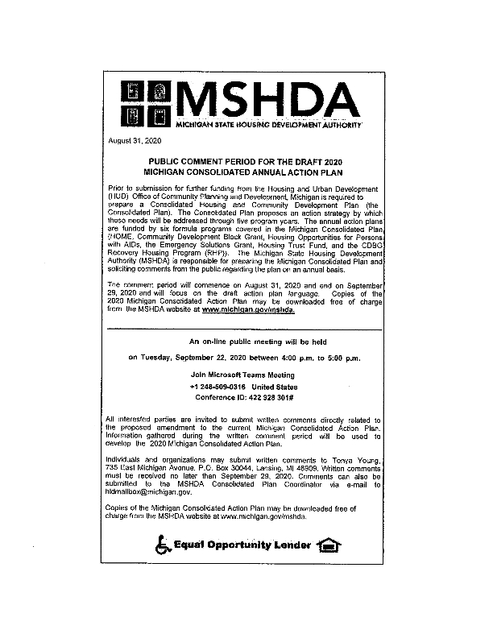
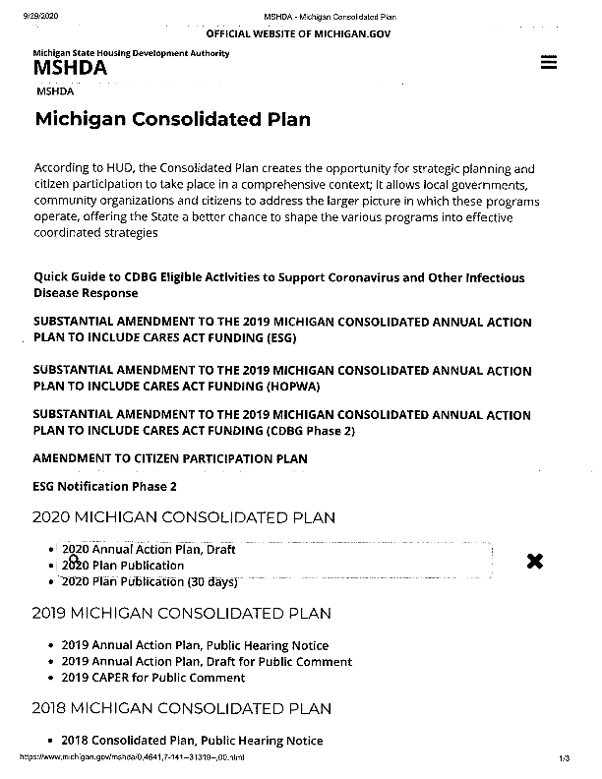
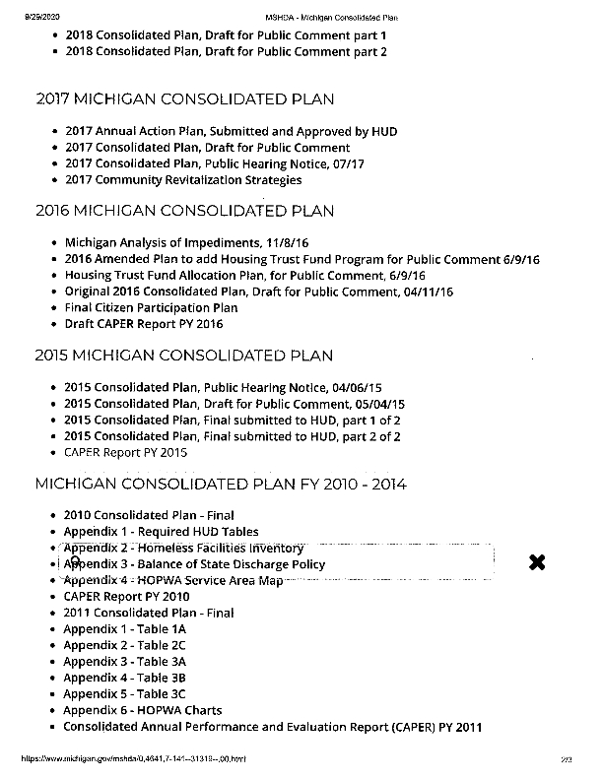
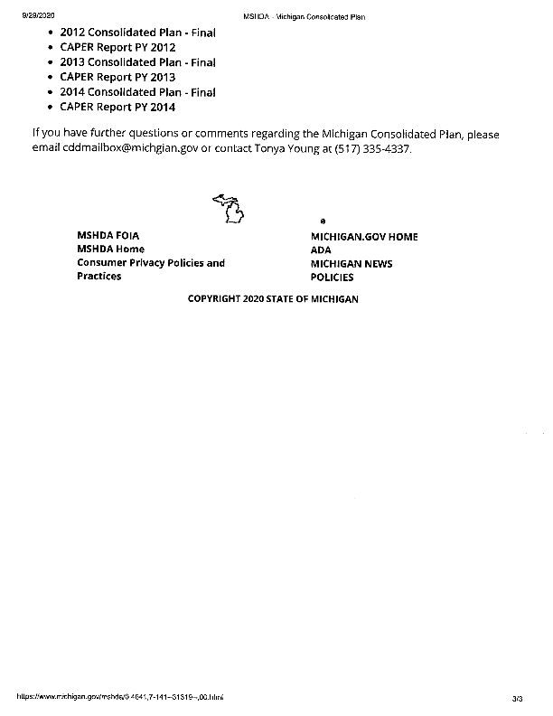


Grantee Unique Appendices
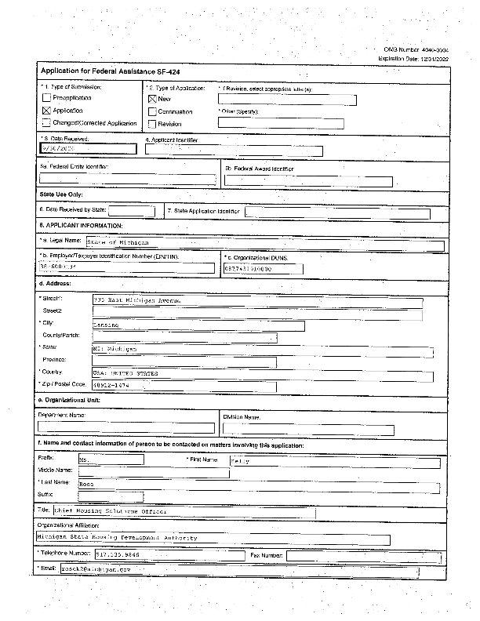
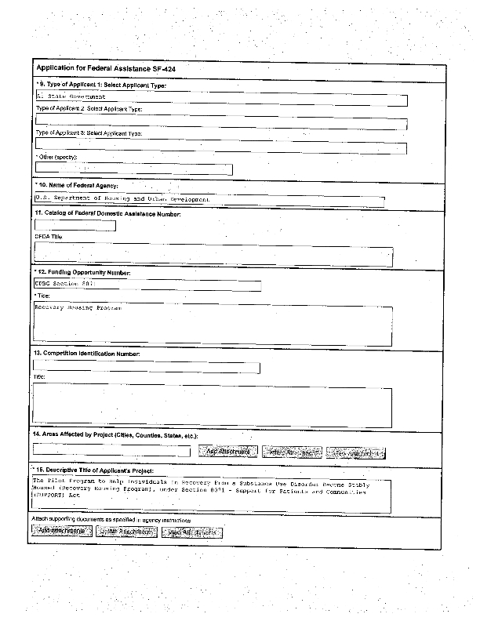
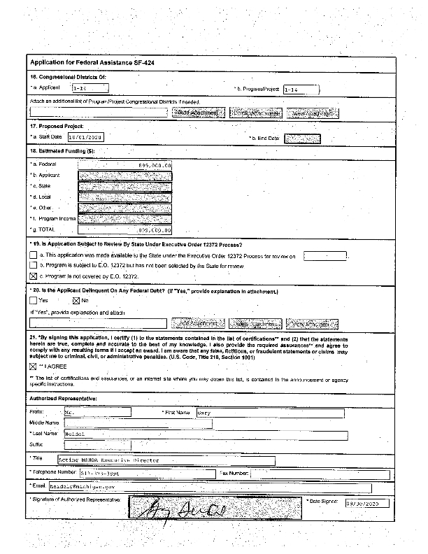
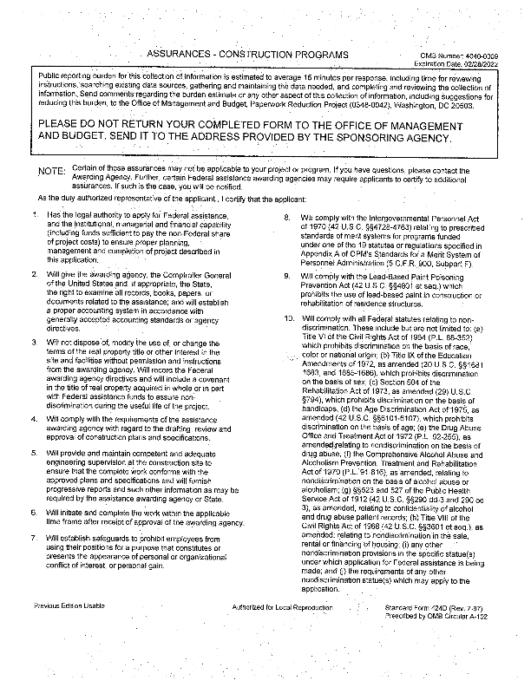
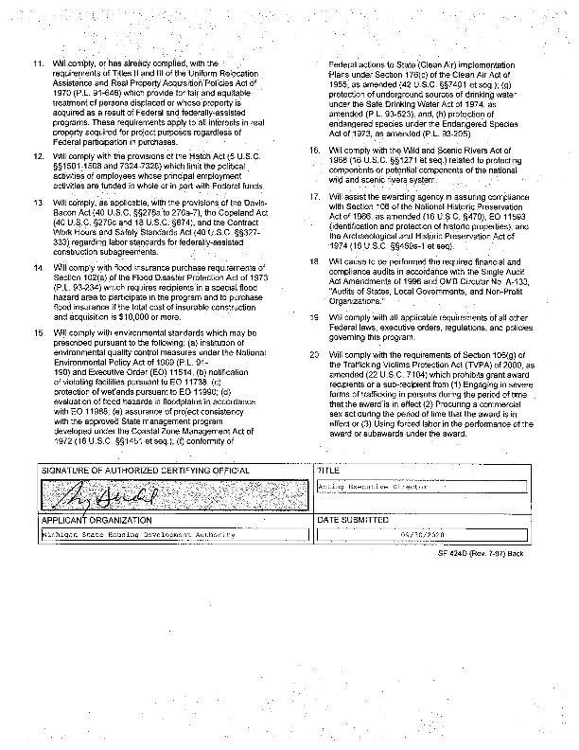

Grantee SF-424's and Certification(s)
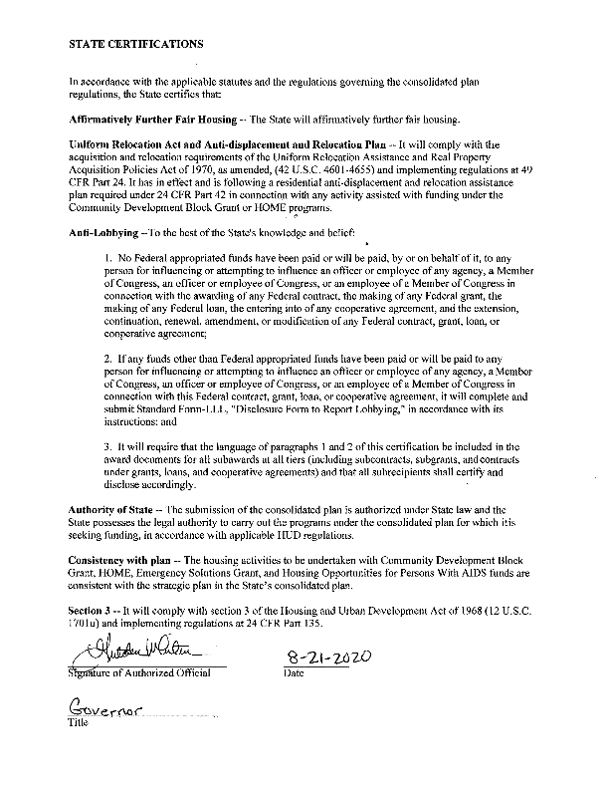
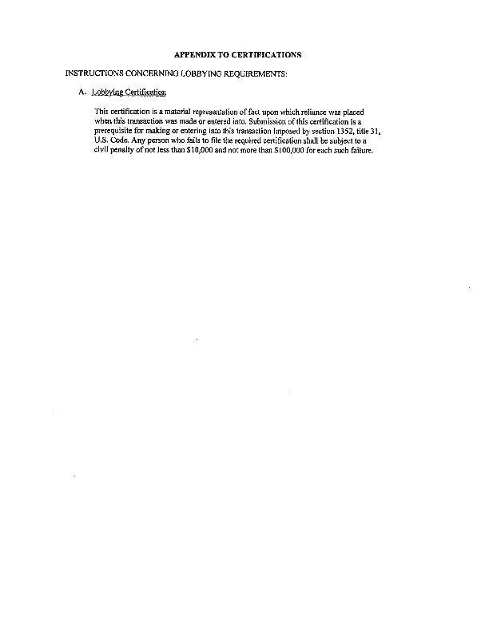
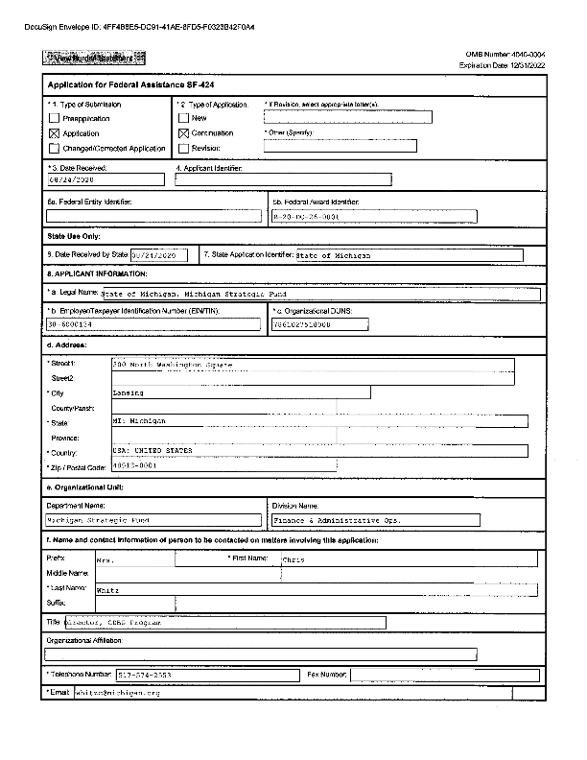
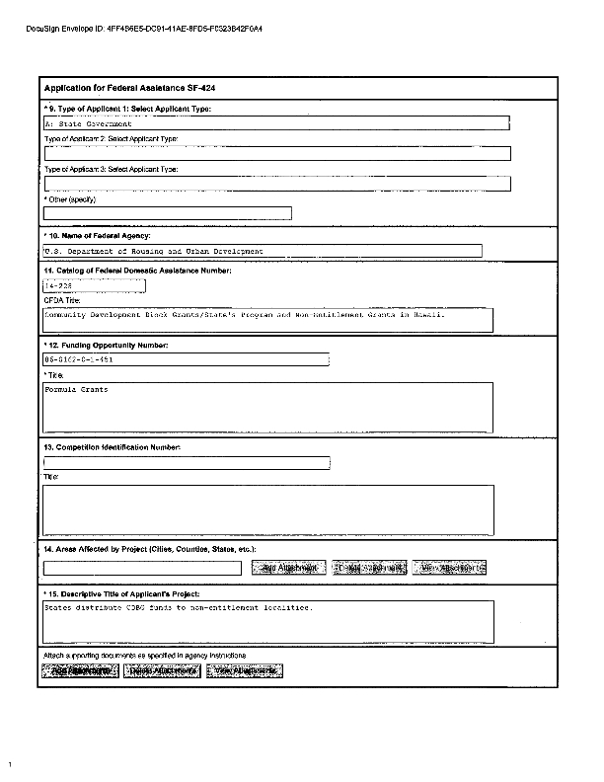
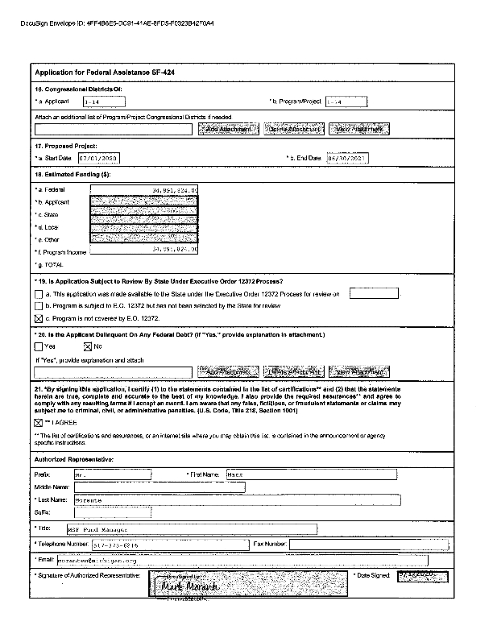
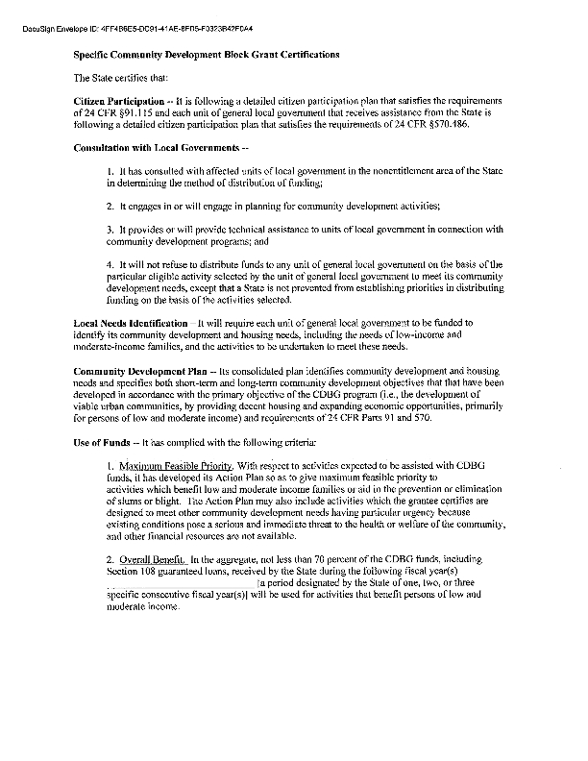
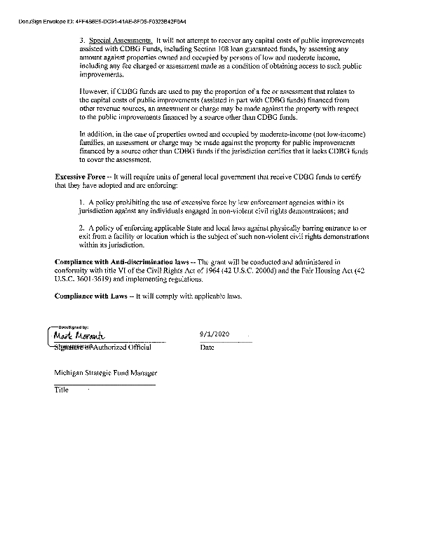
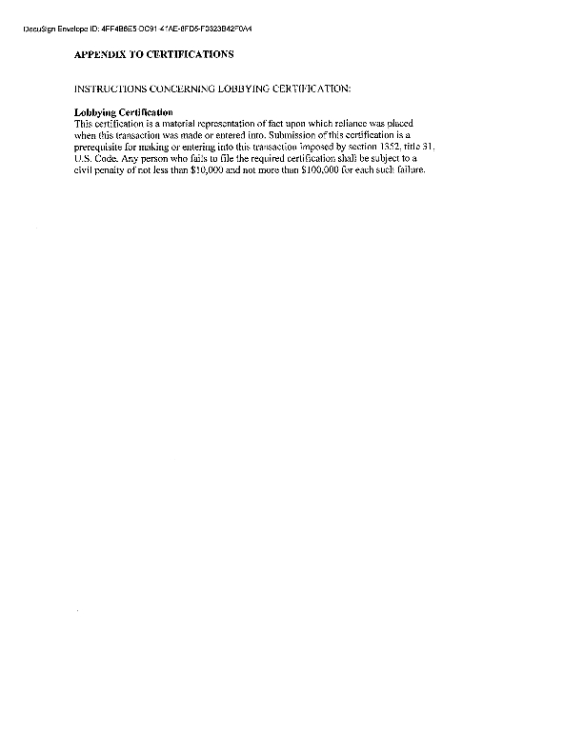
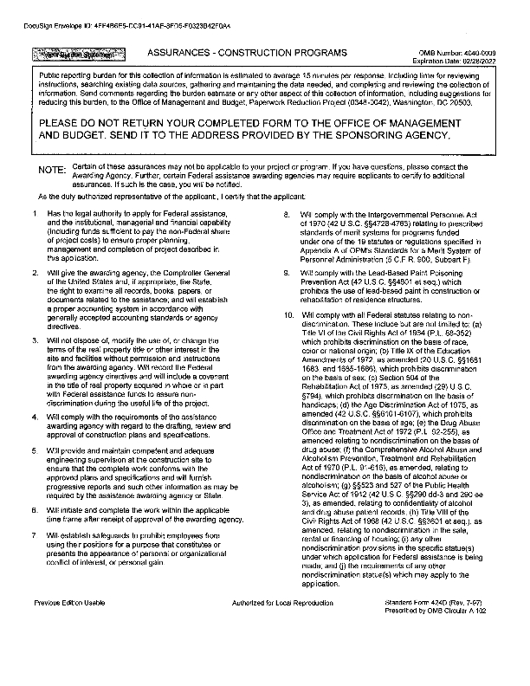
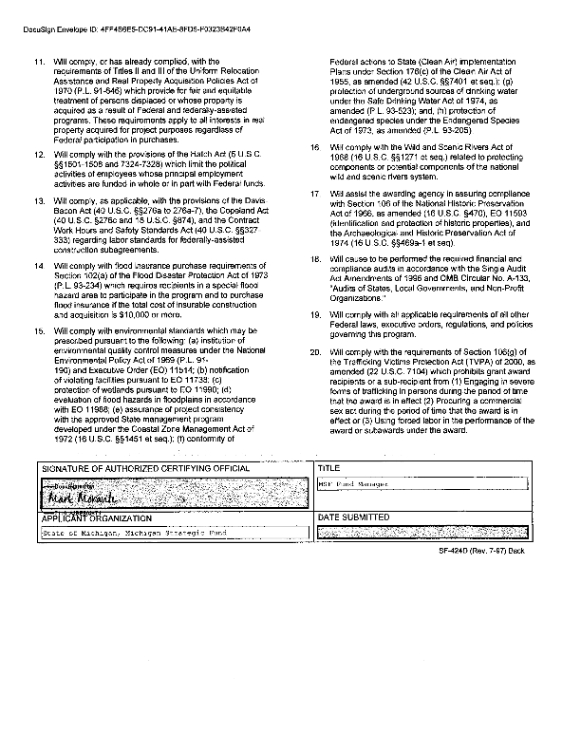
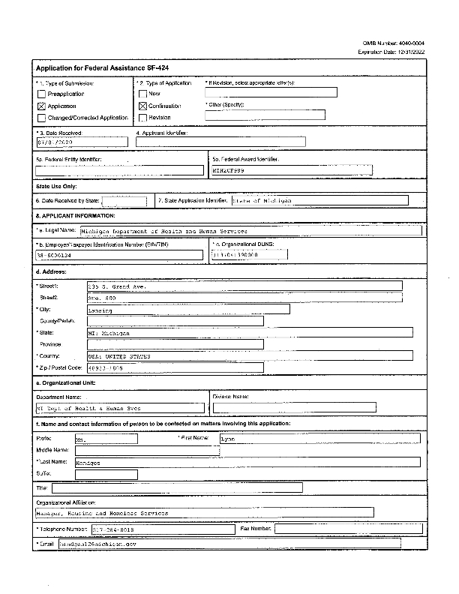
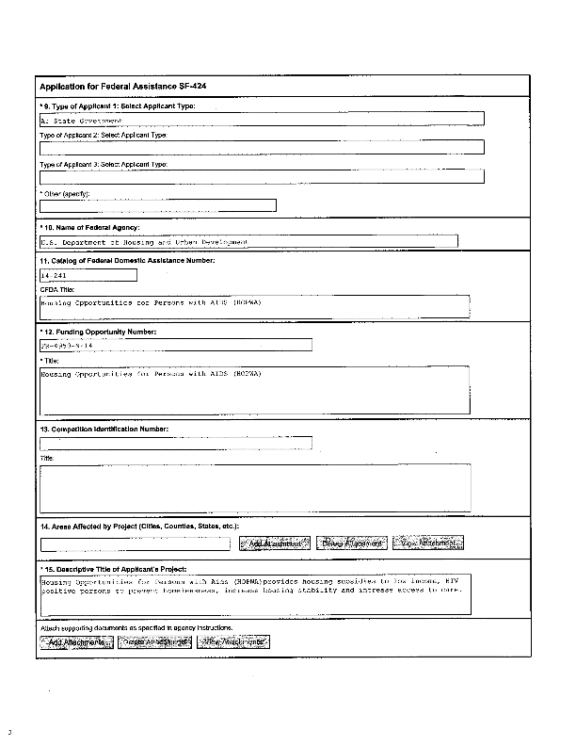
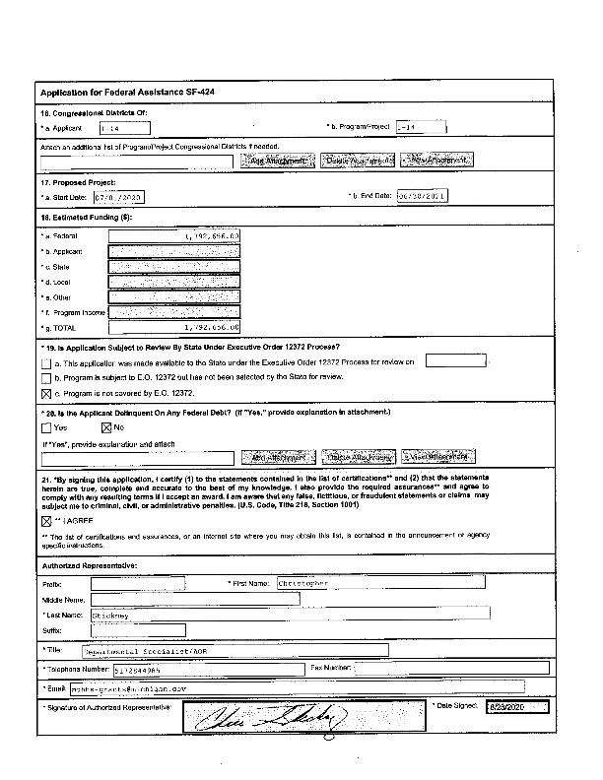
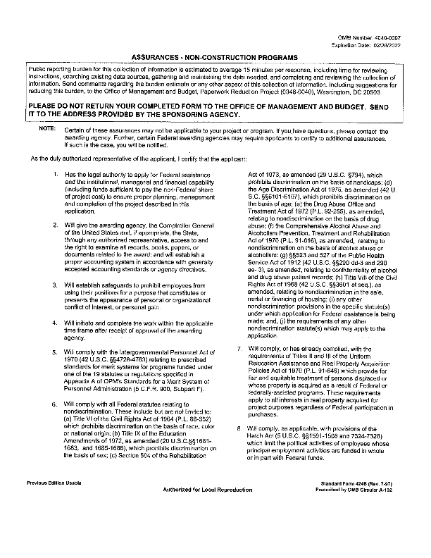
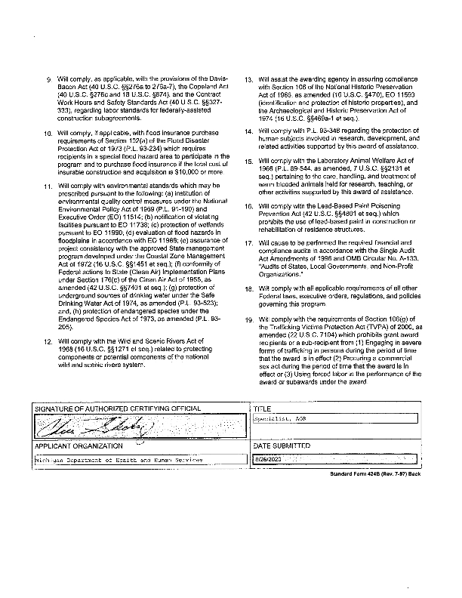
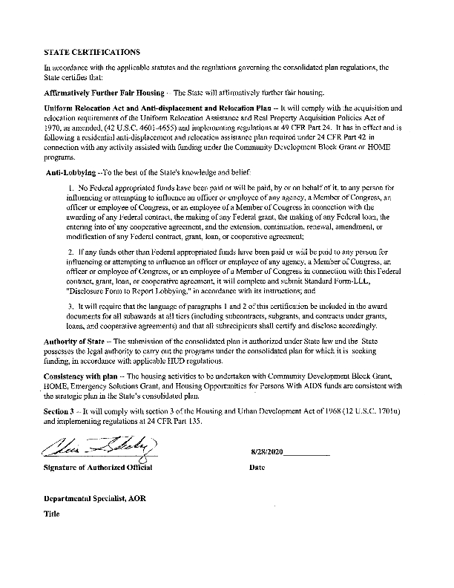
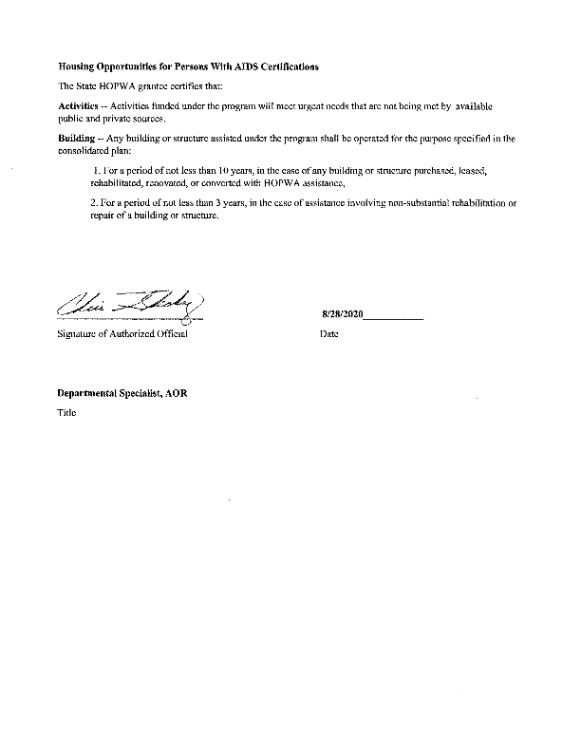
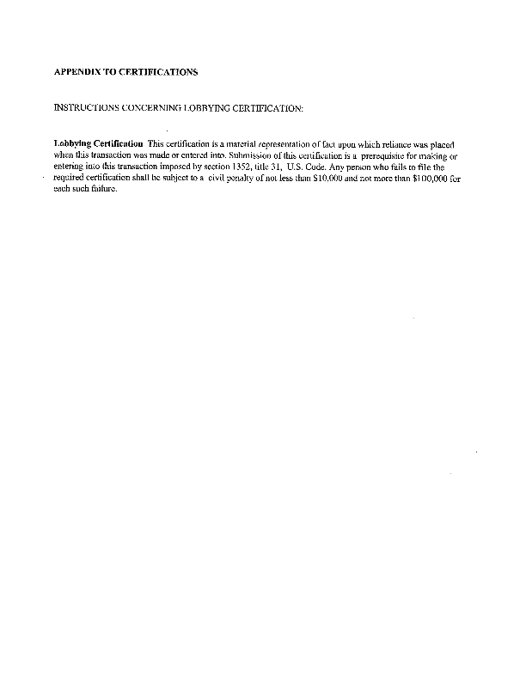
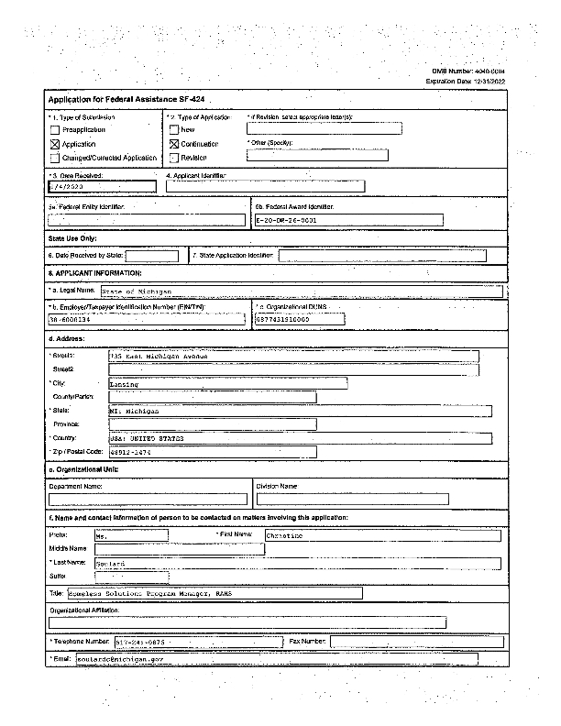
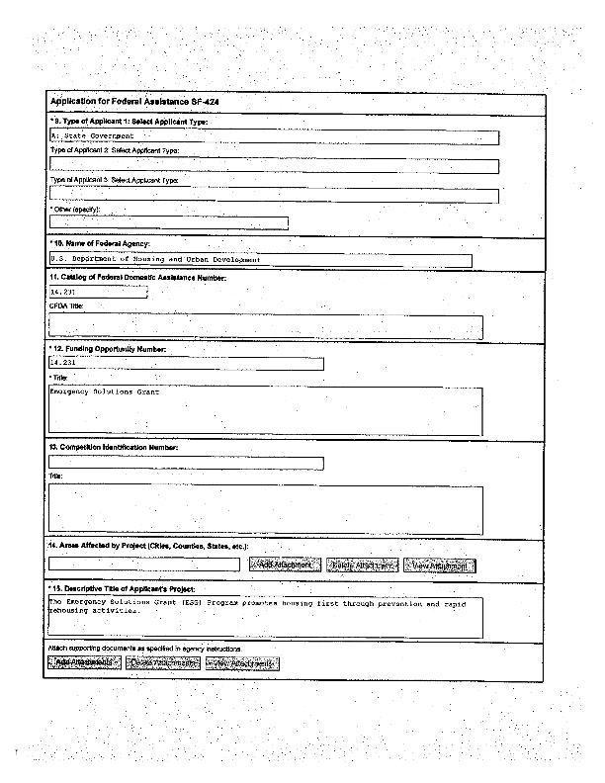
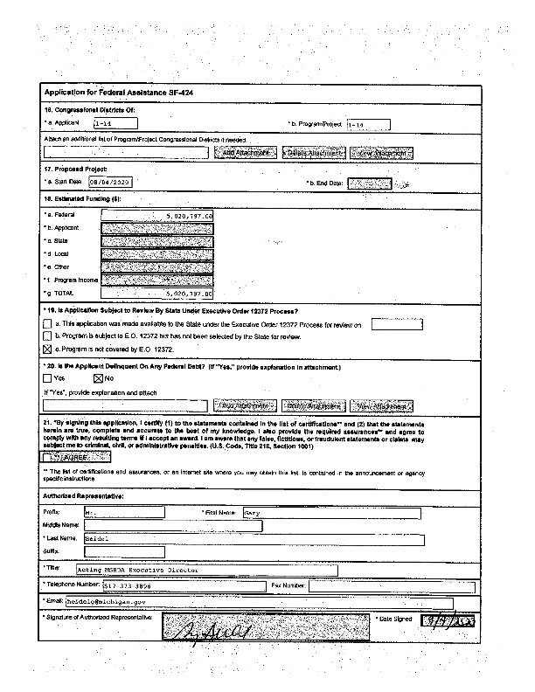
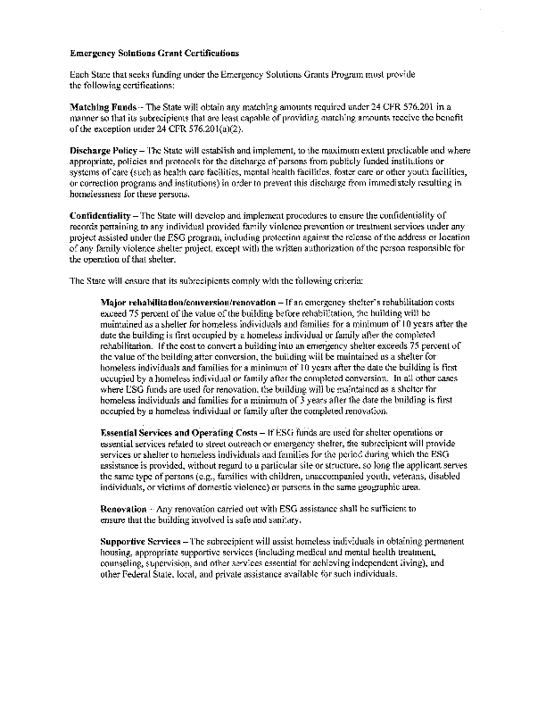
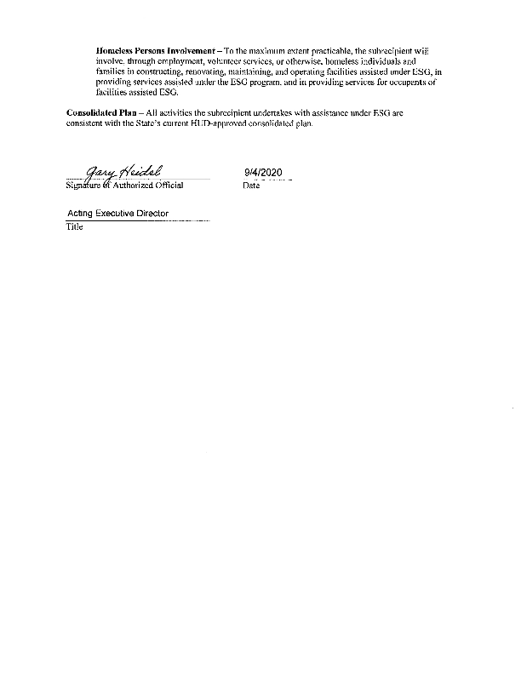
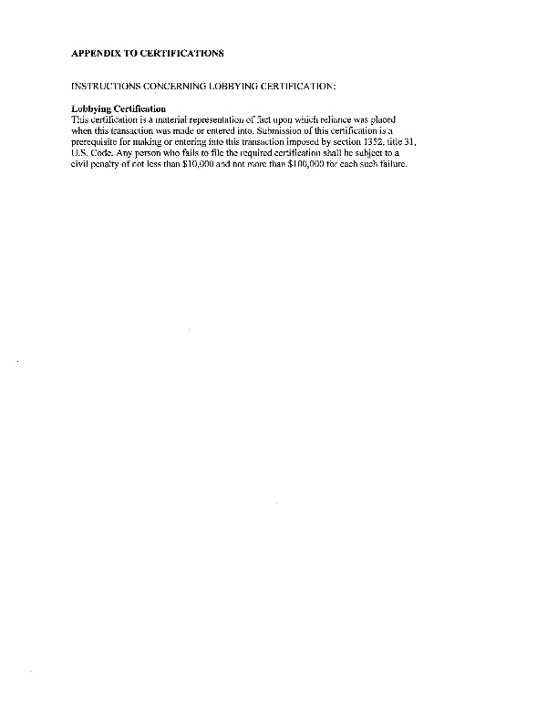
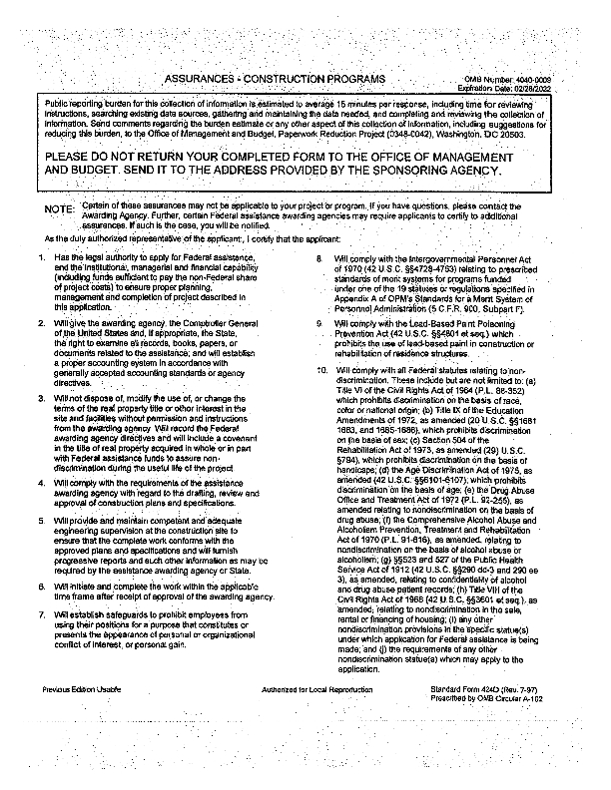
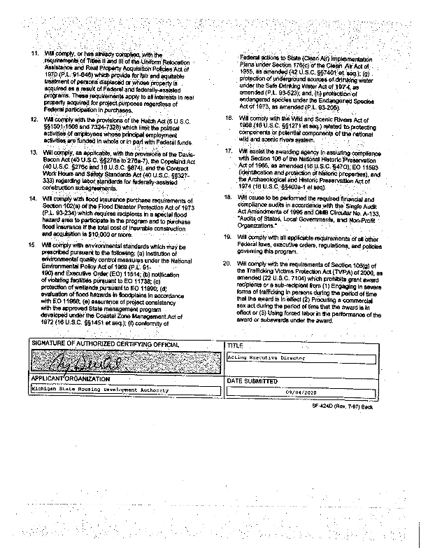
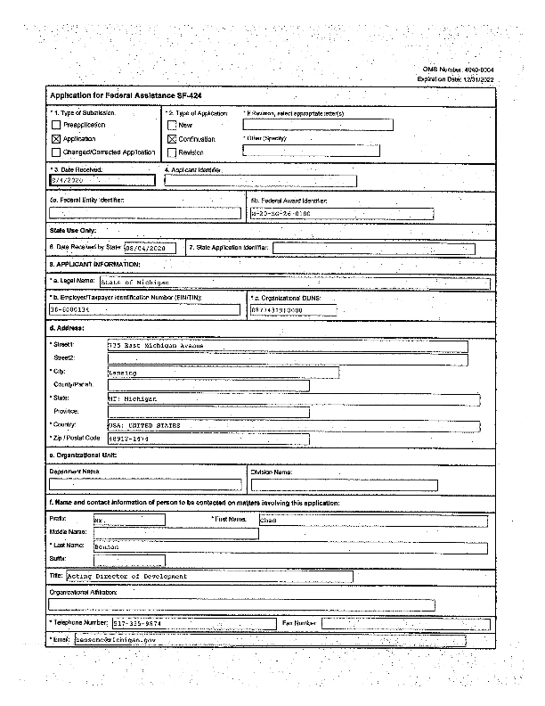
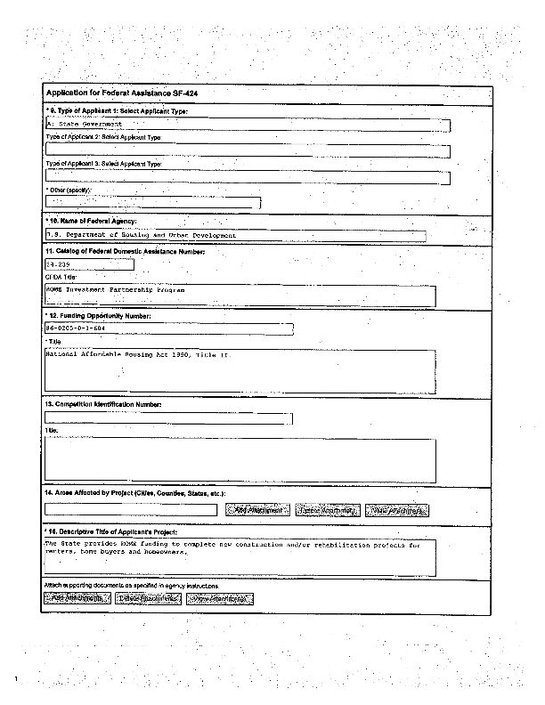
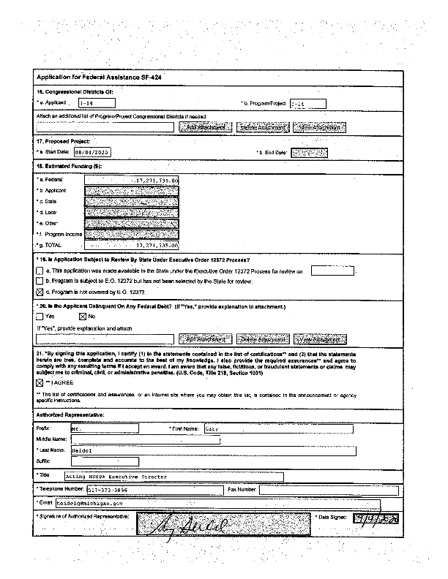
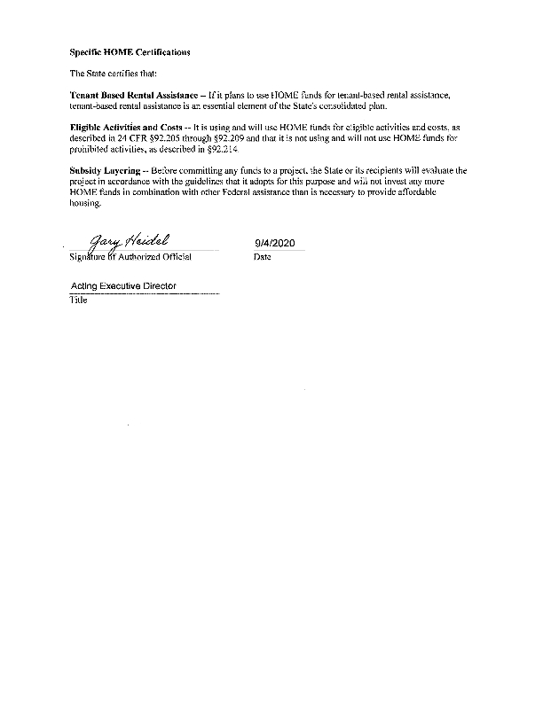
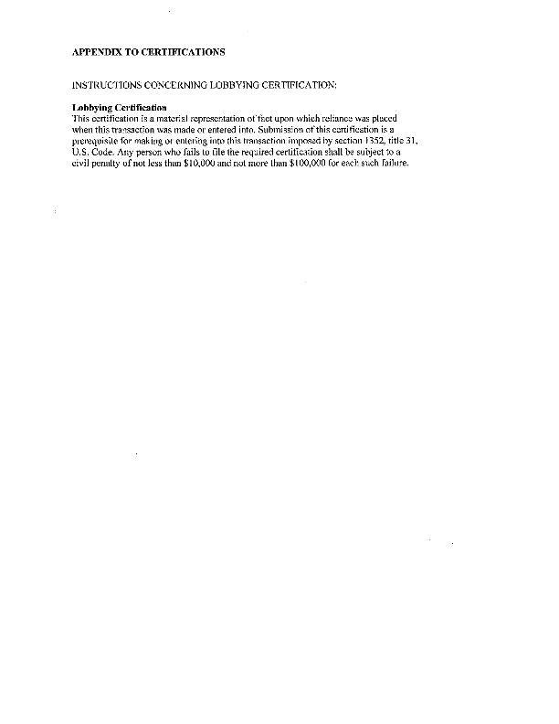
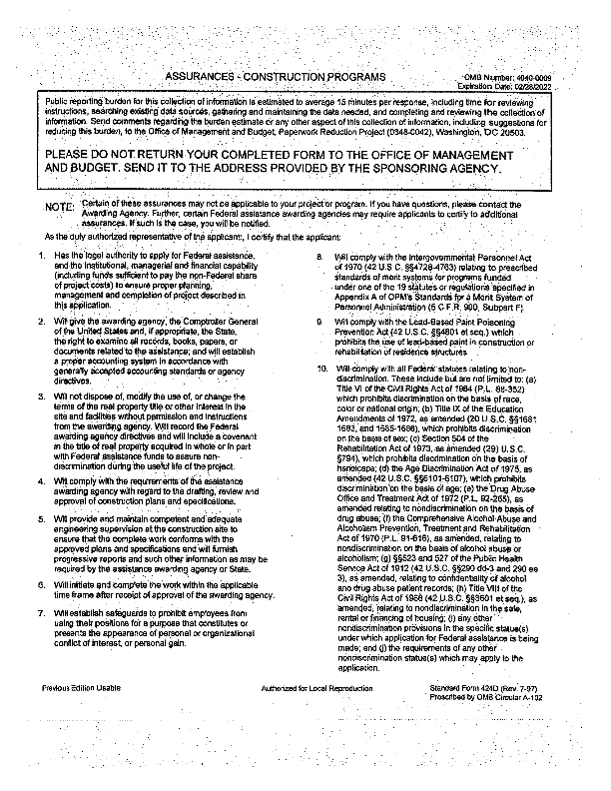
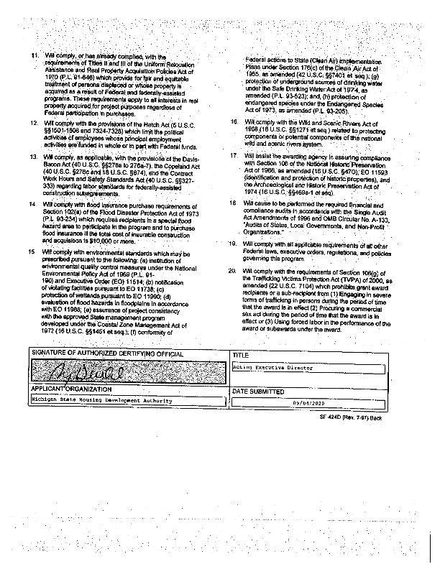
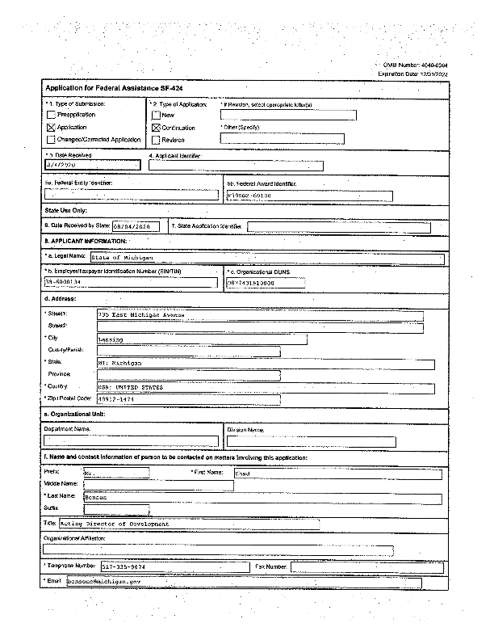
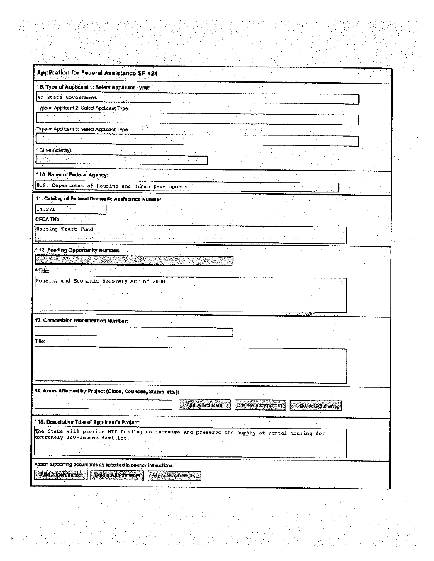
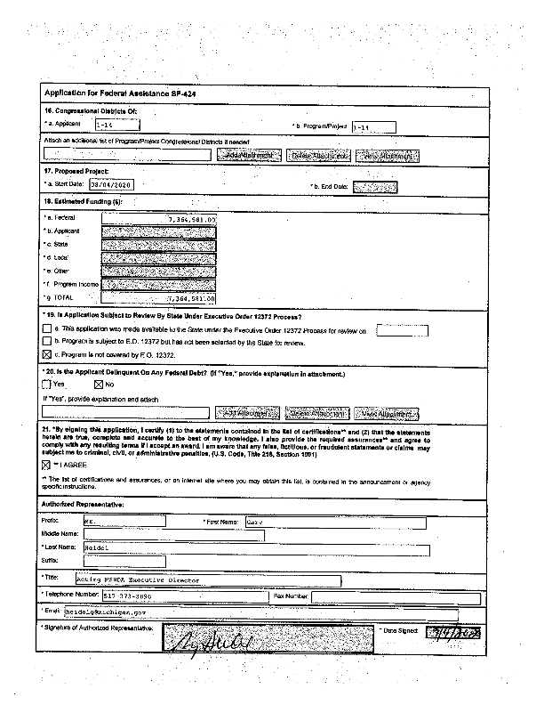
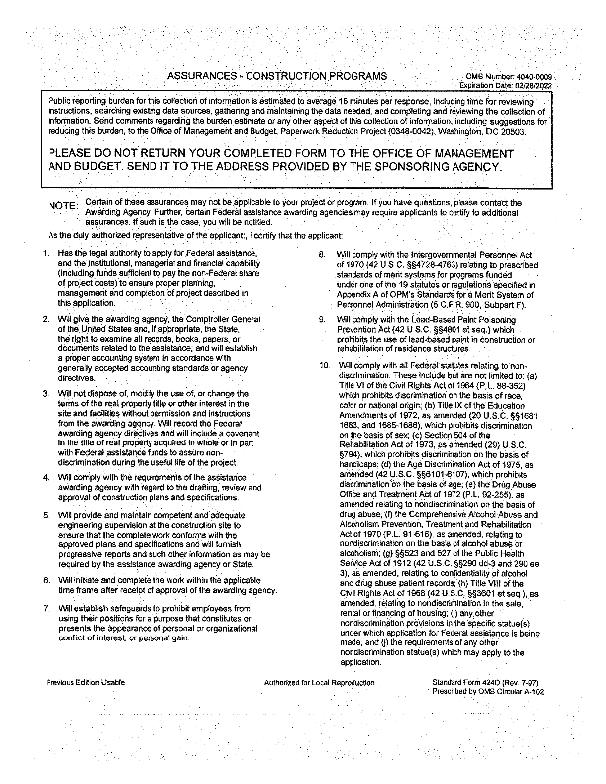
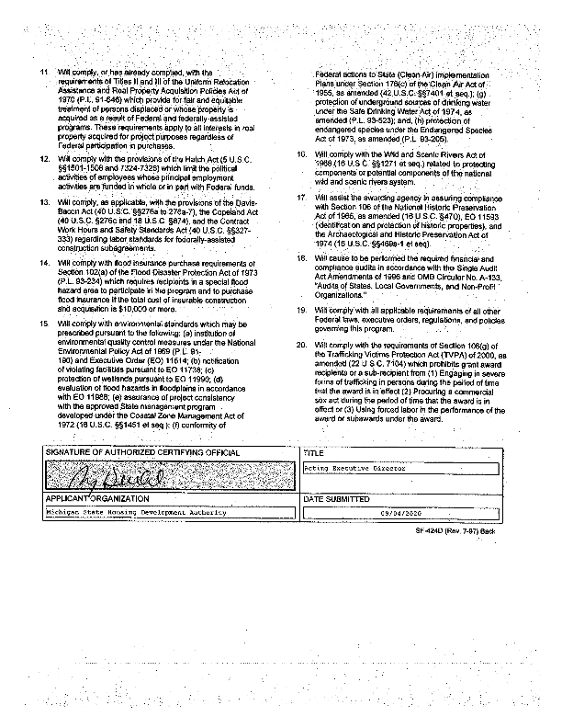

Appendix - Alternate/Local Data Sources

1 | Data Source Name  Housing Survey
 | List the name of the organization or individual who originated the data set.
 | Provide a brief summary of the data set.
 | What was the purpose for developing this data set?
 | Provide the year (and optionally month, or month and day) for when the data was collected.
 | Briefly describe the methodology for the data collection.
 | Describe the total population from which the sample was taken.
 | Describe the demographics of the respondents or characteristics of the unit of measure, and the number of respondents or units surveyed.
2 | Data Source Name  MSHDA Housing Needs Assessment
List the name of the organization or individual who originated the data set.
Michigan State Housing Development Authority
https://www.michigan.gov/documents/mshda/MSHDA-Statewide-Housing-Needs-web_653602_7.pdf
Provide a brief summary of the data set.
Data set supports data already provided.
 | What was the purpose for developing this data set?
 | Provide the year (and optionally month, or month and day) for when the data was collected.
 | Briefly describe the methodology for the data collection.
 | Describe the total population from which the sample was taken.
 | Describe the demographics of the respondents or characteristics of the unit of measure, and the number of respondents or units surveyed.

