**Instructions**

1. Requestor Contact Information:  Double click on this box. [*Fill in the Last Name, First Name, Location, E-mail Address and Contact Number fields (boxes).].  Then click the Esc key to continue.
2. Complete the form for each attendee, as shown in the below example.  [*Complete the required fields (boxes).]
3. For attendees requiring multiple course enrollments: Follow item #2 steps for each course.
4. To add additional attendees to a specific course: Right click on the Course Title, click on Insert, then select Insert Rows Below.
5. Submit the completed form in the Microsoft **Word** format to [MDOT-TechTraining@Michigan.gov](mailto:MDOT-TechTraining@Michigan.gov). Please put “Technical Training” in the Subject line.

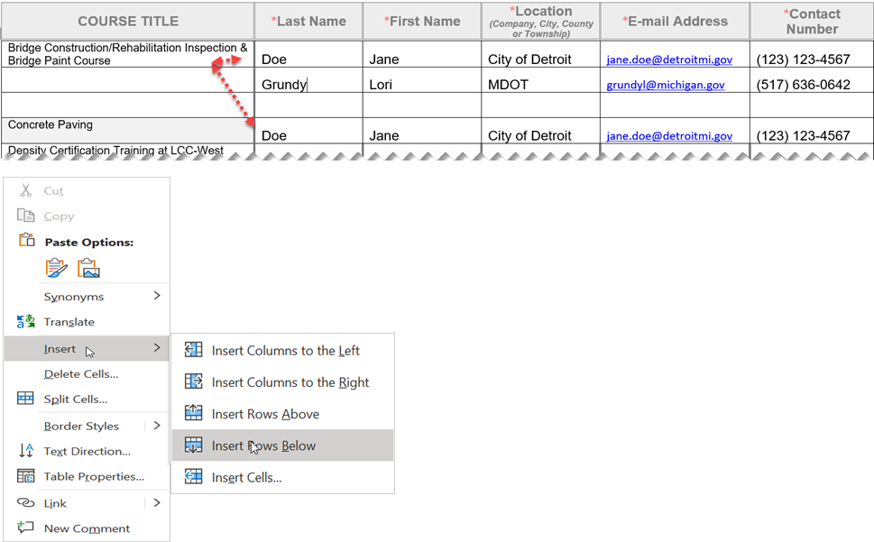

|  |  |  |  |  |  |
| --- | --- | --- | --- | --- | --- |
| Bridge Construction/Rehabilitation Inspection & Bridge Paint Course |  |  |  |  |  |
| Computerized Office Technician (COT)  (*The MDOT* [*2020 Spec book*](https://www.michigan.gov/mdot/-/media/Project/Websites/MDOT/Business/Construction/Standard-Specifications-Construction/2020-Standard-Specifications-Construction.pdf?rev=b944f71da7fb4f9c879f74659f64795b&hash=572ED32A1FC18C8D164C30D646450900) *a laptop with laptop power cord, and a calculator will be required for use.)*  **Note:**MDOT expects full commitment to attendance and participation in this class/course. Certifications and certificates of completion will not be issued for participants that fail to attend and/or participate. If the student does not pass the exam, the full course must be retaken. There will be no retests. |  |  |  |  |  |
| Computerized Office Technician-*Recertification* Exam *(Must have previously passed the Computerized Office Technician course.* *A laptop with laptop power cord, and a calculator will be required for use.)*  **Note:***Proof of non-expired Computerized Office Technician certification is required prior to registering for this exam. If the student does not pass the exam, the full course must be retaken. There will be no retests.* |  |  |  |  |  |
| Concrete Paving Inspection Training  *(This course is strongly encouraged for Technicians inspecting Concrete Paving and Concrete Pavement Restoration Projects, and for Quality Control and Quality Assurance Concrete Testing Technicians.)* |  |  |  |  |  |
| Density Certification Training at FSU  *(Local Agencies go to Ferris State University’s website to register at:* [Ferris.edu/ICET](https://ebill.ferris.edu/C20079_ustores/web/store_main.jsp?STOREID=22&SINGLESTORE=true).*)* |  |  |  |  |  |

|  |  |  |  |  |  |
| --- | --- | --- | --- | --- | --- |
| Geotechnical Construction Inspection Training  **Note:** To receive a certificate the attendee must attend both days. A straightedge and calculator will be required for use. |  |  |  |  |  |
| Hot Mix Asphalt Paving Operations  **Note:** All classes are in-person. Participants must, first, register on the Ferris State University’s (FSU’s) website @ [Ferris.edu/ICET](https://ebill.ferris.edu/C20079_ustores/web/store_main.jsp?STOREID=22&SINGLESTORE=true), as there are some required online prework (quizzes) that you must complete before the in-person class dates.  **Pre-Coursework:** You cannot attend the in-person class if you do not register on the Ferris website, first, @ [Ferris.edu/ICET](https://ebill.ferris.edu/C20079_ustores/web/store_main.jsp?STOREID=22&SINGLESTORE=true). Once registered, all participants will be emailed with further instructions needed to complete the required online prework on the FSU’s E-Learning system. We recommend you register at least two weeks in advance to allow time to complete this process.  **Questions:** Direct them to [ICET@ferris.edu](mailto:ICET@ferris.edu) |  |  |  |  |  |
| Hot Mix Asphalt Paving Operations-Recertification  **Note:** All classes are in-person. Participants must, first, register on the Ferris State University’s (FSU’s) website @ [Ferris.edu/ICET](https://ebill.ferris.edu/C20079_ustores/web/store_main.jsp?STOREID=22&SINGLESTORE=true), as there are some required online prework (quizzes) that you must complete before the in-person class dates.  **Pre-Coursework:** You cannot attend the in-person class if you do not register on the Ferris website, first, @ [Ferris.edu/ICET](https://ebill.ferris.edu/C20079_ustores/web/store_main.jsp?STOREID=22&SINGLESTORE=true). Once registered, all participants will be emailed with further instructions needed to complete the required online prework on the FSU’s E-Learning system. We recommend you register at least two weeks in advance to allow time to complete this process.  **Questions:** Direct them to [ICET@ferris.edu](mailto:ICET@ferris.edu) |  |  |  |  |  |
| MDOT Superpave Asphalt Mix Designers Certification Training  **Note:** *Local Agencies email:* [*tmurphy@murphypavetech.com*](mailto:tmurphy@murphypavetech.comt) *to register.* |  |  |  |  |  |
| Prevailing Wage Training  **Note:** To receive a Certificate of Completion for this course, you must attend both half-day training sessions, consecutively [attend the afternoon virtual session first, followed by the morning session]. |  |  |  |  |  |
| Structural Steel *Bolting* Workshop  **Note:** To receive a Certificate of Completion for this course, you must attend the entire workshop and pass an end of class assessment (open book, timed, 80% minimum score).  **Pre-Coursework:** Review the following documents prior to the workshop.   1. [2024 MDOT Field Manual for Structural Bolting](https://www.michigan.gov/mdot/-/media/Project/Websites/MDOT/Programs/Bridges-and-Structures/Structure-Construction/Field-Manual-for-Structural-Bolting.pdf?rev=bbf2e873317341b9b76ea0066d94a405&hash=584CB26E0383F3D9014256D96EABFB06) 2. [2020 Specification for Structural Joints Using High-Strength Bolts by RCSC](https://www.aisc.org/globalassets/aisc/publications/standards/a348-20w.pdf) |  |  |  |  |  |
| Structural Steel *Welding* Workshop  **Note:** To receive a Certificate of Completion for this course, you must attend the entire workshop and pass an end of class assessment (open book, timed, 80% minimum score).  **Pre-Coursework:** Review the following documents prior to the workshop.   1. [2022 MDOT Field Manual for Structural Welding](https://www.michigan.gov/mdot/-/media/Project/Websites/MDOT/Programs/Bridges-and-Structures/Structure-Construction/Field-Manual-for-Structural-Welding.pdf?rev=ab829cd4bcd345149ce649e720477e3a&hash=AFABAE36EBC67618303AFBDA231C812B) 2. [2020 AWS A2.4 Welding Symbols (high-level review)](https://pubs.aws.org/Download_PDFS/2__A2_4_2020_PV.pdf) 3. [2022 MDOT Field Manual for Pile Welding](https://www.michigan.gov/mdot/-/media/Project/Websites/MDOT/Programs/Bridges-and-Structures/Structure-Construction/Field-Manual-for-Pile-Welding.pdf?rev=c80e7fd31fa84bd6bc2d904365a35c35&hash=C50F012DB5CF720FCAC7B097E76D6007) |  |  |  |  |  |