Creating a Digital Seal

On **Page 4** of this document, customizable seals for both Engineers (top image) and Surveyors (bottom image) are provided. You can use these to create a digital seal if you do not already have one. To customize the image, click on the text block to edit the text.

Click in text block to edit text

Digital seals


After the seal has been customized, the seal must be converted to a JPEG picture to be used as a signature. For the best quality seal, use the following procedure.

* 1. Zoom in on the seal so that it fills the entire view
  2. Take a **Print Screen** of the window that includes the seal and open in Snagit Editor, Windows Paint or similar image editing software.
  3. Crop the picture to only include the seal

Digital Seal


* 1. Save the picture as a JPEG on your computer.

Signing a Document with a Digital Seal in OneSpan

To sign a document in OneSpan with a digital seal, the person who is creating the transaction will need to adjust the signature type for the signature field where the seal needs to be placed.

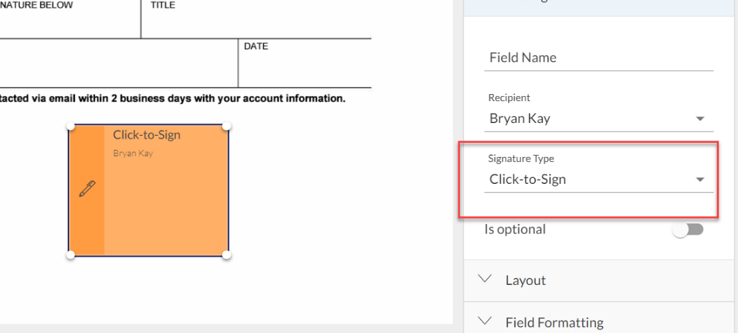

Change the signature type to ‘Capture Signature’

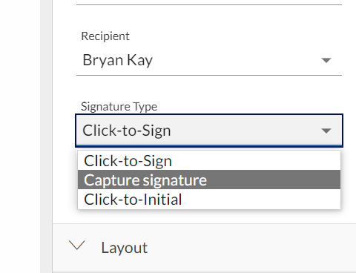

Select the ‘From File’ option.

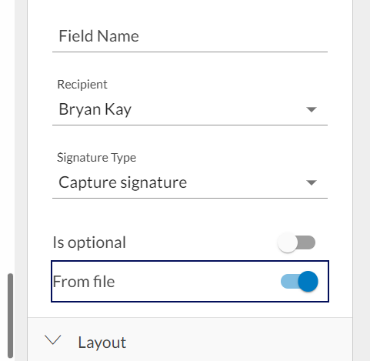

With these settings in place, when the signer clicks on the document, a ‘Capture Signature’ will appear. The signer should select ‘Upload Image’.

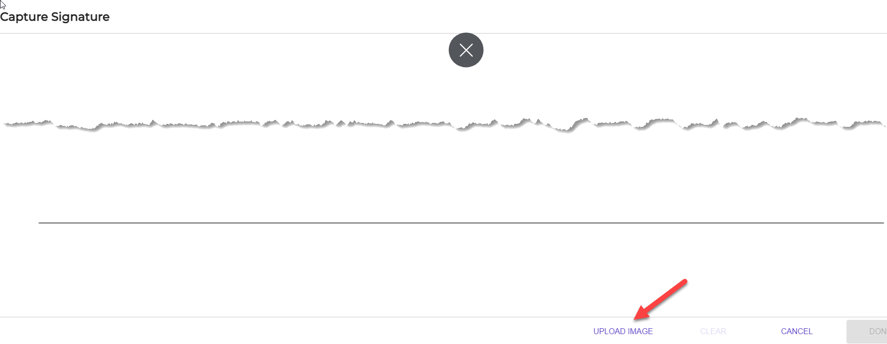

After selecting your digital seal, it will show up as the graphical appearance of the signature.

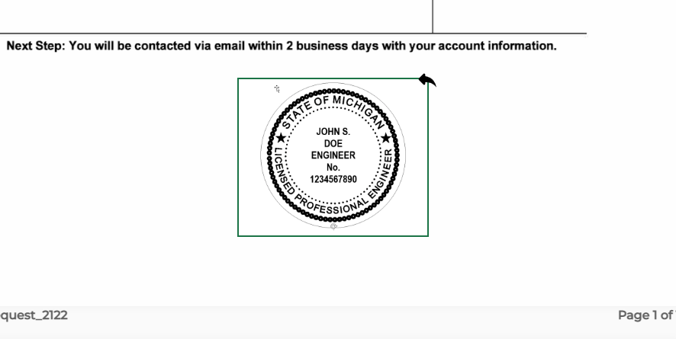



**JOHN S.**

**DOE**

**ENGINEER**

**No.**

**1234567890**



**JOHN S.**

**DOE**

**PROFESSIONAL**

**SURVEYOR**

**No.**

**1234567890**