# CEPI logoCenter for Educational Performance and Information Michigan Postsecondary Data Inventory Security Agreement Instructions for Colleges and Universities

**Please do not return the instruction pages with your security agreement form.**

Institutions of Higher Education are required to submit financial and instructional activity information to the State of Michigan in MPDI.

IHEs should designate at least one person to each of the roles listed below to enter, save, submit, and certify the MPDI data.

**If you are not already an MPDI authorized user**, you must first subscribe to the application through MiLogin for Business. If you do not have a MiLogin for Business account, you may create one at [MiLogin for Business](https://milogintp.michigan.gov/) (https://MiLogintp.michigan.gov). **Please do not create multiple MiLogin for Business accounts**.

1. To request access, [log in to the MiLogin for Business site](https://milogintp.michigan.gov/) and click “Create An Account.”
2. Follow through with all steps to create an account. If you need assistance, please see the [MiLogin User Guide](https://www.michigan.gov/cepi/-/media/Project/Websites/cepi/Security/milogin_user_guide.pdf).
3. Once your account has been created, choose “Discover Online Services.”

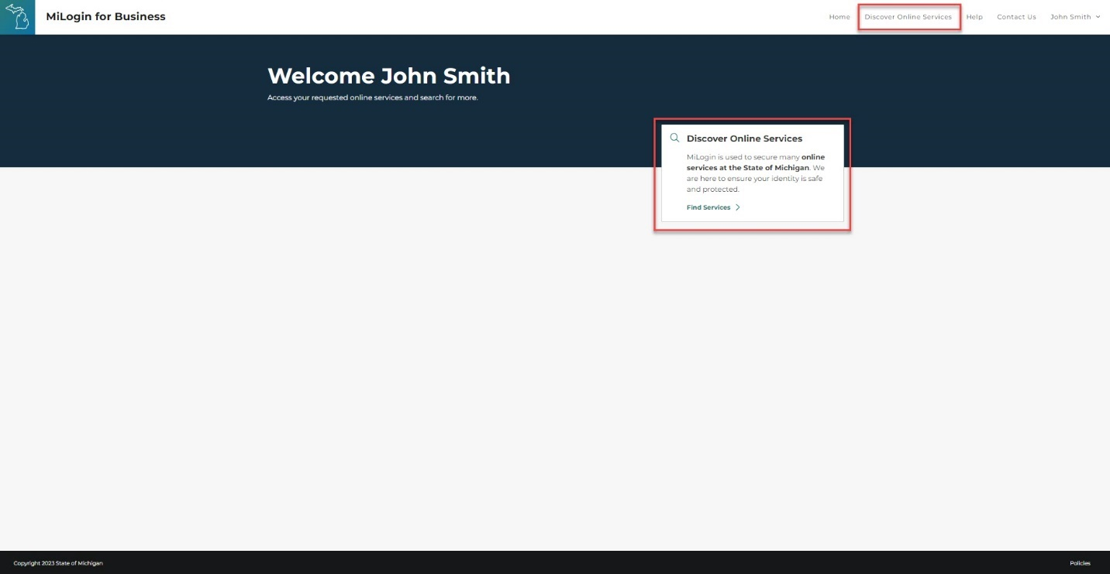

1. On the next page, search for an application by keyword, or select an agency (CEPI) to view available applications. Choose the application to subscribe to by clicking the application description.
2. Review and agree to the Terms & Conditions.
3. Click “Request Service.”

**\****Application users will receive relevant email updates and reminders.*

**CEPI logo**

**Center for Educational Performance and Information Michigan Postsecondary Data Inventory Security Agreement Instructions for Colleges and Universities**

## User Roles:

The following roles are available in the MPDI application. Choose only one edit role per module. To be able to view any reports within the application you must choose the Report – View role.

1. **Data Entry – Edit:** Users with Data Entry privileges are given authorization for a specific college in one or more modules in the MPDI application. This allows the user to enter and save the data entered in the module they have been given privileges for in the MPDI application.
2. **Submitter – Edit:** Users with Submitter privileges are given authorization for a specific college in one or more modules in the MPDI application. This allows the user to enter, save and submit the data in the module they have been given privileges for in the MPDI application.
3. **Reviewer – View:** Users with Reviewer – View privileges are given authorization for a specific college in one or more modules in the MPDI application. This allows the user to view the data in the module they have been given privileges to.
4. **Reports – View:** Users with Reports - View privileges are given authorization for a specific college in either the tuition and fees module and/or all other MPDI modules. This allows the user to view the reports in the MPDI application.
5. **Annual Reporting – View:** Users are given authorization for a specific college in MPDI. This allows the user to view the Annual Reporting collection in the MPDI application.
6. **Data Coordinator- Annual Reporting Requirements Certify Only:** Users with Data Coordinator- Annual Reporting Requirements Certify Only privileges are given authorization for a specific college in MPDI. This allows the user to certify the Annual Reporting Requirements collection only.
7. **Data Coordinator- All Modules:** Users with Data Coordinator- All Modules privileges are given authorization for a specific college in all of the modules in the MPDI application. The Data Coordinator role can enter, save, submit, and certify the data for all modules in the MPDI application, including the annual reporting module. Data Coordinators are also given Report View privileges which allows the user to view and run reports in the MPDI application.

# CEPI logoCenter for Educational Performance and Information Michigan Postsecondary Data Inventory Security Agreement for Colleges and Universities

**Step 1.** Enter the code and name for your college or university.

**Entity Code:**  **Entity Name:** 

**Step 2.** Enter the name of the person being authorized to submit MPDI data for the college indicated above.

**Name:**  **Title:**   
**Email:**  **Phone:** 

**Step 3.** For the authorized individual: Enter your MiLogin for Business account information and check the box to confirm that you have subscribed (requested access) to the MPDI. (Please see the instructions on the previous page.)

**MiLogin for Business Account ID (e.g., smithj1234):** 



**Step 4.** Select the access type and role(s) this individual will perform. See the instructions for a complete description of each role. Permissions may vary slightly depending upon your entity type.

| **User Roles** |  | **Tuition & Fees** | **Financial Aid** | **Valuation & Millages** | **Revenues** | **Expenses** | **Enrollment** | **Employee FTE** | **Net Position** |
| --- | --- | --- | --- | --- | --- | --- | --- | --- | --- |
| **Submitter - Edit** |  |  |  |  |  |  |  |  |  |
| **Data Entry - Edit** |  |  |  |  |  |  |  |  |  |
| **Reviewer - View** |  |  |  |  |  |  |  |  |  |
| **Reports - View** |  |  | | | | | | | |
| **Annual Reporting View** |  |  | | | | | | | |
| **Data Coordinator-Annual Reporting Certify Only** |  | **Institutions can appoint multiple users for this role. Each appointment requires authorization by the Community College President – see step 6 below.** | | | | | | | |
| **Data Coordinator – All Modules** |  | **Institutions can appoint multiple users for this role. Each appointment requires authorization by the Community College President – see step 6 below.** | | | | | | | |

**Step 5.** For the authorized individual: ***Please sign below.***

I agree to abide by the regulations that govern the use of student data within the [Family Educational Rights and Privacy Act](https://www.ecfr.gov/current/title-34/subtitle-A/part-99), as well as the [Privacy Act of 1974](http://www.justice.gov/opcl/privacyact1974.htm), governing records maintained about individuals. I agree to protect my user identification and password from unauthorized use. I understand all access under my user ID is my responsibility, and that allowing anyone else to use my ID will result in my account being deleted.

**Signature: ** **Date:** 

**Step 6.** The **Data Coordinator** assigned on behalf of your college must sign below.

Your **Community College President** must authorize the individual assigned as the Data Coordinator for MPDI. All other roles are authorized by the Data Coordinator.

I attest that the above-named individual is authorized by me to perform the function(s) identified above and to submit data/view reports in the MPDI Application.

**Name:**  **Title:** 

**Signature: ** **Date:** 

Email this form to CEPI: [cepi@michigan.gov](mailto:cepi@michigan.gov) **\****Application users will receive relevant email updates and reminders.*